System Design Project 2018

Last Resort

Table of Contents

Executive Summary 11

Customer Needs 11

Internal Stakeholders 11

External Stakeholders 11

Customers 11

Project Goals 11

Technology Requirements 11

Expected Timeline 11

Stakeholders and User Stories 12

Function Requirements 12

Internal Stakeholders 12

Employees 12

Managers 12

Supervisors 12

External Stakeholders 12

Vendor Partners 12

Customers 12

Actor List 12

User Stories 12

Use Cases 27

Food Operations 27

1.1.05 Create Recipes 27

1.1.09 Add Recipes 28

1.1.11 Provide information about the restaurant 29

1.1.16 Create Food Ticket 30

1.2.14 Browse recipes 31

1.2.21 View Sold Tickets 32

1.2.24 Search Recipes 33

1.2.28 Browse Orders 34

1.2.29 View Recipes Details 35

1.3.07 Add Food Item 36

1.3.10 Update Recipes 37

1.4.05 Delete Recipes 39

1.4.08 Remove Dishes from Menu 40

2.1.02 Add Drink 41

2.1.17 Add Menu List 41

2.2.01 Browse Menu List 42

2.2.05 View Recipe Details 44

2.2.06 View Orders 45

2.3.11 Edit Drink 46

2.4.05 Remove Recipes 47

2.4.08 Deactivate Menu List 48

3.1.05 Create Catering Request 50

3.3.13 Update Catering Request 51

Supply Operations 52

1.1.08 Create Supply 52

1.2.18 Browse Inventory 53

1.3.13 Update Quantities to Correct Mistakes 54

1.2.17 Monitor Demand and Document Inventory 55

1.4.07 Cancel Orders 56

2.1.14 Browse Inventory System 57

2.2.24 Search Order Supplier 58

2.2.51 Browse Order Supply 59

2.2.54 Search for Supplier Account 60

2.3.22 Edit Order Supplies 61

2.4.14 Cancel Order Supplies 62

3.1.16 Create New Supplier 63

3.2.25 Browse Suppliers 64

3.3.19 Update Supplier 65

4.2.17 Search Supplier Account 66

4.2.37 Access Supply Request 67

5.2.10 View Supply Order Details 68

Facility Operations 69

1.2.36 Browse Hours 69

2.1.16 Create Maintenance Ticket 70

2.2.34 View Maintenance Work Orders 71

3.2.32 Read Building List 72

5.1.02 Add Reservation 73

5.2.01 View Details of Reservation 74

5.2.06 View List of Reservations 75

5.2.08 View Maintenance Ticket Details 76

5.2.09 View Room Details 77

5.3.15 Update Maintenance Ticket 78

5.4.03 Deactivate Open Maintenance Slip 79

5.4.06 Deactivate Room 80

Guest Operations 81

1.3.20 Checkout 81

3.4.11 Delete Account 82

5.5.01 Guest Check In 83

5.3.06 Edit Room Reservation 84

5.4.02 Remove Reservation 85

6.1.06 Create User Account 86

6.4.04 Deactivate Guest Account 88

Personnel Management 89

1.2.01 Log In 89

1.2.02 Log Out 90

1.1.19 Create New Employee Role 91

1.1.20 Create New Employee Schedule 92

1.2.45 Retrieve Employee Roles 93

1.2.49 Retrieve Employee Schedule 94

1.2.50 Retrieve Browse Employee Schedules 95

1.3.23 Update Employee Roles 96

1.3.24 Update Employee Schedule 97

1.4.13 Delete Employee Roles 98

1.4.15 Delete Schedules 99

2.2.39 View Total Daily Tips 101

3.2.21 Marketing View Budget 101

3.2.48 Browse Account 102

3.3.29 Update Account 103

6.1.08 Create a Message 104

Event Operations 105

2.2.50 Search for a Schedule Event 106

3.1.03 Create Event 107

3.1.04 Create Event Request 108

3.1.06 Create Advertising Event 109

3.1.08 Create New Sponsor 110

3.1.10 Create Account 111

3.2.23 Read Advertising Event 112

3.2.31 Read Event Request 113

3.2.35 Read Event 114

3.2.36 Read Setup List 115

3.2.37 Read Performance Details 116

3.2.38 Read Account Details 117

3.2.44 Browse Event Request 118

3.2.45 Read All Events 119

3.2.46 Browse Performance 120

3.2.49 Browse Advertising Event 121

3.2.52 Browse Setup List 121

3.3.15 Update Advertising Event 122

3.3.26 Update Performance 123

3.3.30 Update Event Request 124

3.4.10 Delete Scheduled Performance 125

3.4.12 Delete Event Request 126

3.4.14 Delete Events 127

Service and Appointment 128

3.2.30 Read Resort Services 128

3.2.24 Read Review 129

3.2.47 Browse Resort Service 130

3.2.53 Browse Reviews 131

5.2.27 Retrieve Vehicle by License Plate 132

5.2.28 Retrieve Vehicle by Guest Name 133

5.2.37 Retrieve Shuttle Vehicle by Vin 133

5.2.38 Retrieve Shuttle Vehicle by License Plate 135

5.3.12 Update Vehicle’s Parking Spot 135

5.3.16 Update Shuttle Vehicle Status 136

5.4.05 Deactivate Shuttle Vehicle 137

6.2.05 View List of Children 138

6.2.06 View Child Details 139

6.2.23 Update Dependent Record 140

7.1.01 Add a New Dependent 141

7.1.03 Sign Pets Up for Grooming Appointments 142

7.2.14 Groomer Appointment Book 144

7.2.16 Show Appointment Details 145

7.2.21 Browse Pets 146

7.3.14 Change an Appointment Details 147

7.4.05 Delete Appointment 148

Product Operations 150

1.2.39 View Products 150

1.2.40 View Cart 151

2.1.21 Create Report 151

2.2.22 Search Item 153

2.4.13 Delete Item 154

3.2.50 Browse Package 155

3.4.06 Delete Package 157

4.1.04 Create Product 157

4.2.04 View Product 159

4.2.41 Browse Items 159

4.3.05 Edit Product 161

4.4.02 Deactivate Product 162

Use Case Diagrams 164

Food Operations 164

Supply Operations 165

Facility Operations 166

Guest Operations 167

Personnel Management 171

Event Operations 173

Service and Appointment 178

Product Operations 183

Activity Diagrams 186

Customer Operations 186

Catering Request 186

Request Event 187

Reserve Appointment 188

Reserve Resort Room 189

Reserve Spot in Number Dependent Event 190

Process Food Order 191

Food Request 192

Materials 192

Confirm Order 193

Delivery 194

Personnel Management 195

Appointment 196

Purchases and Checkout 197

Event Schedule 198

Maintenance Work Order Viewer 199

Maintenance Ticket 201

Manager – Packages 202

Manager – Supplies 203

Performance Schedule 204

Employee Time-Off Request 205

Work Schedule 206

Interfaces 207

Shell 207

Internal Shell 207

Internal 207

Food Operations 207

Supply Operations 207

Facility Operations 207

Guest Operations 207

Personnel Management 207

Event Operations 207

Service and Appointment 207

Product Operations 208

External 208

Customer Interfaces 208

Data Structure 209

Food Operations 209

Supply Operations 209

Facility Operations 209

Guest Operations 209

Personnel Management 209

Event Operations 209

Service and Appointment 209

Product Operations 209

Sequence Diagrams 210

Food Operations 210

Supply Operations 210

Facility Operations 210

Guest Operations 210

Personnel Management 210

Event Operations 210

Service and Appointment 210

Product Operations 210

Automation 211

Work Scheduling 211

Class Diagram 211

State Diagram 211

Sequence Diagram 211

Ordering Supplies 211

Class Diagram 211

State Diagram 211

Sequence Diagram 211

Reservations 211

Class Diagram 211

State Diagram 212

Sequence Diagram 212

Event Planner 212

Class Diagram 212

State Diagram 212

Sequence Diagram 212

Class Diagram 213

Food Operations 213

Supply Operations 213

Facility Operations 213

Guest Operations 213

Personnel Management 213

Event Operations 213

Service and Appointment 213

Product Operations 213

Data Layer 214

ER Diagram 214

Data Dictionary 214

Stored Procedures 214

System Requirements 215

Hardware 215

Software 215

Integrated Development Environments 215

Tools 215

Languages 215

Timeline 215

Contributors 216

# Executive Summary

## Customer Needs

### Internal Stakeholders

### External Stakeholders

### Customers

## Project Goals

## Technology Requirements

## Expected Timeline

# Stakeholders and User Stories

## Function Requirements

## Internal Stakeholders

### Employees

### Managers

### Supervisors

## External Stakeholders

### Vendor Partners

### Customers

## Actor List

## User Stories

|  |  |  |  |  |  |
| --- | --- | --- | --- | --- | --- |
| **Use Case ID** | **Feature** | **Actor** | **Description** | **Outcome** | **Author** |
| 1.1.03 | Create New Budget Report | Manager | Create New Budget Report | To Create A New Budget Report (Monthly/Quarterly/Yearly/Etc.) | Brandon Beltz |
| 1.1.05 | Create New Recipes | Food Preparer | Create New Recipes | I Can Add More Recipes | Brandon Beltz |
| 1.1.06 | Create New Time Off Request | Worker | Create New Time Off Request | Manager Can Approve Or Deny It | Brandon Beltz |
| 1.1.08 | Create Inventory Order | Inventory Manager | Add Orders To Stock Inventory | So I Can Add More Items To Stock | Chase Schulte |
| 1.1.09 | Create Dishes | Food Preparer | Create Dishes And Add Records | I Can Create New Dishes And Add It To System/Menu | Ramesh Adhikari |
| 1.1.11 | Provide Information About The Restaurant | Manager | Create Insightful Information To Customers About The Restaurant | So I Can Help The Customer Understand The Restaurant | Chase Schulte |
| 1.1.16 | Create Ticket For Table | Food Worker | Create Tickets | I Can Store Purchases Made Through Each Day | Richard Carroll |
| 1.1.19 | Create New Employee Roles | Manager | Create New Employee Roles | Assign/Add A New Role To An Active Employee | Brandon Beltz |
| 1.1.20 | Create New Work Schedule | Supervisor | Create New Work Schedule | Write New Weekly Schedule For Employees | Brandon Beltz |
| 1.2.01 | Log In | User (Internal) | Log In | I Can Access The Options Available To My Role | Richard Carroll |
| 1.2.02 | Log Out | User (Internal) | Log Out | I Can Get Off Work | Richard Carroll |
| 1.2.08 | Retrieve Budget Reports | Manager | Retrieve Budget Reports | Review Budget Reports | Brandon Beltz |
| 1.2.14 | Retrieve Recipes | Food Preparer | Retrieve (Browse) Recipes | Know What Ingredients To Use / How To Make | Brandon Beltz |
| 1.2.18 | Check Inventory Of Items | Inventory Manager | Update Inventory Of Items | So I Can See Current Stock In Inventory | Chase Schulte |
| 1.2.21 | View Sold Tickets | Food Preparer | Retrieve The Sold Tickets | I Can View The Tickets Sold And Send It To Manager/Quantity Of Item Sold | Ramesh Adhikari |
| 1.2.28 | Browse Orders | Food Preparer | View Orders I Need To Make | So I Know What To Make Next | Richard Carroll |
| 1.2.29 | View Recipe | Food Preparer | View Recipe Details | So I Know How To Make Dishes I Am Unfamiliar With | Richard Carroll |
| 1.2.36 | View Open Hours Of Restaurant/Hotel | Customer | View Hours Of Operation For The Restaurant | I Know When The Restaurant Is Open For Business | Phil Hansen |
| 1.2.39 | View Products | Customer | View Available Products | Find Products I'm Interested In | Richard Carroll |
| 1.2.40 | Review Cart | Customer | Review My Cart | Proceed To Purchase Items | Richard Carroll |
| 1.2.45 | Retrieve Employee Roles | Manager | Retrieve Employee Roles | Look Up/Browse Employee Roles | Brandon Beltz |
| **Use Case ID** | **Feature** | **Actor** | **Description** | **Outcome** | **Author** |
| 1.2.50 | Browse Employee Schedule | Manager | Browse Schedule | Browse Schedules | Brandon Beltz |
| 1.3.06 | Update Budget Reports | Manager | Update Budget Reports | Make Changes To Budget Reports | Brandon Beltz |
| 1.3.07 | Add Food Items and/or Beverages To Ticket | Server | Add Food/Beverage Items To The Ticket | I Can Add A Total For The Table's Bill, And Be Ready To Send It To The Kitchen | Phil Hansen |
| 1.3.10 | Update Recipes | Food Preparer | Update Recipes | Change Recipe Ingredients, Steps, Etc. | Brandon Beltz |
| 1.3.13 | Update Quantities To Correct Mistakes | Inventory Manager | Update Quantities Manually In Inventory | So I Can Manually Update Stock That Wasn't Automatically Done | Chase Schulte |
| 1.3.20 | Checkout | Customer | Checkout My Items | Obtain My Items | Richard Carroll |
| 1.3.23 | Update Employee Roles | Manager | Update Employee Roles | Change Employee's Assigned Role | Brandon Beltz |
| 1.3.24 | Update Employee Schedule | Manager | Update Employee Schedule | Make Changes To An Existing Schedule | Brandon Beltz |
| 1.4.03 | Delete Budget Reports | Manager | Delete Budget Reports | Delete Budget Reports | Brandon Beltz |
| 1.4.05 | Delete Recipes | Food Preparer | Delete Recipes | Remove Recipes We Will No Longer Make | Brandon Beltz |
| 1.4.06 | Remove Items From Stock | Inventory Manager | Deactivate Items In Inventory | So I Can Remove A Quantities Of Items From Stock | Chase Schulte |
| 1.4.07 | Cancel Orders | Inventory Manager | Deactivate Orders In Progress | So I Can Cancel Incoming Orders That Aren't Needed | Chase Schulte |
| 1.4.08 | Remove Dishes From Menu | Food Preparer | Deactivate Dishes From Menu | Deactivate Dishes From Menu If It Recalled/Customers Safety | Ramesh Adhikari |
| 1.4.13 | Delete Employee Roles | Manager | Delete Employee Roles | Delete Employee's Assigned Role | Brandon Beltz |
| 1.4.15 | Delete Employee Schedules | Manager | Delete Employee Schedules | Archive Old Schedules | Brandon Beltz |
| 2.1.02 | Add Drink | Food Preparer | Add A New Drink | A New Drink Is In The Db | Jesse Tomash |
| 2.1.09 | Create New Menu Item | Chef | Create A New Menu Item | A New Item Has Been Created For The Menu | Craig Barkley |
| 2.1.14 | Add Items To Inventory | Manager | Add New Items To Inventory | Purchase And Track New Items In Inventory | Kevin Broskow |
| 2.1.15 | Create Supply | Inventory Personnel | Make A Supply Order | Our Inventory Can Be Replenished | Dalton Cleveland |
| 2.1.16 | Create Maintenance Ticket | Manager | Send Tickets For Repairs To Maintenance | Have Them Fix Problematic Issues | Kevin Broskow |
| 2.1.17 | View Recipe Details | Admin | Read A Menu In The System. | I Can Read Menu Choices In Our List | Eduardo Colon |
| 2.1.18 | Create New Building | Manager | Create New Building | New Building Has Been Added To The Database | Craig Barkley |
| 2.1.21 | Create Report | Admin | Create A Product Report In The System | I Can Handle To The Sales Department | Eduardo Colon |
| **Use Case ID** | **Feature** | **Actor** | **Description** | **Outcome** | **Author** |
| 2.1.25 | Create Resort Service | Manager | Create A New Resort Service | The New Resort Service Has Been Added | Craig Barkley |
| 2.1.27 | Create New Set List | Manager | Create A New List Of Sets | The List Of Sets Has Been Created | Craig Barkley |
| 2.2.01 | Browse/Search Menu List | Admin | Check A Product In The System | I Can Replenish It | Eduardo Colon |
| 2.2.05 | View Recipe Details | Food Preparer | View Details For A Specific Recipe | View Ingredients, Processes And Times | Kevin Broskow |
| 2.2.06 | View Current Orders | Food Preparer | View Orders For Current Event | Prepare All Food Items | Kevin Broskow |
| 2.2.10 | Search Menu List | Admin | Search The Menu List | Display The List Of Menus | Craig Barkley |
| 2.2.17 | View Recipe Details | Manager | View Recipe Detail | I Can See What Is In The Recipe | Craig Barkley |
| 2.2.18 | Search Event Schedule | Maintenance Person | Search An Event Schedule In The System | I Can Prepare The Room For That Event | Eduardo Colon |
| 2.2.20 | Read Event Request | Maintenance Person | To Check An Event Schedule In The System | I Can Plan For Any Other Activity | Eduardo Colon |
| 2.2.22 | Search Item | Web Visitor | Search An Item For A Menu In The System | I Can Add It To My Chosen List | Eduardo Colon |
| 2.2.24 | Search Order Supplies | Inventory Personnel | Search Order Supplies In The System | I Can Narrow My Search Criteria. | Eduardo Colon |
| 2.2.26 | Browse Order Supplies | Inventory Personnel | Browse Orders In The System | I Can Choose An Order And Modify It. | Eduardo Colon |
| 2.2.28 | Read Supply | Manager | Read Supply List | I Have Located The Supply Item I Wish To Edit | Eduardo Colon |
| 2.2.34 | View Maintenance Work Orders | Manager | View Current Maintenance Work Orders | Track Their Status | Kevin Broskow |
| 2.2.50 | Read Catering Request Details | Manager | See The Requests | I Can See Requests And Manage Them. | Craig Barkley |
| 2.2.54 | Read Supplier | Marketing | I Need To View Authorized Suppliers | So That I Can Contact Authorized Suppliers For Needs In A Marketing Event. | Carlos |
| 2.2.56 | Read List Of Buildings | Manager | Get A List Of Buildings | So That I Can Manage Automation | Craig Barkley |
| 2.2.58 | Read Package Detail | Manager | Get A List Of Buildings | The Packages Details Are Displayed | Craig Barkley |
| 2.2.60 | Browse Supply Details | Vendor | Browse The Supply Details | The Supply Details Are Displayed | Craig Barkley |
| 2.3.11 | Change Drink/Recipe | Food Preparer | Edit Drink Recipes | Drink Recipes Are Current | Jesse Tomash |
| 2.3.16 | Edit Menu List | Food Preparer | To Adjust Menu Items | I Can Update Available Offerings | Craig Barkley |
| 2.3.20 | Update Resort Service | Manager | Update The Information About Our Resort Services | So That Our Customers Can Accurately See The Services That Our Resort Provides | Dalton Cleveland |
| 2.3.21 | Edit Product Report | Admin | Update The Information In A Product Report | So That The Information Can Be Current And Accurate | Dalton Cleveland |
| **Use Case ID** | **Feature** | **Actor** | **Description** | **Outcome** | **Author** |
| 2.3.24 | Update Customer Order | Customer | Update An Active Order That I Have Placed | So That I Can Remove Any Unwanted Items, Or Add Something That Was Missed | Dalton Cleveland |
| 2.3.27 | Update Package Details. | Manager | Update A Package | The Packages Details Are Displayed | Craig Barkley |
| 2.3.33 | Update Building Details. | Manager | Update Building Details. | Updates Details Are Displayed | Craig Barkley |
| 2.4.07 | Delete Event Review | Admin | Delete Event Review | The Event Review Has Been Deleted | Craig Barkley |
| 2.4.08 | Deactivate Menu List | Admin | Deactivate A Menu In The System. | I Can Remove It, If It Is No Longer Available | Eduardo Colon |
| 2.4.10 | Deactivate Customer Vehicle | Admin | Deactivate A Customer Vehicle | The Customer Vehicle Has Now Been Deactivated | Eduardo Colon |
| 2.4.11 | Delete Comments | Manager | Delete An Inappropriate Or Unnecessary Comment In The System | We Can Maintain A Friendly And Ethical Work Environment | Dalton Cleveland |
| 2.4.12 | Delete Building | Admin | Delete A Building | The Building Has Now Been Deleted | Eduardo Colon |
| 2.4.13 | Delete Item | Web Visitor | Delete An Item From Menu In The System | I Can Decrease My Chosen List Items | Eduardo Colon |
| 2.4.14 | Cancel Order Supplies | Inventory Personnel | Cancel An Order Supply In The System | I Can Avoid Any Charges In No Longer Needed Orders | Eduardo Colon |
| 2.4.50 | Delete Resort Service | Manager | Delete A Resort Service From Resort | I Have An Item Highlighted And Selected A Button Labeled Delete Item | Craig Barkley |
| 3.1.03 | Create Event | Event Manager | I Need To Create An Event | So That The Event Can Be Added To The Schedule | Matt |
| 3.1.04 | Create Event Request | Event Manager | I Would Like To Create An Event Request | So That I Can Host An Event | Caitlin |
| 3.1.05 | Create Catering Request | Event Manager | I Need To Create A Catering Request | So That I Can Create A Catering Event. | Caitlin |
| 3.1.06 | Create Advertising Event | Marketing | I Need To Create An Event Or Service For Promotional Stands | So That I Can Create And Event | Carlos |
| 3.1.08 | Create New Sponsor | Marketing | I Need To Book Sponsors | So That I Can Coordinate Sponsors With The Event Schedule | Caitlin |
| 3.1.09 | Create Packages | Marketing | I Need To Create Packages | So That We Can Create Special Packages For Specific Customers Or Companies. | Carlos |
| 3.1.10 | Create Account | Talent | I Would Like To Create An Account | So That I Can Perform At An Event | Jacob |
| **Use Case ID** | **Feature** | **Actor** | **Description** | **Outcome** | **Author** |
| 3.1.17 | Create Performance | Talent | I Would Like To Add My Performances To My Account | So That I Can Perform At The Event | Jacob |
| 3.1.50 | Create Review | Customer | I Would Like To Leave A Review For An Event That I Have Attended | So That Other People Can See What Events Are Good/Bad | Caitlin |
| 3.2.19 | Read Food Menu | Marketing | I Need To View The Food Service Menu For An Event | So That We Can Advertise The Normal, Seasonal And Local Menus From Our Restaurant And Catering Services. | Carlos |
| 3.2.21 | Read Budget | Marketing | I Need To View The Department Budget | So That I Can View The Budget For Marketing For Planning Marketing Events. | Carlos |
| 3.2.22 | Read Supplier | Marketing | I Need To View Authorized Suppliers | So That I Can Contact Authorized Suppliers For Needs In A Marketing Event. | Carlos |
| 3.2.23 | Read Advertising Event | Marketing | I Need To View Promotional Items | So That We Can See What Promotional Items We Have Available. | Carlos |
| 3.2.25 | Browse Suppliers | Inventory | I Need To View Suppliers | So That We Can Have The List Of Authorized Suppliers. | Carlos |
| 3.2.30 | Read Resort Services | Web Visitor | I Would Like To See The Services The Resort Provides | So That I Can Decide To Attend The Resort | Carlos |
| 3.2.31 | Read Event Request | Event Host | I Would Like To See My Event Request Details | So That I Can See What I Need To Change | Matt |
| 3.2.32 | Read Building List | Event Host | I Would Like To See A List Of Buildings | So That I Can Reserve The Building I Want To Host An Event At | Matt |
| 3.2.34 | Read Review | Customer | I Would Like To See Reviews For Past Events | So That I Can See What Events Are Good/Bad | Matt |
| 3.2.35 | Read Event | Customer | I Would Like To See The Details For An Event | So That I Know What Is Happening At The Event | Jacob |
| 3.2.36 | Read Setup List | Event Staff | I Need To See The List Of What To Set Up | So That I Can Set Up The Correct Amount For An Event | Matt |
| 3.2.37 | Read Performance Details | Talent | I Would Like To Read Through My Performance Details | So That I Know What Is In My Performance | Caitlin |
| 3.2.38 | Read account details | Talent | I Would Like To Read Through My Account Details | So That I Know Exactly What Is In My Account | Caitlin |
| **Use Case ID** | **Feature** | **Actor** | **Description** | **Outcome** | **Author** |
| 3.2.45 | Browse Event | Customer, Worker | I Would Like To See A List Of All Our Events | So That I Can See Which Events | Matt |
| 3.2.46 | Browse Performance | Customer, Worker | I Would Like To See A List Of All Our Performances | So That I Can See Which Performances |  |
| 3.2.47 | Browse Resort Service | Customer, Worker | I Would Like To See A List Of All Our Resort Services | So That I Can See Which Resort Services |  |
| 3.2.48 | Browse Account | Manager | I Would Like To See A List Of All Our Accounts | So That I Can See Which Accounts | Austin B |
| 3.2.49 | Browse Advertising Event | Marketing, Manager | I Would Like To See A List Of All Our Advertising Events | So That I Can See Which Advertising Events | Austin B |
| 3.2.50 | Browse Package | Marketing, Customer | I Would Like To See A List Of All Our Packages | So That I Can See Which Packages | Matthew Hill |
| 3.2.51 | Browse RSVP | Event Host, Event Manager | I Would Like To See A List Of All Our RSVPs | So That I Can See Which RSVPs | Caitlin |
| 3.2.52 | Browse Setup List | Worker | I Would Like To See A List Of All Our Setuplists | So That I Can See Which Setuplists | Caitlin |
| 3.2.53 | Browse Review | Customer, Worker, Manager | I Would Like To See A List Of All Our Reviews | So That I Can See Which Reviews | Dalton |
| 3.3.06 | Update RSVP | Customer | I Would Like To Update My Rsvp | So That If Something Changes In My Plans I Could Update Or Change My Reservation. | Caitlin |
| 3.3.13 | Update Catering Request | Event Manager | I Need To Update A Catering Request | So That I Can Add Or Remove Catering Needs. | Caitlin |
| 3.3.15 | Update Advertising Event | Marketing | I Need To Edit Event Or Service For Promotional Stands | So That I Can Edit The Event's Details. Add Or Remove. | Carlos |
| 3.3.19 | Update Supplier | Marketing | I Need To Edit Outsourcing Suppliers | So That We Can Edit The Information Of A Outsourcing Suppliers. | Carlos |
| 3.3.20 | Update Package | Marketing | I Need To Edit Packages | So That We Can Add Or Remove Features From The Packages. | Carlos |
| 3.3.26 | Update Performance | Talent | I Would To Edit My Performances To My Account | So That I Can Request Different | Jacob |
| 3.3.27 | Update Scheduled Performance | Talent | I Would Like To Update My Scheduled Performances | So That My Performance Details Are Accurate For An Event | Jacob |
| 3.3.29 | Update Account | Web Visitor | I Would Like To Edit My Account | So The Details My Account Can Be More Accurate | Jacob |
| **Use Case ID** | **Feature** | **Actor** | **Description** | **Outcome** | **Author** |
| 3.3.31 | Update Event Details | Event Host | I Would Like To Update An Approved Events Details | So That The Event Can Work How I Want It To | Jacob |
| 3.4.02 | Delete Catering Request | Event Manager | I Need To Delete A Catering Request | So That I Can Cancel A Catering Event. | Caitlin |
| 3.4.03 | Delete Advertising Event | Marketing | I Need To Cancel Event Or Service For Promotional Stands | So That I Can Cancel The Event, Noting The Reason. | Carlos |
| 3.4.05 | Delete Supplier | Marketing | I Need To Delete Outsourcing Suppliers | So That We Can Delete A Outsourcing Supplier That Is Not Going To Work Anymore With The Resort. | Carlos |
| 3.4.06 | Delete Package | Marketing | I Need To Delete Packages | So That We Can Delete A Package. | Carlos |
| 3.4.09 | Delete Performance | Talent | I Need To Delete My Performances From My Account | So That I Am Not Expected To Attend An Event | Jacob |
| 3.4.10 | Delete Scheduled Performance | Talent | I Need To Cancel Scheduled Events | So That The Events Are No Longer On The Schedule | Jacob |
| 3.4.11 | Delete Account | Web Visitor | I Would Like To Request Deactivation Of My Account | So That I Cannot Book A Resort On Accident | Jacob |
| 3.4.12 | Delete Event Request | Event Host | I Would Like To Delete My Event Request | So That The Event Request Does Not Get Approved | Matt |
| 3.4.13 | Delete RSVP | Customer | I Would Like To Cancel My Rsvp | So That I Can Let The Host Know In Advance That I Will No Longer Be Able To Attend The Event. | Caitlin |
| 3.4.14 | Delete Events | Event Manager | I Need To Cancel An Event | So That The Event Is No Longer On The Schedule | Caitlin |
| 4.1.04 | Create Product | Inventory Control | Create New Records For Products | Inventory Control Can Keep Track Of New Products That Are Being Made. | Jared |
| 4.2.04 | View Product | Inventory Control | View Information About A Product | I Can Review Product Information. | Jared |
| 4.2.17 | Search For Supplier Account | Employee | Search For A Specific Supplier Account | Easily Access Contact Information And Products So I Can Place Orders | Dani |
| 4.2.37 | Browse Supply Requests | Manager | Browse A List Of Open Supply Requests | Increase Efficiency By Consolidating Similar Orders | Dani |
| 4.2.41 | Browse Items | Customer | Browse Items | I Can See What I’d Like To Purchase | Dani |
| 4.3.04 | Update Supply Order | Manager | Update The Supply Order | Supply Order List Has Been Updated | Jared Greenfield |
| 4.3.05 | Edit Product | Inventory Control | Edit The Information About A Product | Product Information Can Stay Current And Effective. | Jared |
| **Use Case ID** | **Feature** | **Actor** | **Description** | **Outcome** | **Author** |
| 4.4.02 | Deactivate Product | Inventory Control | Deactivate Product | Inventory Control Can Stop Keeping Records Of Products That Are No Longer In Production | Jared |
| 4.4.03 | Delete Supply Order | Manager | Delete A Supply Order | Supply Order Is Deleted | Dani Russo |
| 4.4.05 | Delete Work Schedule | Production Scheduler | Delete A Work Schedule | Work Schedule Has Been Deleted | Austin Berquam |
| 5.1.02 | Add A Reservation | Receptionists | Add A Reservation | A New Reservation Is In The List | Wes Richardson |
| 5.1.06 | Add Guest's Vehicle | Valet | Add A Vehicle Record | I Can Store Details About A Guest's Car | James Heim |
| 5.1.07 | Create Hotel Room | Manager | Create A Hotel Room | So That We Can Rent Out The Room To A Guest | Craig Barkley |
| 5.1.08 | Create Shuttle Vehicle | Shuttle Driver | Add A Vehicle Record | The Vehicle May Be Used As A Shuttle | James Heim |
| 5.1.13 | Schedule Booking | Guest | Schedule My Booking Information. | I Can Extend My Stay At The Resort. | Matthew Hill |
| 5.2.01 | View Details Of Reservation | Receptionists | View Details Of Reservation | See The Details Of A Reservation | Wes Richardson |
| 5.2.05 | View List Of Maintenance Tickets | Receptionists | View List Of Maintenance Tickets | View A List Of The Maintenance Tickets | Wes Richardson |
| 5.2.06 | View A List Of Reservations | Receptionists | View A List Of Reservations | See All The Reservations | Wes Richardson |
| 5.2.07 | View A List Of Rooms | Receptionists | View A List Of Rooms | See A List Of The Rooms | Wes Richardson |
| 5.2.08 | View Maintenance Ticket Details | Receptionists | View Maintenance Ticket Details | See The Details Of A Maintenance Ticket | Wes Richardson |
| 5.2.09 | View Room Details | Receptionists | View A Room Details | See The Details Of A Room | Wes Richardson |
| 5.2.10 | View Supply Order Detail | Supply Order | View Supply Order Detail | View The Details Of A Supply Order | Wes Richardson |
| 5.2.27 | Browse Guest Vehicles | Valet | Browse Guest Vehicles | I Can Retrieve Details About A Guest's Car | James Heim |
| 5.2.28 | Read Guest Vehicles | Valet | Read Guest Vehicle | I Can View All Cars Registered With A Guest | James Heim |
| 5.2.37 | Read Shuttle Vehicle By Vin | Shuttle Driver | Retrieve Shuttle Vehicle By Vin | I Can View The Details Of A Shuttle Vehicle | James Heim |
| 5.2.38 | Retrieve Shuttle Vehicle By License Plate | Shuttle Driver | Retrieve Shuttle Vehicle By License Plate | I Can View The Details Of A Shuttle Vehicle | James Heim |
| 5.3.01 | Check Guest In | Receptionists | Check Guest In | Check In A Guest That Did Not Have A Reservation | Wes Richardson |
| 5.3.06 | Edit A Reservation | Receptionists | Edit A Reservation | The Reservation Has Been Changed | Wes Richardson |
| 5.3.12 | Update Vehicle | Valet | Update A Vehicle's Record | We Can Keep Track Of A Guest's Vehicle | James Heim |
| 5.3.15 | Update Maintenance Ticket | Shuttle Driver | Update The Progress Of A Maintenance Ticket | I Can Close A Maintenance Ticket | James Heim |
| **Use Case ID** | **Feature** | **Actor** | **Description** | **Outcome** | **Author** |
| 5.3.18 | Update Hotel Room | Receptionists | Update A Hotel Rooms Reservation | The Guest Can Be In Their Desired Room, And Update Each Rooms Availability | Dalton Cleveland |
| 5.4.02 | Deactivate A Reservation | Receptionists | Deactivate A Reservation | Delete The Reservation | Wes Richardson |
| 5.4.03 | Deactivate Maintenance Ticket | Maintenance Worker | Deactivate Maintenance Ticket | I Can Inform Other Workers That A Slip Is Completed, And No Longer Needs Maintenance | Dalton Cleveland |
| 5.4.05 | Deactivate Shuttle Vehicle | Shuttle Driver | Deactivate A Shuttle Vehicle Record | I Can Remove A Vehicle From Our Inventory | James Heim |
| 5.4.06 | Deactivate Room | Janitor | Deactivate A Room | Report A Room's Status As Not In Service / Not Currently Habitable. | Matthew Hill |
| 6.1.03 | Register | Guest | Register For An Event | I Can Have My Child Go To The Event | Tiona White |
| 6.1.06 | Create User Account | Guest | Create User Account | I Can Use Child Care System For Guests And Students. | Gunardi Saputra |
| 6.1.08 | Create A Message (From Staff) | Staff | Create A New Message To The Manager, Staff And Guests | I Can Have Feedback From The Manager, Staff And Guests | Gunardi Saputra |
| 6.2.05 | Browse Children | Manager | See List Of Children In Daycare Or In Events | I Know Everything That Is Going On And What My Staff Needs To Do | Tiona White |
| 6.2.06 | View Child Details | Manager | See The Childs Information | I Can See Age, Guest Contact Information, Etc. | Tiona White |
| 6.3.23 | Update Dependent Record | Guest | Update Dependent Information | So That He/She Could Have Updated Information | Francis Mingomba |
| 6.4.03 | Cancel Registration | Guest | Cancel My Registration | The Resort Will Know Not To Accommodate An Extra Person For Their Event | Dalton Cleveland |
| 6.4.04 | Deactivate Guest Account | Manager | Deactivate Guest Account | I Can See Active And Inactive Accounts | Gunardi Saputra |
| 7.1.03 | Create Groomer Appointment | Pet Staff | Sign Up For Appointments | A Record Has Been Created For The Pet To Have An Appointment With Groomer | Austin Delaney |
| 7.1.04 | Add Medical Record | Pet Worker | Add A Pet’s Medical Information Record | The Pet's Medical Record Is Now Recorded | Austin Delaney |
| 7.2.01 | Read Dependent Record | Pet/Child Worker | View The Details Of A Dependent’s Record | I Can Fulfill Related Services For The Guest | Ben Hanna |
| **Use Case ID** | **Feature** | **Actor** | **Description** | **Outcome** | **Author** |
| 7.2.16 | Read Details Of Appointment | Groomer | Details For Appointment | Details Of Groomer Book Displayed | Cody Herb |
| 7.2.21 | Browse Medical Info | pet Staff | Browse Medical Info | I Can Find A Number Of Pets By Activity | Ben Hanna |
| 7.2.33 | Read Medical Info | Vet tech | Pull A Pet’s Medical Information | A Pets Medical Information Is Displayed To User | Austin Delaney |
| 7.3.01 | Update Dependent Record | Customer | Update My Personal Record | So The Resort Has The Correct Information If They Need To Contact Me. | Dalton Cleveland |
| 7.3.04 | Update Pet Medical Info | Vet tech | Update A Pet’s Medical Info | Pet Medical Information Is Updated | Alisa Roehr |
| 7.3.14 | Update Appointment Details | Pet Receptionist | Change An Appointment Details | Account For A Change In Schedule. | Ben Hanna |
| 7.3.15 | Update Medical Requests | Pet Receptionist | Add Medical Requirements Or Special Treatment Requests | Pet Medical Requirements Or Special Treatments Are Updated | Alisa Roehr |
| 7.4.02 | Delete Dependent Record | Manager | Delete Dependent Record | Delete Dependent Record In The System | Cody Herb |
| 7.4.05 | Cancel/Delete Appointment | Pet Receptionist | Delete/Cancel Appointments | Appointment Canceled/Deleted | Cody Herb |

# Use Cases

## Food Operations

The following use cases detail the design relating food operations and items.

### 1.1.05 Create Recipes

|  |  |  |  |  |
| --- | --- | --- | --- | --- |
| **Use Case ID:** | 1.1.05 | | | |
| **Use Case Name:** | Create Recipes | | | |
| **Created By:** | Brandon Beltz | | **Last Updated By:** | Brandon Beltz |
| **Date Created:** | 2018-09-12 | | **Last Revision Date:** | 2018-11-5 |
| **Actors:** | | Primary: Food Preparer | | |
| **Description:** | | Create new recipes in the database | | |
| **Trigger:** | | User requests system to create a new recipe | | |
| **Preconditions:** | | 1. The Assumptions are true 2. Recipe database must exist 3. If so, recipe database must be accessible (not locked) | | |
| **Postconditions:** | | 1. A new recipe is created in the database | | |
| **Normal Flow:** | | 1. User chooses to create new recipe 2. System prompts user to complete new recipe form 3. Once all required fields are entered, user selects submit 4. New record is created in the recipes database | | |
| **Alternative Flows:** | | 1a. In step 1 of the normal flow, if the User is not logged in to the system   1. System will prompt User to log in 2. User enters correct login information 3. Use Case resumes on step 2   2a. In step 2 of the normal flow, if the recipe database is not found or not accessible   1. System will alert user that database was not found or is locked by someone/is unavailable 2. Use Case terminates   3a. In step 3 of the normal flow, if the recipe already exists in the database   1. System will alert user that the record already exists in the database 2. Use Case terminates | | |
| **Exceptions:** | | 1b. In step 1 of the normal flow, if the User enters incorrect login information   1. System will alert that login credentials were incorrect and prompt User to re-enter login information 2. Step repeats until valid credentials are entered 3. Once entered, Use Case resumes on step 2 of normal flow | | |
| **Includes:** | | System | | |
| **Frequency of Use:** | | On demand, typically 1 to 50 times per day | | |
| **Special Requirements:** | | NA | | |
| **Assumptions:** | | User is logged in. User has permissions. | | |
| **Notes and Issues:** | | NA | | |

### 1.1.09 Add Recipes

|  |  |  |  |  |
| --- | --- | --- | --- | --- |
| **Use Case ID:** | 1.1.09 | | | |
| **Use Case Name:** | Add recipes | | | |
| **Created By:** | Ramesh Adhikari | | **Last Updated By:** | Austin Berquam |
| **Date Created:** | 2018-09-11 | | **Last Revision Date:** | 2018-11-06 |
| **Actors:** | | Chef Manager | | |
| **Description:** | | Chef manager wishes to add recipes | | |
| **Trigger:** | | Chef manager add recipes and saves the changes | | |
| **Preconditions:** | | 1. An add recipes button exists in the system 2. The Assumptions are true | | |
| **Postconditions:** | | 1. An add recipes will be displayed when user is logged into system | | |
| **Normal Flow:** | | 1. The chef manager enters the system with login account 2. The chef manager activates the “Add recipes” button in the system 3. The system shows the fields or list to add the recipes 4. The chef manager adds the recipes 5. The system confirms if chef manager wants to add the recipes 6. The chef manager saves the changes in system 7. The chef manager logs out | | |
| **Alternative Flows:** | | The chef manager selects “Add recipes” option  If the chef manager clicks cancel operation, the system stops  Chef manager enters wrong login email or password and need to go back | | |
| **Exceptions:** | | 1b. In step 1 of the normal flow, if the User enters incorrect login information   1. System will alert that login credentials were incorrect and prompt User to re-enter login information 2. Step repeats until valid credentials are entered 3. Once entered, Use Case resumes on step 2 of normal flow | | |
| **Includes:** | | System | | |
| **Frequency of Use:** | | On demand, typically 1 to 50 times per day | | |
| **Special Requirements:** | | To add recipes the system must be working | | |
| **Assumptions:** | | User is logged in. User has permissions. | | |
| **Notes and Issues:** | | N/A | | |

### 1.1.11 Provide information about the restaurant

|  |  |  |  |  |
| --- | --- | --- | --- | --- |
| **Use Case ID:** | 1.1.11 | | | |
| **Use Case Name:** | Provide information about the restaurant | | | |
| **Created By:** | Chase Schulte | | **Last Updated By:** | Alisa Roehr |
| **Date Created:** | 2018-09-09 | | **Last Revision Date:** | 2018-11-07 |
| **Actors:** | | Customer, Manager | | |
| **Description:** | | Manager provides helpful information about the restaurant | | |
| **Trigger:** | | The Customer calls the Manager number | | |
| **Preconditions:** | | 1. Customer must have a means of contacting Manager via phone number 2. Customer must want information about the restaurant 3. The Assumptions are true. | | |
| **Postconditions:** | | 1. Customer is enriched with info about the restaurant | | |
| **Normal Flow:** | | 1. Customer calls 2. Manager Picks up 3. Customer asks about the restaurant 4. Manager explains the restaurant 5. Customer hangs up | | |
| **Alternative Flows:** | | 4a. In step 3 of the normal flow, if Manager is unable to explain something about the restaurant.   1. Manager will redirect the call to another employee who is more knowledgeable in the problem 2. Use Case Continues from step 2 | | |
| **Exceptions:** | | 2-4a In step 2-4, if the Customer drops the call   1. Customer calls back 2. Customer is redirected to employee they were recently talking too 3. Use Case Continues from step 2   2a. If Manager is unable to pickup   1. Customer will be left suspended in step 1 until a line is free 2. Normal flow will continue | | |
| **Includes:** | | steps 1-2 and 4 are required in all flows pertaining to Manager | | |
| **Frequency of Use:** | | 80-100 times per Employee per day | | |
| **Special Requirements:** | | Phone lines must be running | | |
| **Assumptions:** | | Both Customer and Manager speak the same language  Both Customer and Manager  User is logged in. User has permissions. | | |
| **Notes and Issues:** | | 1. How many calls will Manager be able to take | | |

### 1.1.16 Create Food Ticket

|  |  |  |  |  |
| --- | --- | --- | --- | --- |
| **Use Case ID:** | 1.1.16 | | | |
| **Use Case Name:** | Create Food Ticket | | | |
| **Created By:** | Richard Carroll | | **Last Updated By:** | Austin Berquam |
| **Date Created:** | 2018-09-14 | | **Last Revision Date:** | 2018-11-01 |
| **Actors:** | | Food Worker (Waiter, Bartender) | | |
| **Description:** | | Order system must make a ticket for the ordered items, so they can be purchased | | |
| **Trigger:** | | Waiter sends items requested by customer to the order system | | |
| **Preconditions:** | | 1. Ticket is not made yet 2. The Assumptions are true | | |
| **Postconditions:** | | 1. Ticket is made | | |
| **Normal Flow:** | | 1. Waiter sends items requested by customer to the order system 2. Order System puts items together in a ticket 3. Order system keeps ticket in storage to be retrieved by waiter when they need it | | |
| **Alternative Flows:** | | 1. The Food Worker selects “Create Order” option 2. If the user clicks cancel operation, the system stops | | |
| **Exceptions:** | | 1b. In step 1 of the normal flow, if the User enters incorrect login information   1. System will alert that login credentials were incorrect and prompt User to re-enter login information 2. Step repeats until valid credentials are entered 3. Once entered, Use Case resumes on step 2 of normal flow | | |
| **Includes:** | | Create Ticket (Waiter) | | |
| **Frequency of Use:** | | On Demand | | |
| **Special Requirements:** | | To create orders the system must be working | | |
| **Assumptions:** | | The Program displays text in the area’s native language. User is logged in. User has permissions. | | |
| **Notes and Issues:** | | N/A | | |

### 1.2.14 Browse recipes

|  |  |  |  |  |
| --- | --- | --- | --- | --- |
| **Use Case ID:** | 1.2.14 | | | |
| **Use Case Name:** | Browse recipes | | | |
| **Created By:** | Brandon Beltz | | **Last Updated By:** | Wes Richardson |
| **Date Created:** | 2018-09-12 | | **Last Revision Date:** | 2018-11-09 |
| **Actors:** | | Primary: Food Preparer | | |
| **Description:** | | Retrieve active recipes currently in the database | | |
| **Trigger:** | | User requests system to browse index of recipes | | |
| **Preconditions:** | | 1. User must be logged in 2. Recipe database must exist 3. If so, recipe database must be accessible (not locked) | | |
| **Postconditions:** | | 1. User gains access to the recipe database and can search for or browse recipes | | |
| **Normal Flow:** | | 1. User chooses to retrieve recipes 2. Recipe database is accessed 3. User browses recipes / submits queries to the database 4. Results of queries are displayed | | |
| **Alternative Flows:**  **[Alternative Flow 1 – Not Logged In]** | | 1a. In step 1 of the normal flow, if the User is not logged in to the system   1. System will prompt User to log in 2. User enters correct login information 3. Use Case resumes on step 2   1b. In step 1 of the normal flow, if the User enters incorrect login information   1. System will alert that login credentials were incorrect and prompt User to re-enter login information 2. Step repeats until valid credentials are entered 3. Use Case resumes on step 2 of normal flow   2a. In step 2 of the normal flow, if the recipe database is not found or not accessible   1. System will alert user that database was not found or is locked by someone is unavailable 2. Use Case terminates | | |
| **Exceptions:** | | See alternate flows (above) | | |
| **Includes:** | | Recipe database | | |
| **Frequency of Use:** | | On demand, typically 1 to 50 times per day | | |
| **Special Requirements:** | | N/A | | |
| **Assumptions:** | | The user is logged in. The user has permissions. | | |
| **Notes and Issues:** | | N/A | | |

### 1.2.21 View Sold Tickets

|  |  |  |  |  |
| --- | --- | --- | --- | --- |
| **Use Case ID:** | 1.2.21 | | | |
| **Use Case Name:** | View Sold Tickets | | | |
| **Created By:** | Ramesh Adhikari | | **Last Updated By:** | Matthew Hill |
| **Date Created:** | 2018-09-11 | | **Last Revision Date:** | 2018-11-02 |
| **Actors:** | | Manager | | |
| **Description:** | | Restaurant Manager wishes to view sold tickets | | |
| **Trigger:** | | Restaurant Manager views the sold tickets from records | | |
| **Preconditions:** | | 1. A view sold tickets menu exists in the system 2. The Assumptions are true. | | |
| **Postconditions:** | | 1. A view sold tickets menu will be displayed | | |
| **Normal Flow:** | | 1. The Manager selects View Sold tickets 2. The System responds by showing the list of sold tickets 3. The Manager views the sold tickets from the record 4. The Manager selects a ticket to display details 5. The System displays details of specified ticket 6. The Manager logs out | | |
| **Alternative Flows:** | | 2a) If there are currently no sold tickets in the system   1. The System alerts the Manager that no sold tickets are currently in the system 2. Use Case resumes on step 1 of Normal Flow | | |
| **Exceptions:** | | 2a) If the database query fails   1. The System alerts the Manager and prompts them to try again 2. Use Case resumes on step 1 of Normal Flow | | |
| **Includes:** | | N/A | | |
| **Frequency of Use:** | | On demand | | |
| **Special Requirements:** | | N/A | | |
| **Assumptions:** | | The User is a Manager of the Restaurant  The User is logged in and has proper privileges. | | |
| **Notes and Issues:** | | N/A | | |

### 1.2.24 Search Recipes

|  |  |  |  |  |
| --- | --- | --- | --- | --- |
| **Use Case ID:** | 1.2.24 | | | |
| **Use Case Name:** | Search recipes | | | |
| **Created By:** | Ramesh Adhikari | | **Last Updated By:** | Jeff Stobb |
| **Date Created:** | 2018-09-12 | | **Last Revision Date:** | 2018-11-15 |
| **Actors:** | | Chef Manager | | |
| **Description:** | | Chef manager wishes to search recipes | | |
| **Trigger:** | | Chef manager selects the option to search recipes | | |
| **Preconditions:** | | 1. A search recipes button exists in the system 2. The assumptions are true | | |
| **Postconditions:** | | 1. The recipe being searched for is retrieved | | |
| **Normal Flow:** | | 1. The user selects the option to search for a recipe 2. The user enters the name for the recipe they are searching for 3. The system looks through the list of recipes and returns a list of recipes relating to the keyword that the user entered 4. The user selects the recipe they were looking for 5. The system returns the details of the selected recipe 6. The user reads the recipe 7. The user closes the window and returns the user back to the previous page. | | |
| **Alternative Flows:** | | None currently. | | |
| **Exceptions:** | | 3a. The system cannot find the recipe the user is searching for   1. The system alerts the user that no matching recipes were found 2. The user acknowledges the systems prompt. 3. The system returns the user back to the previous page   5a. The system cannot find the details for the selected recipe   1. The system alerts the user that no details were found for the selected recipe 2. The user acknowledges the systems prompt. 3. The system returns the user back to the previous page | | |
| **Includes:** | | Create, Update, Delete Recipe | | |
| **Frequency of Use:** | | On demand | | |
| **Special Requirements:** | | None currently | | |
| **Assumptions:** | | The user is logged in. The user has permissions. | | |
| **Notes and Issues:** | | None currently | | |

### 1.2.28 Browse Orders

|  |  |  |  |  |
| --- | --- | --- | --- | --- |
| **Use Case ID:** | 1.2.28 | | | |
| **Use Case Name:** | Browse Orders | | | |
| **Created By:** | Richard Carroll | | **Last Updated By:** | Brandon Beltz |
| **Date Created:** | 2018-09-10 | | **Last Revision Date:** | 2018-11-02 |
| **Actors:** | | Food Preparer | | |
| **Description:** | | Browse a list of orders placed | | |
| **Trigger:** | | User requests to browse orders placed | | |
| **Preconditions:** | | 1. The Assumptions are true 2. User has access to food service options | | |
| **Postconditions:** | | 1. Order list is displayed for browsing | | |
| **Normal Flow:** | | 1. User requests to browse order list from 2. Program retrieves list from Internal Order System 3. Program displays order list to the User | | |
| **Alternative Flows:** | | 1. Food list is empty (Normal flow step 2)    1. Program displays message saying the food list is empty    2. Program returns to Normal flow step 1 | | |
| **Exceptions:** | | See alternate flows (above) | | |
| **Includes:** | | Order System | | |
| **Frequency of Use:** | | On Demand | | |
| **Special Requirements:** | | N/A | | |
| **Assumptions:** | | The Program displays text in the area’s native language. User is logged in. User has permissions. | | |
| **Notes and Issues:** | | 1. Should this be a data action? | | |

### 1.2.29 View Recipes Details

|  |  |  |  |  |
| --- | --- | --- | --- | --- |
| **Use Case ID:** | 1.2.29 | | | |
| **Use Case Name:** | View Recipe Details | | | |
| **Created By:** | Richard Carroll | | **Last Updated By:** | Matthew Hill |
| **Date Created:** | 2018-09-11 | | **Last Revision Date:** | 2018-11-07 |
| **Actors:** | | Food Preparer | | |
| **Description:** | | View details of a selected recipe | | |
| **Trigger:** | | User requests to view details of a selected recipe | | |
| **Preconditions:** | | 1. User is logged in 2. Recipe database must exist 3. If so, recipe database must be accessible (not locked) 4. List of recipes has been browsed (1.2.14) | | |
| **Postconditions:** | | 1. Recipe details are displayed | | |
| **Normal Flow:** | | 1. User requests to view details of a selected recipe 2. Program retrieves recipe details 3. Program displays recipe details to the User | | |
| **Alternative Flows:** | | 2a) If selected recipe has no details currently in the database   1. System alerts User that selected recipe currently has no details associated with it 2. Use Case resumes on step 1 of Normal Flow | | |
| **Exceptions:** | | 2a) Database Query fails   1. System alerts User that Database Query has failed 2. Use Case resumes on step 1 of Normal Flow | | |
| **Includes:** | | 1.2.14 Browse Recipes | | |
| **Frequency of Use:** | | On Demand | | |
| **Special Requirements:** | | N/A | | |
| **Assumptions:** | | The Program displays text in the area’s native language | | |
| **Notes and Issues:** | | 2a) of Alternative Flow, if for whatever reason, selected recipe has no  details in the system, should they be able to be added from the same place that the User browses recipes and recipe details? Or, from another form/location? | | |

### 1.3.07 Add Food Item

|  |  |  |  |  |
| --- | --- | --- | --- | --- |
| **Use Case ID:** | 1.3.07 | | | |
| **Use Case Name:** | Add Food Item | | | |
| **Created By:** | Phillip Hansen | | **Last Updated By:** | Matthew Hill |
| **Date Created:** | 2018-10-25 | | **Last Revision Date:** | 2018-11-09 |
| **Actors:** | | Waiter | | |
| **Description:** | | User will be able to add food items to a guest’s ticket, and can send the items back to the kitchen to be made | | |
| **Trigger:** | | User selects a food or beverage item they wish to add | | |
| **Preconditions:** | | A list of food/beverage items has been displayed to the User | | |
| **Postconditions:** | | User has added one or more food/beverage items to a guest’s ticket | | |
| **Normal Flow:** | | 1. User selects an item they wish to add to a ticket  2. System adds the item to specified guest’s ticket  3. System displays guest’s current ticket, with all items and a calculated order total  4. System prompts User to confirm ticket items  5. User selects confirm ticket  6. System sends order to kitchen area | | |
| **Alternative Flows:** | | 5a. If User wants to add/remove an item to ticket   1. User selects cancel 2. Use Case resumes on step 3 of Normal Flow | | |
| **Exceptions:** | | 2a. If kitchen does not have ingredients on-hand to make/prepare item   1. System alerts User that kitchen cannot make specified item at this time 2. Use Case resumes on step 1     6a. If there is an issue sending the order data to the kitchen   1. System alerts User that there was an issue sending order data to the kitchen, prompts User to try sending again 2. Use Case resumes on step 5 of normal Flow | | |
| **Includes:** | | N/A | | |
| **Frequency of Use:** | | Several times per hour, as needed. | | |
| **Special Requirements:** | | Guest Name and Room Number will be displayed alongside their order information | | |
| **Assumptions:** | | User is logged in  User is a Waiter, or somebody working at the restaurant needing to take down guest’s orders | | |
| **Notes and Issues:** | | N/A | | |

### 1.3.10 Update Recipes

|  |  |  |  |  |
| --- | --- | --- | --- | --- |
| **Use Case ID:** | 1.3.10 | | | |
| **Use Case Name:** | Update recipes | | | |
| **Created By:** | Brandon Beltz | | **Last Updated By:** | Wes Richardson |
| **Date Created:** | 2018-09-12 | | **Last Revision Date:** | 2018-11-09 |
| **Actors:** | | Primary: Food Preparer | | |
| **Description:** | | Update existing recipes in the database | | |
| **Trigger:** | | User requests system to update an existing recipe | | |
| **Preconditions:** | | 1. User must be logged in 2. Recipe database must exist 3. If so, recipe database must be accessible (not locked) | | |
| **Postconditions:** | | 1. User gains access to the recipe database and can update an existing recipe | | |
| **Normal Flow:** | | 1. User chooses to update an existing recipe 2. System prompts user for the recipe they want to update 3. If recipe exists, user is asked which information should be updated 4. Once changes are entered, user selects submit 5. The changes are made to the recipe in the database | | |
| **Alternative Flows:** | | 1a. In step 1 of the normal flow, if the User is not logged in to the system   1. System will prompt User to log in 2. User enters correct login information 3. Use Case resumes on step 2   1b. In step 1 of the normal flow, if the User enters incorrect login information   1. System will alert that login credentials were incorrect and prompt User to re-enter login information 2. Step repeats until valid credentials are entered 3. Use Case resumes on step 2 of normal flow   2a. In step 2 of the normal flow, if the recipe database is not found or not accessible   1. System will alert user that database was not found or is locked by someone/is unavailable 2. Use Case terminates   3a. In step 2 of the normal flow, if the recipe does not exist in the database   1. System will alert user that the record does not exist in the database 2. Use Case terminates | | |
| **Exceptions:** | | See alternate flows (above) | | |
| **Includes:** | | View Recipes  View Recipe Details | | |
| **Frequency of Use:** | | On demand, typically 1 to 50 times per day | | |
| **Special Requirements:** | | N/A | | |
| **Assumptions:** | | The user is logged in. The user has permissions | | |
| **Notes and Issues:** | | N/A | | |

### 1.4.05 Delete Recipes

|  |  |  |  |  |
| --- | --- | --- | --- | --- |
| **Use Case ID:** | 1.4.05 | | | |
| **Use Case Name:** | Delete recipes | | | |
| **Created By:** | Brandon Beltz | | **Last Updated By:** | Wes Richardson |
| **Date Created:** | 2018-09-12 | | **Last Revision Date:** | 2018-11-02 |
| **Actors:** | | Primary: Food Preparer | | |
| **Description:** | | Delete recipes in the database | | |
| **Trigger:** | | User requests to delete (deactivate) an existing recipe | | |
| **Preconditions:** | | 1. User must be logged in 2. Recipe database must exist 3. If so, recipe database must be accessible (not locked) | | |
| **Postconditions:** | | 1. User gains access to the recipe database and can delete an existing recipe | | |
| **Normal Flow:** | | 1. User chooses to delete an existing recipe 2. System prompts user for the recipe they want to delete 3. If recipe exists, user is asked to re-confirm that they would like to delete the recipe 4. If yes, the recipe is deleted (deactivated) from the database | | |
| **Alternative Flows:** | | 1a. In step 1 of the normal flow, if the bartender is not logged in to the system   1. System will prompt user to log in 2. User enters correct login information 3. Use Case resumes on step 2   1b. In step 1 of the normal flow, if the bartender enters incorrect login information   1. System will alert that login credentials were incorrect and prompt user to re-enter login information 2. Step repeats until valid credentials are entered 3. Use Case resumes on step 2 of normal flow   2a. In step 2 of the normal flow, if the recipe database is not found or not accessible   1. System will alert user that database was not found or is locked by someone/is unavailable 2. Use Case terminates   3a. In step 2 of the normal flow, if the recipe does not exist in the database   1. System will alert user that the record does not exist in the database 2. Use Case terminates | | |
| **Exceptions:** | | See alternate flows (above) | | |
| **Includes:** | | Recipe database | | |
| **Frequency of Use:** | | On demand, typically 1 to 50 times per day | | |
| **Special Requirements:** | | N/A | | |
| **Assumptions:** | | User is logged in. User has permissions. | | |
| **Notes and Issues:** | | N/A | | |

### 1.4.08 Remove Dishes from Menu

|  |  |  |  |  |
| --- | --- | --- | --- | --- |
| **Use Case ID:** | 1.4.08 | | | |
| **Use Case Name:** | Remove Dishes from Menu | | | |
| **Created By:** | Austin Berquam | | **Last Updated By:** | Ben Hanna |
| **Date Created:** | 2018-10-26 | | **Last Revision Date:** | 2018-11-09 |
| **Actors:** | | Primary: Manager | | |
| **Description:** | | Removing a dish from the menu | | |
| **Trigger:** | | Manager requests Remove Dish | | |
| **Preconditions:** | | 1. A dish is in in the menu | | |
| **Postconditions:** | | 1. The dish is removed from the menu**.** | | |
| **Normal Flow:** | | 1. Manager chooses Edit Dishes 2. Manager selects dish they wish to edit 3. Manager selects delete 4. Dish is taken off the menu | | |
| **Alternative Flows:** | | N/A | | |
| **Exceptions:** | | See alternate flows (above) | | |
| **Includes:** | | N/A | | |
| **Frequency of Use:** | | On demand, 1-365 times per year | | |
| **Special Requirements:** | | 1. The dish must already exist | | |
| **Assumptions:** | | 1. Assume that the dish already exists in the system | | |
| **Notes and Issues:** | | 1. Not sure if this use case is necessary. | | |

### 2.1.02 Add Drink

|  |  |  |  |  |
| --- | --- | --- | --- | --- |
| **Use Case ID:** | 2.1.02 | | | |
| **Use Case Name:** | Add drink | | | |
| **Created By:** | Jesse Tomash | | **Last Updated By:** | Wes Richardson |
| **Date Created:** | 2018-09-14 | | **Last Revision Date:** | 2018-11-09 |
| **Actors:** | | Bartender, Drink UI | | |
| **Description:** | | Add a drink to the Database | | |
| **Trigger:** | | A new drink recipe is discovered | | |
| **Preconditions:** | | 1. User has access to Drink UI 2. User has a new drink to add | | |
| **Postconditions:** | | 1. A new drink recipe is in the DB | | |
| **Normal Flow:** | | 1. User navigates into Drink UI 2. User selects add new drink recipe 3. System prompts for ingredients 4. User enters ingredients 5. User saves new recipe 6. Recipe is added to DB | | |
| **Alternative Flows:** | | 5a. Incorrect information   1. The user is informed what information is incorrect 2. The user corrects the information and clicks save | | |
| **Exceptions:** | | 4a. In step 4 of the normal flow, if we do not have carry an ingredient   1. Drink is not saved 2. User is notified of absence of ingredient | | |
| **Includes:** | | N/A | | |
| **Frequency of Use:** | | A couple times per month | | |
| **Special Requirements:** | | NA | | |
| **Assumptions:** | | User is logged in. User has permissions. | | |
| **Notes and Issues:** | | NA | | |

### 2.1.17 Add Menu List

|  |  |  |  |  |
| --- | --- | --- | --- | --- |
| **Use Case ID:** | 2.1.17 | | | |
| **Use Case Name:** | Add Menu List | | | |
| **Created By:** | Eduardo Colon | | **Last Updated By:** | Jeff Stobb |
| **Date Created:** | 2018-09-18 | | **Last Revision Date:** | 2018-11-01 |
| **Actors:** | | Admin,Menu UI(Database -Secondary) | | |
| **Description:** | | Admin wishes to add a menu option in the system, so he can provide new menu choices in the list | | |
| **Trigger:** | | 1. Admin needs to add a menu option | | |
| **Preconditions:** | | 1. Admin must have an active account with menu role privileges 2. Admin must be logged in | | |
| **Postconditions:** | | 1. Admin will be able to add new menu option to the list | | |
| **Normal Flow:** | | 1. Admin opens System settings 2. Admin selects Add a Menu Option 3. System requests a name for the new menu 4. Admin enters the name for the menu 5. System prompts Admin to confirm choice to create new Menu Option 6. Admin confirms choice 7. System displays the new created menu in the list of menus | | |
| **Alternative Flows:** | | 5a. In step 5 of the Normal Flow, if Admin chooses to cancel choice   1. System resumes on step 3 of the Normal Flow. | | |
| **Exceptions:** | | N/A | | |
| **Includes:** | | N/A | | |
| **Frequency of Use:** | | As needed, at most 10-12 times per week. | | |
| **Special Requirements:** | | N/A | | |
| **Assumptions:** | | User is logged in. User | | |
| **Notes and Issues:** | | There are no open issues | | |

### 2.2.01 Browse Menu List

|  |  |  |  |  |
| --- | --- | --- | --- | --- |
| **Use Case ID:** | 2.2.01 | | | |
| **Use Case Name:** | Browse Menu List | | | |
| **Created By:** | Eduardo Colon | | **Last Updated By:** | Jeff Stobb |
| **Date Created:** | 2018-09-18 | | **Last Revision Date:** | 2018-11-01 |
| **Actors:** | | Admin ,Database (Secondary) | | |
| **Description:** | | Admin wishes to check a product in the system, so he can replenish it. | | |
| **Trigger:** | | Admin needs to browse a menu list | | |
| **Preconditions:** | | Admin must have an active account with menu role privileges  Admin must be logged in | | |
| **Postconditions:** | | Admin will see the Menu List details | | |
| **Normal Flow:** | | 1. Admin needs to create report in the system  2. Admin logs in to resort CMS.  3. Admin username or email.  4. Admin enters password.  5. System validates Admin.  6. Admin needs to browse a menu list  7. System displays a Menu List to choose from  8. Admin selects a Menu from the List  9. Admin press the Browse Menu button  10. System displays more details from that Menu List | | |
| **Alternative Flows:** | | 1a. In step 4 of the normal flow, if the Admin are not online.  1. Admin can’t request browse menu from resort or have events Admin complete the task in the system.  2. Use Case resumes on step 5 | | |
| **Exceptions:** | | 3a. In step 3 of the normal flow, if the Admin enters and invalid Password  1. Transaction is disapproved  2. Message to Admin to re-enter Password  3. Admin enters correct Password  4. Use Case resumes on step 5 of normal flow] | | |
| **Includes:** | | NA | | |
| **Frequency of Use:** | | On Demands: 1-50 times per day | | |
| **Special Requirements:** | | Admin will need to have access to the internet to access event browse menu. | | |
| **Assumptions:** | | N/A | | |
| **Notes and Issues:** | | They have corrected permission to edit and browse menu. | | |

### 2.2.05 View Recipe Details

|  |  |  |  |  |
| --- | --- | --- | --- | --- |
| **Use Case ID:** | 2.2.05 | | | |
| **Use Case Name:** | View recipe details | | | |
| **Created By:** | Kevin Broskow | | **Last Updated By:** | Jeff Stobb |
| **Date Created:** | 2018-09-12 | | **Last Revision Date:** | 2018-11-01 |
| **Actors:** | | Chef, Recipe Database (secondary) | | |
| **Description:** | | Allow user to view details on all recipes in the database | | |
| **Trigger:** | | User selects viewing recipe by clicking on a specific one and clicking a view details button | | |
| **Preconditions:** | | User selects viewing recipe by clicking on a specific one and clicking a view details button | | |
| **Postconditions:** | | User views a detailed window of the recipe selected | | |
| **Normal Flow:** | | 1. User successfully logs into the system 2. User selects viewing specific recipes by selecting one then clicking on a view details button 3. System creates a window for viewing detailed information on recipes 4. System queries the database for the needed information 5. System populates the information fields from the database information 6. System presents user with a window that includes the detailed information | | |
| **Alternative Flows:** | | 1a) If User inputs invalid login credentials   1. System prompts user to re-enter login credentials 2. User enters login credentials 3. System validates input 4. Use case resumes on step 2 of Normal Flow | | |
| **Exceptions:** | | 4a) The database query fails  1.The system prints an error message to user and awaits acknowledgement  2. Use case resumes on step 2. | | |
| **Includes:** | | N/A | | |
| **Frequency of Use:** | | 1-5 times per hour during operating hours | | |
| **Special Requirements:** | | N/A | | |
| **Assumptions:** | | N/A | | |
| **Notes and Issues:** | | Not certain if discontinued recipes should be included | | |

### 2.2.06 View Orders

|  |  |  |  |  |
| --- | --- | --- | --- | --- |
| **Use Case ID:** | 2.2.06 View Orders | | | |
| **Use Case Name:** | Browse Events | | | |
| **Created By:** | Kevin Broskow | | **Last Updated By:** | Dalton Cleveland |
| **Date Created:** | 2018-09-12 | | **Last Revision Date:** | 2018-11-08 |
| **Actors:** | | Primary: Chef  Secondary: Waiter | | |
| **Description:** | | Allow user to view current food orders | | |
| **Trigger:** | | The user selects the options to view current orders | | |
| **Preconditions:** | | The assumptions are true. | | |
| **Postconditions:** | | The users order viewing needs are satisfied | | |
| **Normal Flow:** | | 1. The user looks at the window to see current orders, ordered by first placed 2. User prepares the order 3. User marks the order as complete 4. System removes the order from current orders 5. System displays next upcoming order | | |
| **Alternative Flows:** | | 1a) If there are currently no food orders in the system   1. System alerts User that there are no orders currently in que 2. Use case resumes on step 1 of Normal Flow | | |
| **Exceptions:** | | 2a) The database query fails  1. The system prints an error message and awaits acknowledgement  2. User acknowledges the systems prompt  3. Use case resumes on step 1 of Normal Flow | | |
| **Includes:** | | Create, Update, Delete Order | | |
| **Frequency of Use:** | | As needed during operating hours | | |
| **Special Requirements:** | | None currently. | | |
| **Assumptions:** | | The user is logged in.  The user has access.  The window for current orders is open.  There are available orders to view. | | |
| **Notes and Issues:** | | In a busy kitchen, it doesn't really seem like a chef would have time to stop and mess with a program when they are done with an order... To me, it seems like the person waiting tables should maybe be the one to mark off an order as complete after the chef has fulfilled said order. | | |

### 2.3.11 Edit Drink

|  |  |  |  |  |
| --- | --- | --- | --- | --- |
| **Use Case ID:** | 2.3.11 | | | |
| **Use Case Name:** | Edit Drink | | | |
| **Created By:** | Jesse Tomash | | **Last Updated By:** | Jeff Stobb |
| **Date Created:** | 2018-09-14 | | **Last Revision Date:** | 2018-11-09 |
| **Actors:** | | Food Preparer | | |
| **Description:** | | Edit an existing Drink recipe | | |
| **Trigger:** | | A recipe is found to be wrong, or is wanted to be changed | | |
| **Preconditions:** | | 1. A drink recipe is wrong or wanted to be changed | | |
| **Postconditions:** | | 1. Drink recipe is changed in the DB | | |
| **Normal Flow:** | | 1. Food Preparer needs to create report in the system 2. Food Preparer logs in to resort CMS. 3. Food Preparer username or email. 4. Food Preparer enters password. 5. System validates Food Preparer. 6. Food Preparer finds a recipe to be changed 7. Food Preparer logs into system 8. System displays all drinks 9. Food Preparer searches for the drink to be changed 10. Food Preparer presses edit on the drink to be changed | | |
| **Alternative Flows:** | | 1a. In step 4 of the normal flow, if the Food Preparer are not online.  1. Food Preparer can’t request print report off from resort or have events Food Preparer complete the task in the system.  2. Use Case resumes on step 5 | | |
| **Exceptions:** | | 3a. In step 3 of the normal flow, if the Food Preparer enters and invalid Password  1. Transaction is disapproved  2. Message to Food Preparer to re-enter Password  3. Food Preparer enters correct Password  4. Use Case resumes on step 5 of normal flow | | |
| **Includes:** | | User Log in | | |
| **Frequency of Use:** | | 1 -5 times a week | | |
| **Special Requirements:** | | Food Preparer will need to have access to the internet to access event Edit Drink details. | | |
| **Assumptions:** | | The drink is already in the DB | | |
| **Notes and Issues:** | | They have corrected permission to edit details. | | |

### 2.4.05 Remove Recipes

|  |  |  |  |  |
| --- | --- | --- | --- | --- |
| **Use Case ID:** | 2.4.05 | | | |
| **Use Case Name:** | Remove Recipes | | | |
| **Created By:** | Richard Carroll | | **Last Updated By:** | Jeff Stobb |
| **Date Created:** | 2018-11-07 | | **Last Revision Date:** | 2018-11-09 |
| **Actors:** | | Primary: Food Preparer | | |
| **Description:** | | As a food prepared, I would like to deactivate recipes so that I can keep the system up to date | | |
| **Trigger:** | | User does not need the recipes any longer. | | |
| **Preconditions:** | | User must be logged in  Recipe database must exist  If so, recipe database must be accessible (not locked) | | |
| **Postconditions:** | | The recipe that has been deactivated no longer shown in the database. | | |
| **Normal Flow:** | | 1. User Chooses to retrieve recipes 2. Recipe database is accessed 3. User search recipes to the database 4. User selects one or some recipes to be deactivated. 5. Ask for confirmation before deactivating the data. 6. Show message if deactivated run success. | | |
| **Alternative Flows:** | | 1a. In step 1 of the normal flow, if the User is not logged in to the system   1. System will prompt User to log in 2. User enters correct login information 3. Use Case resumes on step 2   1b. In step 1 of the normal flow, if the User enters incorrect login information   1. System will alert that login credentials were incorrect and prompt User to re-enter login information 2. Step repeats until valid credentials are entered 3. Use Case resumes on step 2 of normal flow   Note: Insert a new row for each distinctive alternative flow.  2a. In step 2 of the normal flow, if the recipe database is not found or not accessible   1. System will alert user that database was not found or is locked by someone/is unavailable 2. Use Case terminates | | |
|
| **Exceptions:** | | 6a. If the deactivated run failure, it will pop up error message and the link to send message to the administrator. | | |
| **Includes:** | | Recipe database | | |
| **Frequency of Use:** | | On demand, typically 1 to 50 times per month | | |
| **Special Requirements:** | | N/A | | |
| **Assumptions:** | | User know English. | | |
| **Notes and Issues:** | | After deactivated, do we need to send the list deactivated recipes to user’s email? | | |

### 2.4.08 Deactivate Menu List

|  |  |  |  |  |
| --- | --- | --- | --- | --- |
| **Use Case ID:** | 2.4.08 | | | |
| **Use Case Name:** | Deactivate Menu List | | | |
| **Created By:** | Eduardo Colon | | **Last Updated By:** | Jeff Stobb |
| **Date Created:** | 2018-09-18 | | **Last Revision Date:** | 2018-11-01 |
| **Actors:** | | Admin, Database (Secondary) | | |
| **Description:** | | The Admin wishes to deactivate a menu in the system, so he can remove it, if it is no longer available | | |
| **Trigger:** | | 1. System displays a Menu List tab | | |
| **Preconditions:** | | 1. Admin must have an active account with menu role privileges 2. Admin must be logged in | | |
| **Postconditions:** | | what happens when the actor’s goal is achieved   1. Admin will be able to deactivate a product from the Menu List details | | |
| **Normal Flow:** | | 1. Admin needs to create report in the system 2. Admin logs in to resort CMS. 3. Admin username or email. 4. Admin enters password. 5. System validates Admin. 6. System displays a Menu List tab 7. Admin press the menu tab 8. System display all the menu list 9. Admin choose a Menu from the List to be deactivated 10. Admin press the deactivate Menu | | |
| **Alternative Flows:** | | 9a. In step 9 of the normal flow, if there is not selected order.  1. System displays an error message  2. Admin acknowledges the error  3. The System returns to step 8 of the normal flow | | |
| **Exceptions:** | | 3a. In step 3 of the normal flow, if the Admin enters and invalid Password   1. Transaction is disapproved 2. Message to Admin to re-enter Password 3. Admin enters correct Password 4. Use Case resumes on step 5 of normal flow | | |
| **Includes:** | | NA | | |
| **Frequency of Use:** | | 1 -5 times a week | | |
| **Special Requirements:** | | Admin will need to have access to the internet to access event deactivate menu | | |
| **Assumptions:** | | User is logged in. User has permissions. | | |
| **Notes and Issues:** | | There are no open issues  They have corrected permission to edit and deactivate menu | | |

### 3.1.05 Create Catering Request

|  |  |  |  |  |
| --- | --- | --- | --- | --- |
| **Use Case ID:** | 3.1.05 | | | |
| **Use Case Name:** | Create Catering Request | | | |
| **Created By:** | Matt LeMarche | | **Last Updated By:** | Ben Hanna |
| **Date Created:** | 2018-09-16 | | **Last Revision Date:** | 2018-11-09 |
| **Actors:** | | Primary Actor: Event Manager | | |
| **Description:** | | The Event manager submits a catering request for an Event | | |
| **Trigger:** | | An Event Request was approved by the Event Manager in which the Event Host wanted the resort to Cater the event | | |
| **Preconditions:** | | 1. An Event Manager approved an Event Request 2. The Event request wanted the Resort to cater the Event 3. Event Manager is logged in | | |
| **Postconditions:** | | 1. A form will be created and sent to the Catering department | | |
| **Normal Flow:** | | 1. Prompts Manager for the Location of the Event 2. Prompts Manager for the Time of the Event 3. Prompts Manager for the number of people attending the Event 4. Prompts the Event Manager for the menu items to cater 5. Prompts Manager to enter any special requests 6. A catering request is created. | | |
| **Alternative Flows:** | | 8a) If desired menu items are not currently in stock   1. System alerts Event Manager that one or more of their requested menu items are not currently in stock 2. Use Case resumes on step 7 | | |
| **Exceptions:** | | 1a) Database Error:   1. Display error message 2. Return to step 1 | | |
| **Includes:** | | N/A | | |
| **Frequency of Use:** | | As needed | | |
| **Special Requirements:** | | N/A | | |
| **Assumptions:** | | N/A | | |
| **Notes and Issues:** | | This may be done by the system instead of manually by the Event Manager  The Event request can be customizable based on what the event requires | | |

### 3.3.13 Update Catering Request

|  |  |  |  |  |
| --- | --- | --- | --- | --- |
| **Use Case ID:** | 3.3.13 | | | |
| **Use Case Name:** | Update Catering Request | | | |
| **Created By:** | Matt LaMarche | | **Last Updated By:** | Alisa Roehr |
| **Date Created:** | 2018-09-16 | | **Last Revision Date:** | 2018-11-04 |
| **Actors:** | | Primary Actor: Event Manager | | |
| **Description:** | | The Event manager updates a submitted catering request for an Event | | |
| **Trigger:** | | An Event Manager requests to update a Catering Request for an Event | | |
| **Preconditions:** | | 1. An Event Manager approved an Event Request 2. The Event request wanted the Resort to cater the Event 3. The Assumptions are true. | | |
| **Postconditions:** | | 1. A form will be created and sent to the Catering department | | |
| **Normal Flow:** | | 1. Prompts Event Manager to choose a Catering Form to update 2. Event Manager selects a Catering Form 3. System returns the Catering Form 4. Event Manager makes Changes to the Catering Form 5. Event Manager requests to save the Catering Form 6. System saves the updated Catering Form 7. System Alerts Catering that a change has been made to the Catering Form | | |
| **Alternative Flows:** | | None currently | | |
| **Exceptions:** | | 1. The Event is too soon for Catering to accept the update | | |
| **Includes:** | | N/A | | |
| **Frequency of Use:** | | As needed | | |
| **Special Requirements:** | | N/A | | |
| **Assumptions:** | | User is logged in. User has permissions. | | |
| **Notes and Issues:** | | N/A | | |

## Supply Operations

The following use cases detail the design relating to the order of supplies and the replenishing of inventory.

### 1.1.08 Create Supply

|  |  |  |  |  |
| --- | --- | --- | --- | --- |
| **Use Case ID:** | 1.1.08 | | | |
| **Use Case Name:** | Create Supply Order | | | |
| **Created By:** | Chase Schulte | | **Last Updated By:** | Jeff Stobb |
| **Date Created:** | 2018-09-09 | | **Last Revision Date:** | 2018-11-09 |
| **Actors:** | | Manager | | |
| **Description:** | | Place orders to get more stock for inventory | | |
| **Trigger:** | | Manager initiates request for a supply order. | | |
| **Preconditions:** | | 1. The Assumptions are true 2. Supplier must exist 3. Supply requested must exist | | |
| **Postconditions:** | | 1. Stock will be ordered for inventory | | |
| **Normal Flow:** | | 1. Manager chooses to create a supply order 2. Manager fills out all necessary fields 3. Manager submits the request 4. Supply order is sent to requested supplier | | |
| **Alternative Flows:** | | 1a. In step 1 of the normal flow, if the manager is not logged in to the system   1. System prompts manager to sign in 2. Use case resumes on step 1   1b. In step 1 of the normal flow, if the system is not available   1. System will alert user that it is not available and to try again later 2. Use Case terminates | | |
|
| **Exceptions:** | | See alternate flows (above) | | |
| **Includes:** | | Suppliers | | |
| **Frequency of Use:** | | Weekly | | |
| **Special Requirements:** | | Inventory must be less than max to add stock | | |
| **Assumptions:** | | User is logged in. User has permissions. | | |
| **Notes and Issues:** | | NA | | |

### 1.2.18 Browse Inventory

|  |  |  |  |  |
| --- | --- | --- | --- | --- |
| **Use Case ID:** | 1.2.18 | | | |
| **Use Case Name:** | Browse inventory | | | |
| **Created By:** | Chase Schulte | | **Last Updated By:** | Austin Berquam |
| **Date Created:** | 2018-09-09 | | **Last Revision Date:** | 2018-11-06 |
| **Actors:** | | Inventory Manager(User) | | |
| **Description:** | | Browse list of inventories | | |
| **Trigger:** | | Inventory Manager requests to browse inventory | | |
| **Preconditions:** | | 1. Inventory must have items | | |
| **Postconditions:** | | 1. List of inventories is displayed and can be browsed | | |
| **Normal Flow:** | | 1. Inventory Manager logs into to system 2. Inventory manager selects browse inventory 3. List of inventory items is displayed for browsing 4. Inventory Manager logs out | | |
| **Alternative Flows:** | | 1a. In step 1 of the normal flow, if the User is not logged in to the system   1. System will prompt User to log in 2. User enters correct login information 3. Use Case resumes on step 2   2a. In step 2 of the normal flow, if the recipe database is not found or not accessible   1. System will alert user that database was not found or is locked by someone/is unavailable 2. Use Case terminates   1b. In step 1 of the normal flow, if the User enters incorrect login information   1. System will alert that login credentials were incorrect and prompt User to re-enter login information 2. Step repeats until valid credentials are entered 3. Use Case resumes on step 2 of normal flow | | |
| **Exceptions:** | | See alternate flows (above) | | |
| **Includes:** | | System (Inventory database) | | |
| **Frequency of Use:** | | On demand, 1-50 times per day | | |
| **Special Requirements:** | | NA | | |
| **Assumptions:** | | List of inventories has already been created. User is logged in. User has permissions. | | |
| **Notes and Issues:** | | NA | | |

### 1.3.13 Update Quantities to Correct Mistakes

|  |  |  |  |  |
| --- | --- | --- | --- | --- |
| **Use Case ID:** | 1.3.13 | | | |
| **Use Case Name:** | Update quantities to correct mistakes | | | |
| **Created By:** | Chase Schulte | | **Last Updated By:** | Jeff Stobb |
| **Date Created:** | 2018-09-09 | | **Last Revision Date:** | 2018-11-09 |
| **Actors:** | | Inventory Manager(User), Manager | | |
| **Description:** | | Place orders to get more stock for inventory | | |
| **Trigger:** | | The Customer calls the Customer Service number | | |
| **Preconditions:** | | 1. Inventory must have items | | |
| **Postconditions:** | | 1. Quantities are updated and fixed | | |
| **Normal Flow:** | | 1. Inventory Manager logs into to system 2. Inventory manager check items in inventory 3. Inventory manager finds item quantity errors and fixes them 4. Inventory Manager logs out | | |
| **Alternative Flows:** | | 3a: Quantities were already correct   1. Normal flow continues at 4 | | |
| **Exceptions:** | | No Items in system:   1. The System displays a message saying that there are no items in the system. 2. The Inventory Manager acknowledges this message | | |
| **Includes:** | | steps 1 and 4 are required in all flows pertaining to cataloguing inventory | | |
| **Frequency of Use:** | | Whenever an error should occur | | |
| **Special Requirements:** | | N/A | | |
| **Assumptions:** | | The user is logged in. The user has permissions | | |
| **Notes and Issues:** | | N/A | | |

### 1.2.17 Monitor Demand and Document Inventory

|  |  |  |  |  |
| --- | --- | --- | --- | --- |
| **Use Case ID:** | 1.2.17 | | | |
| **Use Case Name:** | Monitor Demand and Document Inventory | | | |
| **Created By:** | Chase Schulte | | **Last Updated By:** | Alisa Roehr |
| **Date Created:** | 2018-9-9 | | **Last Revision Date:** | 2018-11-07 |
| **Actors:** | | Inventory Manager(User) | | |
| **Description:** | | Inventory catalogues daily deliveries and shipments into database | | |
| **Trigger:** | | Inventory Manager notices demand going up/down for items | | |
| **Preconditions:** | | 1. Shipments must be in the warehouse 2. The Assumptions are true | | |
| **Postconditions:** | | 1. Demand will be measured, and descriptions will be added to inventory | | |
| **Normal Flow:** | | 1. Inventory Manager logs on to database 2. Inventory Manager examines overall product 3. Inventory Manager determines demand based on item supplies 4. Inventory Manager catalogues demand 5. Inventory Manager logs out of database | | |
| **Alternative Flows:** | | 3a. No items in inventory.   1. The Database will tell the Inventory Manager that there are no items. 2. The Inventory Manager acknowledges the message. 3. Inventory Manager logs out of database   1a. The Database is down.   1. The System will tell the Inventory Manager that a connection to the Database couldn’t be made. 2. Inventory Manager acknowledges the message. | | |
| **Exceptions:** | | Inventory Manager enters wrong password.   1. Access to the Database is denied 2. Message prompts Inventory Manager to re-enter their password. 3. Inventory Manager enters correct password 4. Use Case resumes on Step 2. | | |
| **Includes:** | | Steps 1 and 5 are required in all flows pertaining to cataloguing inventory | | |
| **Frequency of Use:** | | 20 times per day | | |
| **Special Requirements:** | | Database must be up and running  Inventory items must be present | | |
| **Assumptions:** | | Inventory Manager knows how to use system. User is logged in. User has permissions. | | |
| **Notes and Issues:** | | N/A | | |

### 1.4.07 Cancel Orders

|  |  |  |  |  |
| --- | --- | --- | --- | --- |
| **Use Case ID:** | 1.4.07 | | | |
| **Use Case Name:** | Cancel Orders | | | |
| **Created By:** | Chase Schulte | | **Last Updated By:** | Wes Richardson |
| **Date Created:** | 2018-09-09 | | **Last Revision Date:** | 2018-11-09 |
| **Actors:** | | Inventory Manager(User) | | |
| **Description:** | | Cancel an unneeded or unwanted order | | |
| **Trigger:** | | The Inventory Manager selects the option to cancel an existing order | | |
| **Preconditions:** | | 1. The assumptions are true | | |
| **Postconditions:** | | 1. Order is canceled | | |
| **Normal Flow:** | | 1. Inventory Manager selects the order they wish to cancel 2. System returns the details of the specific order 3. Inventory manager selects the option to cancel the current order 4. The system asks the user if they are sure 5. Inventory manager confirms their decision 6. System removes order from current orders 7. The system informs the Inventory manager that their order was cancelled | | |
| **Alternative Flows:** | | 5a. The inventory managers decide not to cancel their order   1. The system returns them back to step 2 of the normal flow | | |
| **Exceptions:** | | N/A | | |
| **Includes:** | | Create, Retrieve, Update Orders | | |
| **Frequency of Use:** | | As Needed | | |
| **Special Requirements:** | | N/A | | |
| **Assumptions:** | | The order they are trying to cancel is active  The user is logged in  The user has access | | |
| **Notes and Issues:** | | N/A | | |

### 2.1.14 Browse Inventory System

|  |  |  |  |  |
| --- | --- | --- | --- | --- |
| **Use Case ID:** | 2.1.14 | | | |
| **Use Case Name:** | Browse inventory system | | | |
| **Created By:** | Kevin Broskow | | **Last Updated By:** | Jeff Stobb |
| **Date Created:** | 2018-09-19 | | **Last Revision Date:** | 2018-11-01 |
| **Actors:** | | Manager, Inventory Database(secondary) | | |
| **Description:** | | Allow user to add items to inventory | | |
| **Trigger:** | | User has selected a button labeled add new item | | |
| **Preconditions:** | | User is logged into the inventory system  User has selected a button labeled add new item | | |
| **Postconditions:** | | A new item has been added into the inventory database | | |
| **Normal Flow:** | | 1. User selects a button labeled add new item 2. System loads an empty form with all the necessary information fields 3. System awaits user entering in all pertinent information. A button labeled finish is pressed by user once information has been entered 4. System queries database to add a new record containing all the user entered information 5. System returns user to Inventory viewer | | |
| **Alternative Flows:** | | 3)User has not filled in all information fields  3a) System prints an error message to user and awaits user acknowledgement  3b) System focuses on the first field that was left empty | | |
| **Exceptions:** | | 4)Database query fails  4a) System prints an error message alerting user of a problem and awaits user acknowledgement  4b) System returns to basic flow step 2 | | |
| **Includes:** | | Inventory System | | |
| **Frequency of Use:** | | 1+ Per week | | |
| **Special Requirements:** | | N/A | | |
| **Assumptions:** | | User information is spelled correctly and is accurate | | |
| **Notes and Issues:** | | N/A | | |

### 2.2.24 Search Order Supplier

|  |  |  |  |  |
| --- | --- | --- | --- | --- |
| **Use Case ID:** | 2.2.24 | | | |
| **Use Case Name:** | Search Order Supplies | | | |
| **Created By:** | Eduardo Colon | | **Last Updated By:** |  |
| **Date Created:** | 2018-09-18 | | **Last Revision Date:** |  |
| **Actors:** | | Inventory Personnel ,Database (Secondary) | | |
| **Description:** | | The Inventory Personnel wishes to search order supplies in the system, so he can narrow his search criteria. | | |
| **Trigger:** | | 1. Inventory Personnel need to search order supplies in the system | | |
| **Preconditions:** | | 1. Inventory Personnel must have an active account with supply role privileges 2. Inventory Personnel must be logged in | | |
| **Postconditions:** | | 1. Inventory Personnel will be able to search order supplies | | |
| **Normal Flow:** | | 1. Inventory Personnel needs to create report in the system 2. Inventory Personnel logs in to resort CMS. 3. Inventory Personnel username or email. 4. Inventory Personnel enters password. 5. System validates Inventory Personnel. 6. System displays search field 7. Inventory Personnel enter the order supply to be searched 8. System returns a matching order supply record | | |
| **Alternative Flows:**  **[Alternative Flow 1 Not**  **In System]** | | 8a. In step 8 of the normal flow, if there is not matching order supply record.   1. System displays an error message 2. Inventory Personnel acknowledges the error 3. The System returns to step 6 of the normal flow. | | |
| **Exceptions:** | | In step 3 of the normal flow, if the Inventory Personnel enters and invalid Password   1. Transaction is disapproved 2. Message to Inventory Personnel to re-enter Password 3. Inventory Personnel enters correct Password 4. Use Case resumes on step 5 of normal flow] | | |
| **Includes:** | | N/A | | |
| **Frequency of Use:** | | On Demand: 1 -50 times per day | | |
| **Special Requirements:** | | Inventory Personnel will need to have access to the internet to access event Search Order Supply. | | |
| **Assumptions:** | | N/A | | |
| **Notes and Issues:** | | They have corrected permission to edit | | |

### 2.2.51 Browse Order Supply

|  |  |  |  |  |
| --- | --- | --- | --- | --- |
| **Use Case ID:** | 2.2.51 | | | |
| **Use Case Name:** | Browse Order Supply | | | |
| **Created By:** | Craig Barkley | | **Last Updated By:** | Jeff Stobb |
| **Date Created:** | 2018-09-20 | | **Last Revision Date:** | 2018-11-09 |
| **Actors:** | | Manager | | |
| **Description:** | | Browse order supplies | | |
| **Trigger:** | | 1. Manager needs to access order to do work. 2. Manager can prioritize work from Order view. | | |
| **Preconditions:** | | 1. Personnel are logged in to the resort CMS 2. Personnel has access to necessary Order views | | |
| **Postconditions:** | | 1. Personnel have current order details 2. Personnel has logged out of system. | | |
| **Normal Flow:** | | 1. Personnel logs in to resort CMS. 2. Personnel enters username or email. 3. Personnel enters password. 4. System validates personnel. 5. System prompts user to select event edit view. 6. Personnel selects current order to view. 7. Personnel view and print details. 8. Save updates and close records. | | |
| **Alternative Flows:** | | 1a. In step 4 of the normal flow, if the personnel are not online.   1. Personnel can request Events Details print off from resort or events manager. 2. Use Case resumes on step 5 | | |
| **Exceptions:** | | 2a. In step 2 of the normal flow, if the customer enters and invalid Password   1. Transaction is disapproved 2. Message to personnel to re-enter Password 3. Personnel enters correct Password 4. Use Case resumes on step 4 of normal flow | | |
| **Includes:** | | Personnel could also email Current Orders updates. The Manager would also have access to this exact flow since they may be printing out the Event details to those who do not have access to email. | | |
| **Frequency of Use:** | | This Use Case will be executed for Each Event Unless personnel have Access to online event to retrieve data themselves. | | |
| **Special Requirements:** | | Personnel will need to have access to the internet to access event details. | | |
| **Assumptions:** | | That Personnel will have access to the internet and that the Catering manager will follow procedure and ensure that Maintenance has accessed the event to view off details. | | |
| **Notes and Issues:** | | 1. They have corrected permission to edit and save events details. | | |

### 2.2.54 Search for Supplier Account

|  |  |  |  |  |
| --- | --- | --- | --- | --- |
| **Use Case ID:** | 2.2.54 | | | |
| **Use Case Name:** | Search for Supplier Account | | | |
| **Created By:** | Craig Barkley | | **Last Updated By:** | Jeff Stobb |
| **Date Created:** | 2018-09-20 | | **Last Revision Date:** | 2018-11-01 |
| **Actors:** | | Supplier | | |
| **Description:** | | Search Supplier account. | | |
| **Trigger:** | | 1. Manager needs to access Supplier account information 2. Managers needs to use accessed information to complete work. | | |
| **Preconditions:** | | 1. Personnel are logged in to the resort CMS 2. Personnel has access to Supplier account records. | | |
| **Postconditions:** | | 1. Personnel attained new Supplier account information. 2. Personnel Manager has logged out of system. | | |
| **Normal Flow:** | | 1. Personnel logs in to resort CMS. 2. Personnel enters username or email. 3. Personnel enters password. 4. System validates personnel. 5. System prompts user to select Supplier account view. 6. Personnel retrieves data. 7. Personnel close Supplier account records. | | |
| **Alternative Flows:** | | 1a. In step 4 of the normal flow, if the new employees do not have access to the internet.   1. Personnel can request Employee information to be printed off from resort or another manager. 2. Use Case resumes on step 5 | | |
| **Exceptions:** | | 2a. In step 2 of the normal flow, if the Supplier account enters and invalid Password   1. Transaction is disapproved 2. Message to personnel to re-enter Password 3. Personnel enters correct Password 4. Use Case resumes on step 4 of normal flow] Use Case resumes on step 3 of normal flow] | | |
| **Includes:** | | 1. Personnel could also email task related information on the Supplier account. The Manager would also have access to this exact flow since they may be printing out Supplier account information details to those who do not have access to email. | | |
| **Frequency of Use:** | | This Use Case will be executed to resolve Supplier account issues. Unless personnel have access to online Supplier account data themselves. | | |
| **Special Requirements:** | | Personnel will need to have access to the internet to access event details. | | |
| **Assumptions:** | | 1. That Personnel will have access to the internet and that the Catering manager will follow procedure and ensure that Maintenance has accessed the Supplier account details. 2. They have corrected permission to edit and save events details. | | |
| **Notes and Issues:** | | There are none currently. | | |

### 2.3.22 Edit Order Supplies

|  |  |  |  |  |
| --- | --- | --- | --- | --- |
| **Use Case ID:** | 2.3.22 | | | |
| **Use Case Name:** | Edit Order Supplies | | | |
| **Created By:** | Eduardo Colon | | **Last Updated By:** | Jeff Stobb |
| **Date Created:** | 2018-09-18 | | **Last Revision Date:** | 2018-11-09 |
| **Actors:** | | Inventory Personnel, Database (Secondary) | | |
| **Description:** | | The Inventory Personnel wishes to edit order supplies in the system, so he can add or remove chosen Item from it | | |
| **Trigger:** | | 1. System displays an order tab | | |
| **Preconditions:** | | 1. Inventory Personnel must have an active account with supply role privileges 2. Inventory Personnel must be logged in | | |
| **Postconditions:** | | 1. Inventory Personnel will be able to edit an order supply | | |
| **Normal Flow:** | | 1. System displays an order tab 2. Inventory Personnel press the order tab 3. System displays the order lists 4. Inventory Personnel select the order to be edited 5. Inventory Personnel press the edit order 6. System displays all the details for that order 7. Inventory Personnel remove or add the supplies from that order 8. System displays the new modified order with all new details | | |
| **Alternative Flows:** | | 4a. In step 4 of the normal flow, if there is not selected order.   1. System displays an error message 2. Inventory Personnel acknowledges the error 3. The System returns to step 3 of the normal flow | | |
| **Exceptions:** | | See Alternative Flows (above) | | |
| **Includes:** | | N/A | | |
| **Frequency of Use:** | | On Demand. | | |
| **Special Requirements:** | | Inventory personnel will need to have access to the internet to access event  to edit order supplies | | |
| **Assumptions:** | | N/A | | |
| **Notes and Issues:** | | They have corrected permission to edit events order supplies. | | |

### 2.4.14 Cancel Order Supplies

|  |  |  |  |  |
| --- | --- | --- | --- | --- |
| **Use Case ID:** | 2.4.14v2 | | | |
| **Use Case Name:** | Cancel Order Supplies | | | |
| **Created By:** | Craig Barkley | | **Last Updated By:** | Jeff Stobb |
| **Date Created:** | 2018-09-20 | | **Last Revision Date:** | 2018-11-01 |
| **Actors:** | | Manager | | |
| **Description:** | | Deactivate Order | | |
| **Trigger:** | | 1. Order needs to be deactivated. 2. Saved for possible reactivation later. | | |
| **Preconditions:** | | 1. Manager are logged in to the resort CMS 2. Manager has access to necessary inventories. | | |
| **Postconditions:** | | 1. Manager have deactivated order. 2. Manager has logged out of system. | | |
| **Normal Flow:** | | 1. Manager logs in to resort CMS. 2. Manager enters username or email. 3. Manager enters password. 4. System validates Manager. 5. Manager accesses order record. 6. Manager selects to deactivate order. 7. Manager save updated record. | | |
| **Alternative Flows:** | | 1a. In step 4 of the normal flow, if the Manager are not online.   1. Manager can request order deactivate order off from resort or have events manager complete the task in the system. 2. Use Case resumes on step 5 | | |
| **Exceptions:** | | 2a. In step 2 of the normal flow, if the manager enters and invalid Password   1. Transaction is disapproved 2. Message to Manager to re-enter Password 3. Manager enters correct Password 4. Use Case resumes on step 4 of normal flow | | |
| **Includes:** | | 2. Manager could also order deactivation updates. The Manager would also have access to this exact flow since they may be printing out the deactivation details to those who do not have access to email. | | |
| **Frequency of Use:** | | This Use Case will be executed for Each order deactivation Manager has Access to online event to retrieve data and update it themselves. | | |
| **Special Requirements:** | | Manager will need to have access to the internet to access event deactivation details. | | |
| **Assumptions:** | | That Manager will have access to the internet and that the Catering manager will follow procedure and ensure that order deactivation is processed and that they event to view off details. | | |
| **Notes and Issues:** | | 1. They have corrected permission to edit and save events details. | | |

### 3.1.16 Create New Supplier

|  |  |  |  |  |
| --- | --- | --- | --- | --- |
| **Use Case ID:** | 3.1.16 | | | |
| **Use Case Name:** | Create New Supplier | | | |
| **Created By:** | Carlos Arzu | | **Last Updated By:** | Austin Berquam |
| **Date Created:** | 2018-09-13 | | **Last Revision Date:** | 2018-11-06 |
| **Actors:** | | Marketing Manager or assistant | | |
| **Description:** | | The marketing department needs work that cannot be made inhouse and has suppliers that will do the work in name of the resort, arts, web advertising, database recompilation and more. | | |
| **Trigger:** | | The User clicks “Add Supplier” | | |
| **Preconditions:** | | 1. Marketing manager or assistant are logged in. | | |
| **Postconditions:** | | 1. Marketing manager or assistant Save the profile. | | |
| **Normal Flow:** | | 1. Marketing Manager or assistant log in. 2. Marketing Manager or assistant select a new profile. 3. Marketing Manager or assistant fill all the requested spaces on the new profile. 4. Marketing Manager or assistant check for errors. 5. Marketing Manager or assistant save the profile. | | |
| **Alternative Flows:** | | 1. Marketing Manager or assistant save, and a requested field is not filled system will return to step 3 in normal flow. | | |
| **Exceptions:** | | 1b. In step 1 of the normal flow, if the User enters incorrect login information   1. System will alert that login credentials were incorrect and prompt User to re-enter login information 2. Step repeats until valid credentials are entered 3. Once entered, Use Case resumes on step 2 of normal flow | | |
| **Includes** | | Supplier Information | | |
| **Frequency of Use:** | | Not Frequently Used. | | |
| **Special Requirements:** | | Information of the supplier is already known | | |
| **Assumptions:** | | The user is logged in. The user has permissions. | | |
| **Notes and Issues:** | | N/A | | |

### 3.2.25 Browse Suppliers

|  |  |  |  |  |
| --- | --- | --- | --- | --- |
| **Use Case ID:** | 3.2.25 | | | |
| **Use Case Name:** | Browse Suppliers | | | |
| **Created By:** | Eduardo Colon | | **Last Updated By:** | Eduardo Colon |
| **Date Created:** | 2018-09-18 | | **Last Revision Date:** | 2018-10-30 |
| **Actors:** | | Inventory | | |
| **Description:** | | Inventory reviews inventory suppliers | | |
| **Trigger:** | | Inventory wants to see suppliers | | |
| **Preconditions:** | | Inventory must have an active account with role privileges  Inventory must be logged in | | |
| **Postconditions:** | | Inventory  will be able to view inventory supplies | | |
| **Normal Flow:** | | 1. Inventory needs to browse inventory in the system 2. Inventory logs in to resort CMS. 3. Inventory username or email. 4. Inventory enters password. 5. System validates Inventory. 6. System displays an inventory tab 7. Inventory presses the inventory tab 8. System display a list of inventory suppliers | | |
| **Alternative Flows:** | | 1a. In step 4 of the normal flow, if the Inventory are not online.   1. Inventory can’t request browse inventory suppliers off from resort or have events Inventory complete the task in the system. 2. Use Case resumes on step 5 | | |
| **Exceptions:** | | 3a.   In step 3 of the normal flow, if the Inventory enters and invalid Password   1. Transaction is disapproved 2. Message to Inventory to re-enter Password 3. Inventory enters correct Password 4. Use Case resumes on step 6 of normal flow] | | |
| **Includes:** | | N/A | | |
| **Frequency of Use:** | | 1 -5 times a week | | |
| **Special Requirements:** | | Inventory will need to have access to the internet to access browse Inventory suppliers. | | |
| **Assumptions:** | | N/A | | |
| **Notes and Issues:** | | They have corrected permission to browse inventories. | | |

### 3.3.19 Update Supplier

|  |  |  |  |  |
| --- | --- | --- | --- | --- |
| **Use Case ID:** | 3.3.19 | | | |
| **Use Case Name:** | Update Supplier | | | |
| **Created By:** | Dalton Cleveland | | **Last Updated By:** | Dalton Cleveland |
| **Date Created:** | 2018-11-02 | | **Last Revision Date:** | 2018-11-02 |
| **Actors:** | | Primary Actor: Manager | | |
| **Description:** | | Edit the basic information regarding our current supplier | | |
| **Trigger:** | | User clicks on the option to update supplier | | |
| **Preconditions:** | | 1. The Assumptions are true. | | |
| **Postconditions:** | | 1. The correct supplier information is updated | | |
| **Normal Flow:** | | 1. The user selects on a specific supplier from a list of suppliers 2. The system returns the details of that specific supplier 3. The user enters their updated information about the supplier 4. The system asks the user if they would like to save their changes 5. The user confirms their changes 6. The system saves, and updates the supplier information 7. The system returns a message saying that the supplier was updated | | |
| **Alternative Flows:** | | 1. In step 4, the user decides to cancel their changes. 2. The system then returns the user to the previous screen (Details about the current supplier) 3. In step 3, the user doesn't make changes and tries to submit. 4. The system alerts the user that no changes were made 5. Then the system returns the user back to the update screen | | |
| **Exceptions:** | | None currently | | |
| **Includes:** | | Create, Retrieve, Delete/Deactivate Supplier | | |
| **Frequency of Use:** | | As needed | | |
| **Special Requirements:** | | None currently | | |
| **Assumptions:** | | User is logged in. User has access. The supplier they are trying to update exists | | |
| **Notes and Issues:** | | None currently | | |

### 4.2.17 Search Supplier Account

|  |  |  |  |  |
| --- | --- | --- | --- | --- |
| **Use Case ID:** | 4.2.17 | | | |
| **Use Case Name:** | Search Supplier Account | | | |
| **Created By:** | Dani Russo | | **Last Updated By:** | Dalton Cleveland |
| **Date Created:** | 2018-09-11 | | **Last Revision Date:** | 2018-11-15 |
| **Actors:** | | Primary: Employee | | |
| **Description:** | | The Employee searches a list of suppliers | | |
| **Trigger:** | | The Employee enters in search criteria and submits | | |
| **Preconditions:** | | 1. The assumptions are true 2. The Employee is viewing the list of suppliers | | |
| **Postconditions:** | | 1. The program displays a list of suppliers based off the search results | | |
| **Normal Flow:** | | 1. The Employee enters search criteria submits 2. The Program requests a matching record from the Database 3. The Database returns a matching record 4. The Program displays information inside the record | | |
| **Alternative Flows:** | | 1. The Database does not find a matching record (Normal Flow, Step 3)  a. The Program sends the Manager an error message  b. The Employee acknowledges the message  c. The Program returns to Normal Flow Step 1  2. In step 3 of the normal flow, if the supplier database is not found or not accessible   1. System will alert user that database was not found or is locked by someone/is unavailable 2. Use Case terminates | | |
| **Exceptions:** | | N/A | | |
| **Includes:** | | Supplier Database | | |
| **Frequency of Use:** | | On Demand | | |
| **Special Requirements:** | | None currently | | |
| **Assumptions:** | | User is logged in. User has permissions. | | |
| **Notes and Issues:** | | User is logged in to the system as a member or guest. | | |

### 4.2.37 Access Supply Request

|  |  |  |  |  |
| --- | --- | --- | --- | --- |
| **Use Case ID:** | 4.2.37 | | | |
| **Use Case Name:** | Access Supply Requests | | | |
| **Created By:** | Dani Russo | | **Last Updated By:** | Dani Russo |
| **Date Created:** | 2018-09-13 | | **Last Revision Date:** | 2018-11-09 |
| **Actors:** | | Primary: Manager | | |
| **Description:** | | The Manager can view pending supply requests from other employees | | |
| **Trigger:** | | The Manager selects “New Office Orders” and submits | | |
| **Preconditions:** | | 1. The assumptions are true | | |
| **Postconditions:** | | 1. The Manager can view a list of all new/pending order requests. | | |
| **Normal Flow:** | | 1. The Manager selects “New Office Orders” and submits 2. The Program requests a list of new orders from the database 3. The Database returns request 4. The Program displays a list of all new/pending order requests | | |
| **Alternative Flows:** | | 1. In step 3 of the normal flow, if the order database is not found or not accessible   1. System will alert user that database was not found or is locked by someone/is unavailable 2. Use Case terminates | | |
| **Exceptions:** | | N/A | | |
| **Includes:** | | Order Database | | |
| **Frequency of Use:** | | Daily | | |
| **Special Requirements:** | | N/A | | |
| **Assumptions:** | | User is logged in. User has permissions. | | |
| **Notes and Issues:** | | N/A | | |

### 5.2.10 View Supply Order Details

|  |  |  |  |  |
| --- | --- | --- | --- | --- |
| **Use Case ID:** | 5.2.10 | | | |
| **Use Case Name:** | View Supply Order Details | | | |
| **Created By:** | Wes Richardson | | **Last Updated By:** | Craig Barkley |
| **Date Created:** | 2018-09-14 | | **Last Revision Date:** | 2018-11-06 |
| **Actors:** | | Manager | | |
| **Description:** | | 1. The manager reads the supply order detail and can make assessment on the supply order and its details. | | |
| **Trigger:** | | 1. Details of a supply order need to be viewed to verify correctness of purchase. 2. As well this feature can be used for planning and accounting purposes. | | |
| **Preconditions:** | | 1. Navigation from home screen to supply page 2. Click on Orders Button 3. The order will have to be placing to see the details screen. | | |
| **Postconditions:** | | 1. The screen Displays the details of a supply order. | | |
| **Normal Flow:** | | 1. The user clicks View Supply orders 2. The user clicks the order with Supplies to view 3. The user clicks View Detail 4. The user can email or print supply order 5. The user closes application window. | | |
| **Alternative Flows:** | | 2a. In step 2 of the normal flow, if the order has not been placed the View Supply order button will not be highlighted.   1. System will prompt user of missing Detail 2. User accepts Alert 3. Use Case resumes on step 1 | | |
| **Exceptions:** | | 3a. In step 3 of the normal flow, if the user is unable to view details   1. Request is canceled 2. Message to user unable to View Document 3. User continues to step 5. | | |
| **Includes:** | | Cancel Order  Alter Order  View Supply order List | | |
| **Frequency of Use:** | | Periodically as supplies are order and inventory is checked. | | |
| **Special Requirements:** | | Manager needs to have access to view records. | | |
| **Assumptions:** | | User is logged in. User has permissions. | | |
| **Notes and Issues:** | | Make sure order is placing to view details. | | |

## Facility Operations

The following use cases detail the design relating to the resort maintenance and manufacturing.

### 1.2.36 Browse Hours

|  |  |  |  |  |
| --- | --- | --- | --- | --- |
| **Use Case ID:** | 1.2.36 | | | |
| **Use Case Name:** | Browse Hours | | | |
| **Created By:** | Austin Berquam | | **Last Updated By:** | Dalton Cleveland, Craig Barkley |
| **Date Created:** | 2018-10-26 | | **Last Revision Date:** | 2018-11-15 |
| **Actors:** | | Primary: Public User | | |
| **Description:** | | A customer views the hours of the restaurant/hotel | | |
| **Trigger:** | | The actor selects to View Hours | | |
| **Preconditions:** | | 1. There are hours available to view | | |
| **Postconditions:** | | 1. The customer successfully views hours | | |
| **Normal Flow:** | | 1. The actor selects the option to view hours 2. The system returns the list of hours for each section of the resort 3. The actor views hours | | |
| **Alternative Flow:** | | 1. There are no alternative flows currently | | |
| **Exceptions:** | | 2a. The hours have not been created   1. The systems return a statement saying that there are currently no hours posted 2. The user accepts the systems prompt 3. The system returns the user back to the home page. | | |
| **Includes:** | | 1. Create, Update, Delete Hours | | |
| **Frequency of Use:** | | 1. On demand | | |
| **Special Requirements:** | | 1. None currently. | | |
| **Assumptions:** | | 1. The user is logged in 2. The user has access | | |
| **Notes and Issues:** | | 1. None currently. | | |

### 2.1.16 Create Maintenance Ticket

|  |  |  |  |  |
| --- | --- | --- | --- | --- |
| **Use Case ID:** | 2.1.16 | | | |
| **Use Case Name:** | Create Maintenance Ticket | | | |
| **Created By:** | Kevin Broskow | | **Last Updated By:** | Dalton Cleveland |
| **Date Created:** | 2018-09-19 | | **Last Revision Date:** | 2018-11-08 |
| **Actors:** | | Manager, Maintenance system(secondary) | | |
| **Description:** | | Allow Manager to create a maintenance ticket | | |
| **Trigger:** | | Manager selects create new ticket button | | |
| **Preconditions:** | | The assumptions are true. | | |
| **Postconditions:** | | A maintenance ticket has been created and sent to the maintenance department | | |
| **Normal Flow:** | | 1. Manger selects Create a Maintenance Ticket 2. System pulls a list from the database of the available Maintenance forms 3. Manager selects which form they would like to fill out 4. System pulls up a form containing all the necessary fields to generate a new ticket 5. Manger fills out the form 6. Manger presses submit button 7. System validates form 8. System queries database and creates a new record 9. System prints a confirmation to Admin and awaits acknowledgement 10. System returns user to maintenance viewer | | |
| **Alternative Flows:** | | 6a) Form has partially-filled in fields, or some fields have missing or incorrect information   1. System prompts Admin to re-enter information. 2. Use Case resumes on step 5 of Normal Flow | | |
| **Exceptions:** | | 6a) Database connection is not made or interrupted   1. System alerts Admin of Database issue. 2. Use Case resumes on step 1 of Normal Flow | | |
| **Includes:** | | Inventory System | | |
| **Frequency of Use:** | | On demand | | |
| **Special Requirements:** | | N/A | | |
| **Assumptions:** | | 1. All user information is entered correctly and is accurate 2. User is logged into the maintenance system 3. User has access | | |
| **Notes and Issues:** | | Assumes there will multiple types of maintenance forms with different types of data fields. Customer verbally illustrated this to Activity Diagram team. | | |

### 2.2.34 View Maintenance Work Orders

|  |  |  |  |  |
| --- | --- | --- | --- | --- |
| **Use Case ID:** | 2.2.34 | | | |
| **Use Case Name:** | View Maintenance Work Orders | | | |
| **Created By:** | Kevin Broskow | | **Last Updated By:** | Austin Delaney |
| **Date Created:** | 2018-09-19 | | **Last Revision Date:** | 2018-11-08 |
| **Actors:** | | Manager, Maintenance system(secondary) | | |
| **Description:** | | Allow user to view all maintenance work orders | | |
| **Trigger:** | | User logs into the maintenance system | | |
| **Preconditions:** | | User enters a valid login | | |
| **Postconditions:** | | The user is browsing a list of current maintenance work orders | | |
| **Normal Flow:** | | 1. User logs into the maintenance system 2. System queries database to pull up all current work orders 3. System provides a list to user | | |
| **Alternative Flows:** | | NA | | |
| **Exceptions:** | | 2)Database query fails  2a) System prints an error message alerting user of a problem and awaits user acknowledgement  2b)System returns to basic flow step 1 | | |
| **Includes:** | | Maintenance System | | |
| **Frequency of Use:** | | 3+ Per week | | |
| **Special Requirements:** | | NA | | |
| **Assumptions:** | | There is an existing maintenance system | | |
| **Notes and Issues:** | | Some sort of color coded status tracking? | | |

### 3.2.32 Read Building List

|  |  |  |  |  |
| --- | --- | --- | --- | --- |
| **Use Case ID:** | 3.2.32 | | | |
| **Use Case Name:** | Read Building List | | | |
| **Created By:** | Matt LaMarche | | **Last Updated By:** | Austin Berquam |
| **Date Created:** | 2018-09-18 | | **Last Revision Date:** | 2018-11-02 |
| **Actors:** | | Event Host | | |
| **Description:** | | An Event Host wants to view a List of Buildings and the schedules for them | | |
| **Trigger:** | | Event Host requests to view a List of Buildings and the schedules for the | | |
| **Preconditions:** | | 1. The assumptions are true | | |
| **Postconditions:** | | 1. The Event Host will be able to view the list of all buildings available for reservations | | |
| **Normal Flow:** | | 1. Event Host requests to see the list of all Buildings 2. System returns all Buildings which are available to reserve 3. Event Host selects a Building 4. System returns more information on the Building including schedule | | |
| **Alternative Flows:** | | 2a) If database query fails   1. System alerts Event Host, prompts them to try their search again 2. Use Case resumes on step 1 of Normal Flow | | |
| **Exceptions:** | | 2a) If database query fails   1. System alerts Event Host, prompts them to try their search again 2. Use Case resumes on step 1 of Normal Flow | | |
| **Includes:** | | The list of reservations | | |
| **Frequency of Use:** | | On demand | | |
| **Special Requirements:** | | N/A | | |
| **Assumptions:** | | Reservations and available rooms schedule has been made. User is logged in. User has permissions. | | |
| **Notes and Issues:** | | N/A | | |

### 5.1.02 Add Reservation

|  |  |  |  |  |
| --- | --- | --- | --- | --- |
| **Use Case ID:** | 5.1.02 | | | |
| **Use Case Name:** | Add Reservation | | | |
| **Created By:** | Wes Richardson | | **Last Updated By:** | Wes Richardson |
| **Date Created:** | 2018-09-13 | | **Last Revision Date:** | 2018-11-07 |
| **Actors:** | | Receptionists or Concierge | | |
| **Description:** | | The user will add a reservation for the Resort Customer | | |
| **Trigger:** | | A Resort Customer calls to make a reservation | | |
| **Preconditions:** | | 1. User is an employee of Resort 2. The user has the role of Receptionist or Concierge | | |
| **Postconditions:** | | 1. The user is informed that the reservation was made and is returned to the starting screen | | |
| **Normal Flow:** | | 1. The user clicks the Button “Make Reservation” 2. The data entry screen comes up and the user fills in the text boxes 3. The user clicks the submit button 4. The system tells the user “Reservation complete” | | |
| **Alternative Flows:** | | 3a. Information is missing   1. The system will inform the user to fill out all boxes   3b. Incorrect information (Letter is a number field)   1. The system will inform the user what information is incorrect | | |
| **Exceptions:** | | 3c. Database Issues   1. The system informs the user of the database issue and that it did not save the reservation | | |
| **Includes:** | | System | | |
| **Frequency of Use:** | | 3 per hour | | |
| **Special Requirements:** | | N/A | | |
| **Assumptions:** | | User is logged in. User has permissions. | | |
| **Notes and Issues:** | | N/A | | |

### 5.2.01 View Details of Reservation

|  |  |  |  |  |
| --- | --- | --- | --- | --- |
| **Use Case ID:** | 5.2.01 | | | |
| **Use Case Name:** | View Details of Reservation | | | |
| **Created By:** | Wes Richardson | | **Last Updated By:** | Craig Barkley |
| **Date Created:** | 2018-09-13 | | **Last Revision Date:** | 2018-11-01 |
| **Actors:** | | receptionists, Managers, Guest | | |
| **Description:** | | 1. Receptionists read the reservations detail and can make assessment on the reservations and its details. | | |
| **Trigger:** | | 1. Details of a reservations need to be viewed to verify correctness of purchase. 2. As well  This feature can be used for booking, planning and accounting purposes. | | |
| **Preconditions:** | | 1. Navigation from home screen to reservations page 2. Click on reservations Button 3. The reservations will have to be place in reservations to see the details screen. | | |
| **Postconditions:** | | 1. The screen Displays the details of a reservations. | | |
| **Normal Flow:** | | 1. The user clicks View reservations 2. The user clicks the reservations with reservations to view 3. The user clicks View Detail 4. The user can email or print reservations 5. The user closes application window. | | |
| **Alternative Flows:** | | 2a. In step 2 of the normal flow, if the reservations have not been placed the View reservations button will not be highlighted.   1. System will prompt user of missing Detail 2. User accepts Alert 3. Use Case resumes on step 1 | | |
| **Exceptions:** | | 3a.   In step 3 of the normal flow, if the user is unable to view details   1. Request is canceled 2. Message to user unable to View Document 3. User continues to step 5. | | |
| **Includes:** | | Cancel reservations  Alter reservations  View reservations List | | |
| **Frequency of Use:** | | Periodically as reservations are reservations and inventory are checked. | | |
| **Special Requirements:** | | receptionists need to have access to view records. | | |
| **Assumptions:** | | User is logged in. User has permissions. | | |
| **Notes and Issues:** | | Make sure reservations is place in reservations to view details. | | |

### 5.2.06 View List of Reservations

|  |  |  |  |  |
| --- | --- | --- | --- | --- |
| **Use Case ID:** | 5.2.06 | | | |
| **Use Case Name:** | View List of Reservations | | | |
| **Created By:** | Wes Richardson | | **Last Updated By:** | Dalton Cleveland |
| **Date Created:** | 2018-09-13 | | **Last Revision Date:** | 2018-11-09 |
| **Actors:** | | Primary Actor: Receptionist | | |
| **Description:** | | The screen will display a list of reservations | | |
| **Trigger:** | | The user selects the option to view current reservations | | |
| **Preconditions:** | | The assumptions are true. | | |
| **Postconditions:** | | The users’ reservation viewing needs are satisfied. | | |
| **Normal Flow:** | | 1. The user selects the option to view reservations 2. The system returns the list of current reservations 3. The user reads through the list of reservations 4. The user is satisfied. 5. The user closes the window. | | |
| **Alternative Flows:** | | 2a. There are no reservations to view   1. The system alerts the user that there are currently no reservations for it to display 2. User accepts the systems prompt. 3. System closes the window and returns user to previous page. | | |
| **Exceptions:** | | 2a. The system has an error loading the list of reservations   1. The system alerts the user that it cannot retrieve the list of current reservations 2. The user accepts the prompt from the system 3. System closes the window and returns the user to the previous page | | |
| **Includes:** | | Create, Update, Delete Reservation | | |
| **Frequency of Use:** | | On demand. | | |
| **Special Requirements:** | | None currently. | | |
| **Assumptions:** | | The user is logged in.  The user has access. | | |
| **Notes and Issues:** | | None currently. | | |

### 5.2.08 View Maintenance Ticket Details

|  |  |  |  |  |
| --- | --- | --- | --- | --- |
| **Use Case ID:** | 5.2.08 | | | |
| **Use Case Name:** | View Maintenance Ticket Details | | | |
| **Created By:** | Wes Richardson | | **Last Updated By:** | Dalton Cleveland |
| **Date Created:** | 9-14-2018-09-14 | | **Last Revision Date:** | 2018-11-15 |
| **Actors:** | | Receptionists or Concierge  Maintenance | | |
| **Description:** | | View Maintenance Ticket Details | | |
| **Trigger:** | | The user clicks view details on an item in the list of Maintenance Tickets | | |
| **Preconditions:** | | The assumptions are true | | |
| **Postconditions:** | | The screen displays the details of a maintenance ticket | | |
| **Normal Flow:** | | 1. The user clicks view maintenance tickets 2. The system displays the list of current maintenance tickets 3. The user clicks view details button next to the list item 4. The system displays the details of the maintenance ticket 5. The user reads the details of the ticket 6. The user closes the detail window 7. The system returns the user to the previous screen | | |
| **Alternative Flows:** | | 1a. The system cannot find the list of maintenance tickets   1. The system alerts the user that it could not find any current tickets 2. The user acknowledges the systems prompt 3. The system returns the user back to the previous page | | |
| **Exceptions:** | | Database issues | | |
| **Includes:** | | View list of Maintenance Tickets  Alter Maintenance Ticket  Mark Maintenance Ticket as Complete | | |
| **Frequency of Use:** | | As needed | | |
| **Special Requirements:** | | None currently | | |
| **Assumptions:** | | User is logged in.  User has permissions. | | |
| **Notes and Issues:** | | None currently | | |

### 5.2.09 View Room Details

|  |  |  |  |  |
| --- | --- | --- | --- | --- |
| **Use Case ID:** | 5.2.09 | | | |
| **Use Case Name:** | View Room Details | | | |
| **Created By:** | Wes Richardson | | **Last Updated By:** | Wes Richardson |
| **Date Created:** | 2018-09-14 | | **Last Revision Date:** | 2018-11-07 |
| **Actors:** | | Receptionists, Manager, Guest | | |
| **Description:** | | View Room Details | | |
| **Trigger:** | | The user needs to look up the details of a certain room | | |
| **Preconditions:** | | Receptionist already in the system. | | |
| **Postconditions:** | | The details of the selected room are displayed on the screen | | |
| **Normal Flow:** | | 1. The user clicks view Rooms 2. The user clicks the room they wish to view 3. The user clicks details | | |
| **Alternative Flows:**  **[Alternative Flow 1 – Not in Network]** | | 1a. If the online link doesn’t work, it will pop the link to the offline link | | |
| **Exceptions:** | | 1b. Database issues   1. The user is informed what the database issue is 2. The user is informed cannot display information | | |
| **Includes:** | | 1. View Rooms list 2. Alter Room Status | | |
| **Frequency of Use:** | | 200 times a day | | |
| **Special Requirements:** | | NA | | |
| **Assumptions:** | | User is logged in. User has permissions. | | |
| **Notes and Issues:** | | NA | | |

### 5.3.15 Update Maintenance Ticket

|  |  |  |  |  |
| --- | --- | --- | --- | --- |
| **Use Case ID:** | 5.3.15 | | | |
| **Use Case Name:** | Update Maintenance Ticket | | | |
| **Created By:** | James Heim | | **Last Updated By:** | Dalton Cleveland |
| **Date Created:** | 2018-09-13 | | **Last Revision Date:** | 2018-11-08 |
| **Actors:** | | Shuttle Driver | | |
| **Description:** | | To update the progress of a maintenance ticket. | | |
| **Trigger:** | | User selects the option to update maintenance ticket | | |
| **Preconditions:** | | 1. The assumptions are true 2. A ticket has already been made. | | |
| **Postconditions:** | | 1. Ticket is updated | | |
| **Normal Flow:** | | 1. User selects a specific maintenance ticket 2. System returns the details about that ticket 3. User selects the option to update ticket 4. System allows user to make changes to the ticket 5. User makes their desired changes to the ticket. 6. User chooses the option to save changes 7. System asks the user if they are sure they would like to submit their changes 8. System saves the users changes and shows the tickets updated details | | |
| **Alternative Flows:** | | 6a. The system asks the user if they would like to save their changes   1. The user accepts the offer to save changes 2. The use case resumes on step 8 of the normal flow   6b. The system asks the user if they would like to save their changes   1. The user declines the offer to save changes 2. The use case resumes on step 4 of the normal flow | | |
| **Exceptions:** | | 6a. The user doesn't make any changes and tries to save.   1. The system alerts the user that no changes were made. 2. Returns user to step 4 of the normal flow. | | |
| **Includes:** | | Create, Retrieve, Delete Maintenance Ticket | | |
| **Frequency of Use:** | | As needed. | | |
| **Special Requirements:** | | None currently. | | |
| **Assumptions:** | | User is logged in  User has access | | |
| **Notes and Issues:** | | None currently. | | |

### 5.4.03 Deactivate Open Maintenance Slip

|  |  |  |  |  |
| --- | --- | --- | --- | --- |
| **Use Case ID:** | 5.4.03 | | | |
| **Use Case Name:** | Deactivate Open Maintenance Slip | | | |
| **Created By:** | Dalton Cleveland | | **Last Updated By:** | Dalton Cleveland |
| **Date Created:** | 2018-09-13 | | **Last Revision Date:** | 2018-10-31 |
| **Actors:** | | Maintenance Worker | | |
| **Description:** | | Closes an open maintenance slip that has been completed | | |
| **Trigger:** | | Worker clicks on the option to close a slip | | |
| **Preconditions:** | | 1. The Assumptions are true | | |
| **Postconditions:** | | 1. The maintenance slip is closed. | | |
| **Normal Flow:**  **(The Normal Steps that would happen if all proceeded correctly)** | | 1. The user selects the option to view a specific maintenance slip 2. The system returns the details of the corresponding slip 3. The user selects the option to deactivate the slip 4. The system removes the slip from the list of open slips 5. The system adds the slip to the list of closed slips | | |
| **Alternative Flows:** | | 1. There are no alternate flows | | |
| **Exceptions:** | | There are no exceptions | | |
| **Includes:** | | Create, Retrieve, Update Maintenance Slips | | |
| **Frequency of Use:** | | As Needed (Whenever A Slip Is Completed) | | |
| **Special Requirements:** | | NA | | |
| **Assumptions:** | | User is logged in.  User has permissions. | | |
| **Notes and Issues:** | | 1. NA | | |

### 5.4.06 Deactivate Room

|  |  |  |  |  |
| --- | --- | --- | --- | --- |
| **Use Case ID:** | 5.4.06 | | | |
| **Use Case Name:** | Deactivate Room | | | |
| **Created By:** | Matthew Hill | | **Last Updated By:** | Jeff Stobb |
| **Date Created:** | 2018-09-14 | | **Last Revision Date:** | 2018-11-01 |
| **Actors:** | | Janitor  System. | | |
| **Description:** | | Report a room’s status as “not in service”. | | |
| **Trigger:** | | User opens employee portal. | | |
| **Preconditions:** | | 1. User needs to be logged out. 2. System needs to be online. 3. Room needs to be decided by manager as not currently habitable. | | |
| **Postconditions:** | | 1. User needs to be logged out. | | |
| **Normal Flow:** | | 1. User opens employee portal. 2. User inputs employee ID. 3. User inputs password. 4. User submits input. 5. System validates user’s input. 6. System prompts user for desired operation. 7. User selects “report room as not in service“ option. 8. System prompts User for room number. 9. User inputs room number. 10. System validates input. 11. System asks User to confirm their choice. 12. User confirms their choice. 13. System acknowledges User’s decision. 14. User logs out of the system. | | |
| **Alternative Flows:**  **[Alternative Flow 1 – Not in Network]** | | Step 5: If user’s log-in input is invalid,   1. System prompts user to re-enter valid data. 2. User submits input. 3. System validates user’s input. 4. Input is valid, use case resumes on step 6.   Step 10: If room number is invalid,   1. System prompts user to re-enter valid room number. 2. User submits input. 3. System validates input. 4. Input is valid, use case resumes on step 11.   Step 11: If user decides to not confirm,   1. System acknowledges user’s decision. 2. Use case resumes on step 8. | | |
| **Exceptions:** | | N/A | | |
| **Includes:** | | Steps 1-6 are included with all use cases involving use of the employee portal. | | |
| **Frequency of Use:** | | 1-10 times per day. | | |
| **Special Requirements:** | | N/A | | |
| **Assumptions:** | | 1. User is an employee of the resort hotel. 2. User is a maid / janitor of the resort hotel. | | |
| **Notes and Issues:** | | N/A | | |

## Guest Operations

The following use cases detail the design relating to the guest and member services including reservations and check in/out processes.

### 1.3.20 Checkout

|  |  |  |  |  |
| --- | --- | --- | --- | --- |
| **Use Case ID:** | 1.3.20 | | | |
| **Use Case Name:** | Checkout | | | |
| **Created By:** | Richard Carroll | | **Last Updated By:** | Jeff Stobb |
| **Date Created:** | 2018-09-14 | | **Last Revision Date:** | 2018-11-15 |
| **Actors:** | | Primary Actor: Front Desk Clerk/Receptionist | | |
| **Description:** | | Guest wishes to check out of the Resort | | |
| **Trigger:** | | User selects the option to checkout of resort | | |
| **Preconditions:** | | 1. The assumptions are true | | |
| **Postconditions:** | | 1. Guest has paid for their tab 2. The Room the guest stayed in is updated to vacant | | |
| **Normal Flow:** | | 1. Primary Actor requests the Guest information  2. System returns Guest Information  3. Primary Actor requests to check the Guest out of the Resort  4. System performs Checkout actions | | |
| **Alternative Flows:** | | 2a. The Guest’s information isn’t in the system.  3. The System shows a message saying that the Guest’s information wasn’t found.  4. Primary Actor acknowledges the message.  5. The program returns to step 1. | | |
| **Exceptions:** | | 1a. Database issues   1. The user is informed of the database issues 2. The user is returned to the starting screen | | |
| **Includes:** | | Check-In | | |
| **Frequency of Use:** | | On Demand | | |
| **Special Requirements:** | | None currently | | |
| **Assumptions:** | | The Guest is currently staying at our Resort  The user is logged in  The user has access | | |
| **Notes and Issues:** | | None currently | | |

### 3.4.11 Delete Account

|  |  |  |  |  |
| --- | --- | --- | --- | --- |
| **Use Case ID:** | 3.4.11 | | | |
| **Use Case Name:** | Delete Account | | | |
| **Created By:** | Jacob Miller | | **Last Updated By:** | Dalton Cleveland |
| **Date Created:** | 2018-09-20 | | **Last Revision Date:** | 2018-11-01 |
| **Actors:** | | Web Visitor | | |
| **Description:** | | A Web Visitor has deactivated their account | | |
| **Trigger:** | | A Web Visitor requests to leave their schedule | | |
| **Preconditions:** | | 1. The assumptions are true | | |
| **Postconditions:** | | 1. The Web Visitor has deactivated their account | | |
| **Normal Flow:** | | 1. The Web Visitor requests to remove their account 2. The system asks if they are sure 3. The Web Visitor confirms 4. The system deactivates the account | | |
| **Alternative Flows:**  **[Alternative Flow 1 – Not in Network]** | | 3a. In Step 3 of the normal flow if the Web Visitor declines   1. The system returns them to the previous screen. | | |
| **Exceptions:** | | Not sure currently | | |
| **Includes:** | | Create, Retrieve, Update Account | | |
| **Frequency of Use:** | | On demand | | |
| **Special Requirements:** | | Not sure currently | | |
| **Assumptions:** | | The user is having an existing account  The user is logged in  The user has access | | |
| **Notes and Issues:** | | None | | |

### 5.5.01 Guest Check In

|  |  |  |  |  |
| --- | --- | --- | --- | --- |
| **Use Case ID:** | 5.5.01 | | | |
| **Use Case Name:** | Guest Check IN | | | |
| **Created By:** | Craig Barkley | | **Last Updated By:** | Jeff Stobb |
| **Date Created:** | 2018-10-31 | | **Last Revision Date:** | 2018-11-01 |
| **Actors:** | | Receptionist | | |
| **Description:** | | Create new Guest Schedule | | |
| **Trigger:** | | 1. A new guest has arrived, and a room needs to be booked. 2. Managers needs to schedule within the system. | | |
| **Preconditions:** | | 1. Receptionist are logged in to the resort CMS. 2. Receptionist have access to enter in customer data and assign room. | | |
| **Postconditions:** | | 1. Receptionist has created a guest account. 2. Receptionist has logged out of system. | | |
| **Normal Flow:** | | 1. The Check-In Screen, choose between. 2. Repeat Guests. 3. Identifying VIPs. 4. View Guest or enter in new guest information. 5. Room Number assigned to guest. 6. Available Credit Line is opened. 7. Deposit Payment can be accepted at this time. 8. Review this Reservation 9. Answer any questions. | | |
| **Alternative Flows:** | | 1a. In step 4 of the normal flow, if the new Guests do not have access to the internet.   1. Receptionist can request Guest information to be print off from resort or another manager. 2. Use Case resumes on step 5 | | |
| **Exceptions:** | | 2a. In step 6 of the normal flow, if the customer enters and invalid Payment   1. Transaction is disapproved 2. Message to Receptionist to re-enter information 3. Receptionist enters correct Credit Card. 4. Use Case resumes on step 4 of normal flow | | |
| **Includes:** | | Receptionist could also email updated guest information. The Manager would also have access to this exact flow since they may be printing out Guest information details to those who do not have access to email. | | |
| **Frequency of Use:** | | This Use Case will be executed for Guests Unless Receptionist has Access to online view and request schedules themselves. | | |
| **Special Requirements:** | | Receptionist will need to have access to the internet to access schedule details. | | |
| **Assumptions:** | | That Receptionist will have access to the internet and that the Catering manager will follow procedure and ensure that Guests have accessed the schedule details. | | |
| **Notes and Issues:** | | 1. They have corrected permission to edit and save events details. | | |

### 5.3.06 Edit Room Reservation

|  |  |  |  |  |
| --- | --- | --- | --- | --- |
| **Use Case ID:** | 5.3.06 | | | |
| **Use Case Name:** | Edit Room Reservation | | | |
| **Created By:** | Wes Richardson | | **Last Updated By:** | Wes Richardson |
| **Date Created:** | 9-14-2018 | | **Last Revision Date:** | 2018-11-02 |
| **Actors:** | | Receptionist, Manager, Guest | | |
| **Description:** | | To change some aspect of a Reservation for a Resort customer | | |
| **Trigger:** | | The Resort customer requests a change or an error was made | | |
| **Preconditions:** | | The user is logged in | | |
| **Postconditions:** | | The selected reservation has been altered and the user is returned to the starting screen | | |
| **Normal Flow:** | | 1. The user brings up a list of reservation 2. The users select the reservation they wish to alter 3. The user clicks details 4. The user selects edit reservation 5. The user alters the parts of the reservation they wish to alter 6. The user clicks submit 7. The system informs the user that the reservation has been saved 8. The user is returned to the starting screen | | |
| **Alternative Flows:** | | 6a.In step 6, The Reservation was not updated   1. The user is informed Reservation not updated 2. The user hits “OK” 3. The user is returned to the update reservation list | | |
| **Exceptions:** | | 6a. The user doesn’t have all the needed boxes filled out, the system doesn’t let the user continue.  6b.The user has filled out incorrect information the system doesn’t let the user continue i.e. non-numbers in a date field | | |
| **Includes:** | | View Reservation List  Remove Reservation  View Reservation Details | | |
| **Frequency of Use:** | | 3 times a day | | |
| **Special Requirements:** | | N/A | | |
| **Assumptions:** | | User is logged in. User has permissions. | | |
| **Notes and Issues:** | | N/A | | |

### 5.4.02 Remove Reservation

|  |  |  |  |  |
| --- | --- | --- | --- | --- |
| **Use Case ID:** | 5.4.02 | | | |
| **Use Case Name:** | Remove Reservation | | | |
| **Created By:** | Wes Richardson | | **Last Updated By:** | Gunardi Saputra  Wes Richardson |
| **Date Created:** | 2018-09-13 | | **Last Revision Date:** | 2018-11-02  2018-11-09 |
| **Actors:** | | Receptionist, Manager, Guest | | |
| **Description:** | | As a receptionist, I would like to Deactivate a Reservation so that I can delete the reservation | | |
| **Trigger:** | | Resort customer wants to cancel Reservation | | |
| **Preconditions:** | | 1. User is an employee of Resort 2. The user has the role of Receptionist or Concierge | | |
| **Postconditions:** | | 1. The user successfully removes reservation and is informed 2. The reservation was not removed, and the user is told why | | |
| **Normal Flow:** | | 1. The user looks up the reservations from a list 2. The user clicks to look at the details of a reservation 3. The user clicks the remove reservation button 4. The user is asked to confirm they want to remove the reservation 5. The user is returned to the starting screen | | |
| **Alternative Flows:** | | 2.a. If the user cannot find the reservations from a list, it will pop up an error message.  3.a. If the user cannot see the detail of the reservation, it can continue to normal flow step | | |
| **Exceptions:** | | 1a. Database Issues   1. The user is informed of the database issue 2. The user is returned to the starting screen | | |
| **Includes:** | | 1. View List of Reservation 2. View Details of Reservation | | |
| **Frequency of Use:** | | 50 per week | | |
| **Special Requirements:** | | NA | | |
| **Assumptions:** | | The user is logged in. The user has permissions | | |
| **Notes and Issues:** | | 1. Do we need to save the history for any removing reservation? | | |

### 6.1.06 Create User Account

|  |  |  |  |  |
| --- | --- | --- | --- | --- |
| Use Case ID: | 6.1.06 | | | |
| Use Case Name: | Create User Account | | | |
| Created By: | Gunardi Saputra | | Last Updated By: | Gunardi Saputra |
| Date Created: | 2018-09-20 | | Last Revision Date: | 2018-11-05 |
| Actors: | | Primary: Guest | | |
| Description: | | Create new user account so I can use the system with my account. | | |
| Trigger: | | Guest want to use child care system to. | | |
| Preconditions: | | 1. Guest has active email address for email confirmation 2. Guest has active US phone number | | |
| Postconditions: | | 1. Guest has a user login 2. Guest need to click confirmation email to activate the new user account | | |
| Normal Flow: | | 1. Guest enter user login (email address) 2. System validates if Guest ‘s email is already in the database 3. Guest enters password 4. Guest reenter password 5. System prompts user to check email and make a validation. 6. Guest validates email and click the link to sign in | | |
| Alternative Flows: | | 2a. In step 2 of the normal flow, if the Guest is already in the database   1. System will prompt Guest to enter the password 2. Log in   2b. In step 2 of the normal flow, if the customer is not in the bank network   1. System will prompt Guest to create user account 2. Guest enter user login (email address) 3. System will check if Guest’s email is already in the database 4. Use Case resumes on step 3 of normal flow. | | |
| Exceptions: | | 1a. In step 1 of the normal flow, if the Guest enters invalid email address   1. System will prompt Guest to enter the right email format 2. Message to Guest correct email address   3a. In step 3 of the normal flow, if the Guest enters invalid password pattern or less than minimum requirement   1. System will prompt Guest to reenter the right password 2. Message to Guest correct password   4a. In step 4 of the normal flow, if the Guest enters different password confirmation   1. System will prompt Guest to reenter the confirmation password 2. Message to Guest that the confirmation password is different with the first password. | | |
| Includes: | | n/a | | |
| Frequency of Use: | | 50 per day | | |
| Special Requirements: | | n/a | | |
| Assumptions: | | Guest understand English and follow the message instruction. User is logged in. User has permissions. | | |
| Notes and Issues: | | 1. What is the minimum password character? 2. What is the maximum password character? | | |

### 6.4.04 Deactivate Guest Account

|  |  |  |  |  |
| --- | --- | --- | --- | --- |
| **Use Case ID:** | 6.4.04 | | | |
| **Use Case Name:** | Deactivate Guest account | | | |
| **Created By:** | Gunardi Saputra | | **Last Updated By:** | Matthew Hill, Gunardi Saputra |
| **Date Created:** | 2018-09-20 | | **Last Revision Date:** | 2018-10-26, 2018-10-31 |
| **Actors:** | | Primary: Manager | | |
| **Description:** | | A Manager wishes to deactivate an account due to its inactivity | | |
| **Trigger:** | | Manager wants to view a list of currently active accounts | | |
| **Preconditions:** | | 1. Manager is logged in | | |
| **Postconditions:** | | 1. Manager can deactivate any account due to inactivity | | |
| **Normal Flow:** | | 1. Manager logs into the system 2. System validates login credentials 3. Manager selects Guests menu 4. Select Account 5. Select Deactivate Account 6. System displays a list of accounts. 7. Manager selects an account to deactivate 8. System prompts for confirmation to deactivate 9. Manager confirms choice. 10. Account is deactivated | | |
| **Alternative Flows:**  **[Alternative Flow 1 – Not in Network]** | | 2a. If Manager inputs invalid login credentials   1. System informs Manager of error and prompts them to re-enter login credentials 2. Manager re-enters login credentials. 3. Use Case resumes on step 2 of the Normal Flow   9a. If Manager cancels choice   1. System confirms choice. 2. Use Case resumes on step 6 of the Normal Flow | | |
| **Exceptions:** | | 2a. If Manager inputs invalid login credentials   1. System informs Manager of error and prompts them to re-enter login credentials 2. Manager re-enters login credentials. 3. Use Case resumes on step 2 of the Normal Flow | | |
| **Includes:** | | Save the update to the database. | | |
| **Frequency of Use:** | | 50 per month | | |
| **Special Requirements:** | | Call or contact inactive guest before deactivating. | | |
| **Assumptions:** | | User is an actual Manager and is logged into the system. | | |
| **Notes and Issues:** | | Do we need to send the inactive guest list to the manager 2 week before deactivation? | | |

## Personnel Management

The following use cases detail the design relating to the employees and their roles and schedule management and member services including reservations and check in/out processes, as well as general logging in and out.

### 1.2.01 Log In

|  |  |  |  |  |
| --- | --- | --- | --- | --- |
| **Use Case ID:** | 1.2.01 | | | |
| **Use Case Name:** | Log in | | | |
| **Created By:** | Richard Carroll | | **Last Updated By:** | Matthew Hill |
| **Date Created:** | 2018-09-10 | | **Last Revision Date:** | 2018-11-07 |
| **Actors:** | | User | | |
| **Description:** | | User wishes to log in and access features available to their specific role | | |
| **Trigger:** | | User enters user name and submits | | |
| **Preconditions:** | | 1. The Assumptions are true | | |
| **Postconditions:** | | 1. User is logged in 2. The program has provided access to the User’s functionality | | |
| **Normal Flow:** | | 1. The User enters their username 2. The Program requests a password 3. The User enters their password and submits 4. The Program requests from the Data Store a User record matching the username and password 5. The Data Store returns a matching User record 6. The Program displays the User’s functionality options | | |
| **Alternative Flows:** | | 5a. If there is no matching User Record   1. The Program displays an error message 2. The User acknowledges the error 3. The Program returns to Basic Flow Step 1 | | |
| **Exceptions:** | | 3a. If the User inputs invalid login credentials   1. The system alerts the User that invalid login credentials were given, and prompts the User to re-enter login credentials 2. The User submits valid login credentials 3. The System validates login credentials 4. Use Case resumes on step 4 of Normal Flow | | |
| **Includes:** | | Save the log in history for every user. | | |
| **Frequency of Use:** | | On demand | | |
| **Special Requirements:** | | N/A | | |
| **Assumptions:** | | The user interface is in the area’s native language. | | |
| **Notes and Issues:** | | 1. How many failed attempts can a user? | | |

### 1.2.02 Log Out

|  |  |  |  |  |
| --- | --- | --- | --- | --- |
| **Use Case ID:** | 1.2.02 | | | |
| **Use Case Name:** | Log Out | | | |
| **Created By:** | Richard Carroll | | **Last Updated By:** | Gunardi Saputra |
| **Date Created:** | 2018-09-10 | | **Last Revision Date:** | 2018-11-07 |
| **Actors:** | | User | | |
| **Description:** | | The User wishes to log out of the system | | |
| **Trigger:** | | The User selects Log out Option on the interface | | |
| **Preconditions:** | | 1. The Assumptions are true | | |
| **Postconditions:** | | 1. The User is no longer logged in. | | |
| **Normal Flow:** | | 1. The User Selects the log out Option on the interface 2. The Program requests confirmation for logout request 3. User confirms request 4. The Program logs the User out and goes to 1.2.01 step one | | |
| **Alternative Flows:** | | 1. The User declines the confirmation to log out (Normal Flow step 3)    1. The Program exits basic flow | | |
| **Exceptions:** | | 1. N/A | | |
| **Includes:** | | N/A | | |
| **Frequency of Use:** | | On Demand | | |
| **Special Requirements:** | | N/A | | |
| **Assumptions:** | | The interface is in the area’s native language  User is logged in. | | |
| **Notes and Issues:** | | 1. Do we need to terminate the connection after some period not active in the system? | | |

### 1.1.19 Create New Employee Role

|  |  |  |  |  |
| --- | --- | --- | --- | --- |
| **Use Case ID:** | 1.1.19 | | | |
| **Use Case Name:** | Create new employee role | | | |
| **Created By:** | Brandon Beltz | | **Last Updated By:** | Alisa Roehr |
| **Date Created:** | 2018-09-21 | | **Last Revision Date:** | 2018-11-07 |
| **Actors:** | | Primary: Manager | | |
| **Description:** | | Create new employee role | | |
| **Trigger:** | | Manager requests new employee role to be created | | |
| **Preconditions:** | | 1. The Assumptions are true | | |
| **Postconditions:** | | 1. If logged in and request is submitted successfully, new employee role will be added to the system | | |
| **Normal Flow:** | | 1. Manager chooses to create new employee role 2. Manager fills in the new role details 3. Manager completes the request 4. New employee role is created in the system | | |
| **Alternative Flows:** | | 1a. In step 1 of the normal flow, if the Manager is not logged in to the system   1. System prompts the Manager to log in 2. Once correct credentials are provided and submitted, Manager will be logged in 3. Use Case resumes on step 1   1b. In step 1 of the normal flow, if the system is not available   1. System will alert user that it is not available and to try again later 2. Use Case terminates | | |
| **Exceptions:** | | 3a. If the role submitted already exists  1. Transaction is disapproved  2. Message to User that the role already exists  3. User corrects the submission by entering non-duplicate information  4. Use Case resumes on step 4 | | |
| **Includes:** | | System | | |
| **Frequency of Use:** | | On demand, 1-50 times per week | | |
| **Special Requirements:** | | N/A | | |
| **Assumptions:** | | User is logged in. User has permissions. | | |
| **Notes and Issues:** | | N/A | | |

### 1.1.20 Create New Employee Schedule

|  |  |  |  |  |
| --- | --- | --- | --- | --- |
| **Use Case ID:** | 1.1.20 | | | |
| **Use Case Name:** | Create new employee schedule | | | |
| **Created By:** | Brandon Beltz | | **Last Updated By:** | Wes Richardson |
| **Date Created:** | 2018-09-18 | | **Last Revision Date:** | 2018-11-02 |
| **Actors:** | | Primary: Supervisor | | |
| **Description:** | | Create new employee schedule | | |
| **Trigger:** | | User requests new employee schedule to be created | | |
| **Preconditions:** | | 1. User must be logged in 2. Selected employee profile must be active (have at least one role) | | |
| **Postconditions:** | | 1. If logged in and request is submitted successfully, and employee profile is active, new employee schedule will be added to the system | | |
| **Normal Flow:** | | 1. User chooses to create new employee schedule 2. User chooses employee to create the schedule for 3. User fills in the new schedule 4. User completes the request 5. New employee schedule is created in the system | | |
| **Alternative Flows:** | | 1a. In step 1 of the normal flow, if the User is not logged in to the system   1. System prompts the User to sign in 2. Use Case resumes on step 1   1b. In step 1 of the normal flow, if the system is not available   1. System will alert user that it is not available and to try again later 2. Use Case terminates   2a. In step 2 of the normal flow, if the employee is not active   1. System will alert user that employee is not active 2. Use Case terminates | | |
| **Exceptions:** | | See alternate flows (above) | | |
| **Includes:** | | System | | |
| **Frequency of Use:** | | On demand, 1-50 times per week | | |
| **Special Requirements:** | | Only users with permission can create employee schedules. | | |
| **Assumptions:** | | User is logged in. User has permissions. | | |
| **Notes and Issues:** | | N/A | | |

### 1.2.45 Retrieve Employee Roles

|  |  |  |  |  |
| --- | --- | --- | --- | --- |
| **Use Case ID:** | 1.2.45 | | | |
| **Use Case Name:** | Retrieve employee roles | | | |
| **Created By:** | Brandon Beltz | | **Last Updated By:** | Wes Richardson |
| **Date Created:** | 2018-09-13 | | **Last Revision Date:** | 2018-11-09 |
| **Actors:** | | Primary: Supervisor | | |
| **Description:** | | Retrieve employee roles | | |
| **Trigger:** | | User requests to access employee roles | | |
| **Preconditions:** | | 1. User must be logged in | | |
| **Postconditions:** | | 1. If logged in and request is submitted successfully, employee roles are retrieved and available for browsing | | |
| **Normal Flow:** | | 1. User chooses retrieve employee roles 2. Employee roles are fetched from the system (database) 3. User can choose to browse the records | | |
| **Alternative Flows:** | | 1a. In step 1 of the normal flow, if the User is not logged in to the system   1. System prompts the User to sign in 2. Use Case resumes on step 1   1b. In step 1 of the normal flow, if the system is not available   1. System will alert user that it is not available and to try again later 2. Use Case terminates | | |
| **Exceptions:** | | See alternate flows (above) | | |
| **Includes:** | | View Employee Roles | | |
| **Frequency of Use:** | | On demand, 1-100 times per year | | |
| **Special Requirements:** | | N/A | | |
| **Assumptions:** | | The user is logged in. The user has permissions | | |
| **Notes and Issues:** | | N/A | | |

### 1.2.49 Retrieve Employee Schedule

|  |  |  |  |  |
| --- | --- | --- | --- | --- |
| **Use Case ID:** | 1.2.49 | | | |
| **Use Case Name:** | Retrieve employee schedule | | | |
| **Created By:** | Brandon Beltz | | **Last Updated By:** | Jeff Stobb |
| **Date Created:** | 2018-09-18 | | **Last Revision Date:** | 2018-11-01 |
| **Actors:** | | Primary: Supervisor | | |
| **Description:** | | Retrieve selected employee schedule from browsed list | | |
| **Trigger:** | | User requests to retrieve an employee schedule | | |
| **Preconditions:** | | 1. User must be logged in 2. Employee schedule must have already been created | | |
| **Postconditions:** | | 1. If logged in and employee schedule was already created, and request is submitted successfully, employee schedule will be retrieved | | |
| **Normal Flow:** | | 1. User chooses an employee schedule from the browsed list 2. User chooses view schedule | | |
| **Alternative Flows:** | | 1a. In step 1 of the normal flow, if the User is not logged in to the system   1. System prompts the User to sign in 2. Use Case resumes on step 1   1b. In step 1 of the normal flow, if the system is not available   1. System will alert user that it is not available and to try again later 2. Use Case terminates   2a. In step 2 of the normal flow, if the employee schedule does not exist   1. System will alert user that employee schedule has not yet been created 2. Use Case terminates | | |
| **Exceptions:** | | See alternate flows (above) | | |
| **Includes:** | | System | | |
| **Frequency of Use:** | | On demand, 1-20 times per week | | |
| **Special Requirements:** | | N/A | | |
| **Assumptions:** | | The user is logged in. The user has permissions. | | |
| **Notes and Issues:** | | N/A | | |

### 1.2.50 Retrieve Browse Employee Schedules

|  |  |  |  |  |
| --- | --- | --- | --- | --- |
| **Use Case ID:** | 1.2.50 | | | |
| **Use Case Name:** | Retrieve browse employee schedules | | | |
| **Created By:** | Brandon Beltz | | **Last Updated By:** | Wes Richardson |
| **Date Created:** | 2018-09-18 | | **Last Revision Date:** | 2018-11-09 |
| **Actors:** | | Primary: Supervisor | | |
| **Description:** | | Retrieve list of employee schedules | | |
| **Trigger:** | | User requests to browse list of employee schedules | | |
| **Preconditions:** | | 1. Assumptions are true 2. Employee schedule must have already been created | | |
| **Postconditions:** | | 1. Supervisors needs of browsing through schedules is satisfied. 2. No information is changed. | | |
| **Normal Flow:** | | 1. User chooses the option to browse employee schedules 2. System returns the list of employees’ schedules 3. User selects a specific employees schedule to view details of 4. User exits program. | | |
| **Alternative Flows:** | | 1a. In step 1 of the normal flow, if the User is not logged in to the system   1. System prompts the User to sign in 2. Use Case resumes on step 1   1b. In step 1 of the normal flow, if the system is not available   1. System will alert user that it is not available and to try again later 2. Use Case terminates   2a. In step 2 of the normal flow, if the employee schedule does not exist   1. System will alert user that employee schedule has not yet been created 2. Use Case terminates | | |
| **Exceptions:** | | 2b. Database issues   1. The user is informed of the database issue 2. The user is returned to the starting screen | | |
| **Includes:** | | Create, Update, Delete Employee Schedule | | |
| **Frequency of Use:** | | On demand, 1-10 times per week | | |
| **Special Requirements:** | | N/A | | |
| **Assumptions:** | | User is logged in.  User has permissions.  There are active employees with existing schedules. | | |
| **Notes and Issues:** | | N/A | | |

### 1.3.23 Update Employee Roles

|  |  |  |  |  |
| --- | --- | --- | --- | --- |
| **Use Case ID:** | 1.3.23 | | | |
| **Use Case Name:** | Update employee roles | | | |
| **Created By:** | Brandon Beltz | | **Last Updated By:** | Wes Richardson |
| **Date Created:** | 2018-09-19 | | **Last Revision Date:** | 2018-11-09 |
| **Actors:** | | Primary: Manager | | |
| **Description:** | | Update/edit employee role(s) | | |
| **Trigger:** | | Manager requests edit employee roles | | |
| **Preconditions:** | | 1. Manager must be logged in 2. Employee profile must have already been created | | |
| **Postconditions:** | | 1. If logged in and employee profile was already created, and request is submitted successfully, changes to employee role will be made to the system | | |
| **Normal Flow:** | | 1. Manager chooses edit employee role 2. Manager chooses employee to edit the role for 3. Manager fills in the change(s) to the role(s) 4. Manager completes the request 5. Employee role is updated in the system | | |
| **Alternative Flows:**  **[Alternative Flow 1 – Already Logged In]** | | 1a. In step 1 of the normal flow, if the Manager is not logged in to the system   1. System prompts the Manager to sign in 2. Use Case resumes on step 1   b. In step 1 of the normal flow, if the system is not available   1. System will alert user that it is not available and to try again later 2. Use Case terminates   2a. In step 2 of the normal flow, if the employee is not active   1. System will alert user that employee has not yet been created 2. Use Case terminates | | |
| **Exceptions:** | | See alternate flows (above) | | |
| **Includes:** | | Create, Retrieve, Delete/Deactivate Employee Roles | | |
| **Frequency of Use:** | | On demand, 1-20 times per week | | |
| **Special Requirements:** | | N/A | | |
| **Assumptions:** | | The user is logged in. The user has permissions. | | |
| **Notes and Issues:** | | N/A | | |

### 1.3.24 Update Employee Schedule

|  |  |  |  |  |
| --- | --- | --- | --- | --- |
| **Use Case ID:** | 1.3.24 | | | |
| **Use Case Name:** | Update employee schedule | | | |
| **Created By:** | Brandon Beltz | | **Last Updated By:** | Jeff Stobb |
| **Date Created:** | 2018-09-18 | | **Last Revision Date:** | 2018-11-01 |
| **Actors:** | | Primary: Supervisor | | |
| **Description:** | | Update/edit employee schedule | | |
| **Trigger:** | | Supervisor/user requests edit employee schedule | | |
| **Preconditions:** | | 1. User must be logged in 2. Employee schedule must have already been created | | |
| **Postconditions:** | | 1. If logged in and employee schedule was already created, and request is submitted successfully, changes to employee schedule will be made to the system | | |
| **Normal Flow:** | | 1. User chooses edit employee schedule 2. User chooses employee to edit the schedule for 3. User fills in the changes to the schedule 4. User completes the request 5. Employee schedule is updated in the system | | |
| **Alternative Flows:**  **[Alternative Flow 1 – Already Logged In]** | | 1a. In step 1 of the normal flow, if the User is not logged in to the system   1. System prompts the User to sign in 2. Use Case resumes on step 1 | | |
| **Alternative Flows:**  **[Alternative Flow 2 – System unavailable]** | | 1b. In step 1 of the normal flow, if the system is not available   1. System will alert user that it is not available and to try again later 2. Use Case terminates | | |
| **Alternative Flows:**  **[Alternative Flow 3 – Selected employee schedule not yet created]** | | 2a. In step 2 of the normal flow, if the employee is not active   1. System will alert user that employee schedule has not yet been created 2. Use Case terminates | | |
| **Exceptions:** | | See alternate flows (above) | | |
| **Includes:** | | System | | |
| **Frequency of Use:** | | On demand, 1-20 times per week | | |
| **Special Requirements:** | | N/A | | |
| **Assumptions:** | | N/A | | |
| **Notes and Issues:** | | NA | | |

### 1.4.13 Delete Employee Roles

|  |  |  |  |  |
| --- | --- | --- | --- | --- |
| **Use Case ID:** | 1.4.13 | | | |
| **Use Case Name:** | Delete employee roles | | | |
| **Created By:** | Brandon Beltz | | **Last Updated By:** | Wes Richardson |
| **Date Created:** | 2018-09-13 | | **Last Revision Date:** | 2018-11-09 |
| **Actors:** | | Primary: Manager | | |
| **Description:** | | Delete (deactivate) employee roles | | |
| **Trigger:** | | Manager requests to delete employee role records | | |
| **Preconditions:** | | 1. Manager must be logged in | | |
| **Postconditions:** | | 1. Employee role is deleted | | |
| **Normal Flow:** | | 1. Manager chooses delete employee roles 2. Employee roles are fetched from the system (database) 3. Manager chooses to delete a role 4. Manager confirms again they would like to delete the role 5. Manager submits the change and the employee role is deleted | | |
| **Alternative Flows:** | | 1a. In step 1 of the normal flow, if the Manager is not logged in to the system   1. System prompts the Manager to sign in 2. Use Case resumes on step 1   1b. In step 1 of the normal flow, if the system is not available   1. System will alert user that it is not available and to try again later 2. Use Case terminates   3a. In step 3 of the normal flow, if the employee is not found by the system   1. System will alert the Manager that no record was found 2. Use Case terminates | | |
| **Exceptions:** | | 1a. If the manager enters the wrong user name or password:   1. it will pop up an error message. 2. it will ask for the correct user name or password 3. it is limited to 3 times trial | | |
| **Includes:** | | System | | |
| **Frequency of Use:** | | On demand, 1-5 times per year | | |
| **Special Requirements:** | | N/A | | |
| **Assumptions:** | | The user is logged in. The user has permissions. | | |
| **Notes and Issues:** | | Do we need to send a list of deactivated employees to Manager email? | | |

### 1.4.15 Delete Schedules

|  |  |  |  |  |
| --- | --- | --- | --- | --- |
| **Use Case ID:** | 1.4.15 | | | |
| **Use Case Name:** | Delete schedules | | | |
| **Created By:** | Brandon Beltz | | **Last Updated By:** | Gunardi Saputra |
| **Date Created:** | 2018-09-19 | | **Last Revision Date:** | 2018-11-06 |
| **Actors:** | | Primary: Supervisor | | |
| **Description:** | | Delete (archive) schedules | | |
| **Trigger:** | | User requests to delete (archive) schedule | | |
| **Preconditions:** | | 1. The Assumptions are true 2. There must be schedules to delete | | |
| **Postconditions:** | | 1. If logged in and request is submitted successfully (and schedule exists), schedule is deleted (archived) | | |
| **Normal Flow:** | | 1. User chooses delete schedules 2. Employee schedules are fetched from the system 3. User chooses to delete a schedule 4. User confirms again they would like to delete the schedule 5. User submits the change and the schedule is deleted (archived) | | |
| **Alternative Flows:**  **[Alternative Flow 1 – Not Logged In]** | | 1a. In step 1 of the normal flow, if the User is not logged in to the system   1. System prompts the User to sign in 2. Use Case resumes on step 1   1c. In step 1 of the normal flow, if there are no schedules to delete   1. System will alert the user that no schedules are available to delete 2. Use Case terminates   1b. In step 1 of the normal flow, if the system is not available   1. System will alert user that it is not available and to try again later 2. Use Case terminates | | |
| **Exceptions:** | | See alternate flows (above) | | |
| **Includes:** | | System | | |
| **Frequency of Use:** | | On demand, 1-50 times per year | | |
| **Special Requirements:** | | N/A | | |
| **Assumptions:** | | The user knows English. User is logged in. User has permissions. | | |
| **Notes and Issues:** | | 1. Do we need to store every deleted schedule history? 2. Do we need to send deleted list schedule to the user? | | |

### 2.2.39 View Total Daily Tips

|  |  |  |  |  |
| --- | --- | --- | --- | --- |
| **Use Case ID:** | 2.2.39 | | | |
| **Use Case Name:** | View total daily tips | | | |
| **Created By:** | Jesse Tomash | | **Last Updated By:** | Dalton Cleveland |
| **Date Created:** | 2018-09-15 | | **Last Revision Date:** | 2018-11-15 |
| **Actors:** | | Bartender, Food Worker | | |
| **Description:** | | Bartender views total daily tips | | |
| **Trigger:** | | User selects the option to view total daily tips | | |
| **Preconditions:** | | There were tips received today  The assumptions are true | | |
| **Postconditions:** | | 1. Daily tips are distributed | | |
| **Normal Flow:** | | 1. The user selects the option to total todays tips 2. The system totals the daily tips 3. The system displays the total tip amount 4. The system shows how the tips were distributed 5. The system distributes the tips properly to each worker 6. The system displays a prompt saying that the tips were distributed | | |
| **Alternative Flows:** | | There are none currently. | | |
| **Exceptions:** | | 1a. The system cannot find any tips for the date specified   1. The system alerts the user that no tips were found for today 2. The user acknowledges the systems prompt 3. The system returns the user to the previous page. | | |
| **Includes:** | | Create, Update, Delete Tip | | |
| **Frequency of Use:** | | At least once per work day | | |
| **Special Requirements:** | | None currently | | |
| **Assumptions:** | | The user is logged in  The user has access | | |
| **Notes and Issues:** | | None currently | | |

### 3.2.21 Marketing View Budget

|  |  |  |  |  |
| --- | --- | --- | --- | --- |
| **Use Case ID:** | 3.2.21 | | | |
| **Use Case Name:** | Marketing-View Budget | | | |
| **Created By:** | Carlos Arzu | | **Last Updated By:** | Wes Richardson |
| **Date Created:** | 2018-09-13 | | **Last Revision Date:** | 2018-11-09 |
| **Actors:** | | Marketing Manager or assistant | | |
| **Description:** | | The marketing department needs to be checking constantly their budget, so they can organize the activities and make strategic plans. | | |
| **Trigger:** | |  | | |
| **Preconditions:** | | 1. Marketing Manager or assistant are logged in. | | |
| **Postconditions:** | | Marketing Manager has viewed budget of a specified topic. | | |
| **Normal Flow:** | | 1. Marketing Manager or assistant log in. 2. Marketing Manager or assistant select Budget (it will only show the budget of topic related to the marketing department). 3. Marketing Manager or assistant can add notes but cannot edit the budget. 4. Marketing Manager or assistant close the app. | | |
| **Alternative Flows:** | | 2a) If no topic is selected   1. System prompts Marketing Manager to select a topic first, 2. Use Case resumes on step 2 of Normal Flow. | | |
| **Exceptions:** | | 2a.Database issues   1. The user is informed of the database issue 2. The user is returned to the starting screen | | |
| **Includes** | | N/A | | |
| **Frequency of Use:** | | Used when needed. | | |
| **Special Requirements:** | | N/A | | |
| **Assumptions:** | | The user is logged in. The user has permissions | | |
| **Notes and Issues:** | | N/A | | |

### 3.2.48 Browse Account

|  |  |  |  |  |
| --- | --- | --- | --- | --- |
| **Use Case ID:** | 3.2.48 | | | |
| **Use Case Name:** | Browse Account | | | |
| **Created By:** | Austin Berquam | | **Last Updated By:** | Austin Berquam |
| **Date Created:** | 2018-10-26 | | **Last Revision Date:** | 2018-11-02 |
| **Actors:** | | Manager | | |
| **Description:** | | A Manager wants to view the account of a customer/employee | | |
| **Trigger:** | | Managers submits view account | | |
| **Preconditions:** | | 1. The assumptions are true. | | |
| **Postconditions:** | | 1. The account information is open for the manager to view | | |
| **Normal Flow:** | | 1. Manager requests to see the account of the employee or customer 2. System returns account information 3. Manager views account information | | |
| **Alternative Flows:** | | 1. In step 1 of the normal flow, if the User is not logged in to the system  2. System will prompt User to log in  3. User enters correct login information | | |
| **Exceptions:** | |  | | |
| **Includes:** | | Information of the customer or employee account | | |
| **Frequency of Use:** | | On demand | | |
| **Special Requirements:** | | An account must be made to view an account | | |
| **Assumptions:** | | Manager is logged in and accounts exist | | |
| **Notes and Issues:** | | 1. None | | |

### 3.3.29 Update Account

|  |  |  |  |  |
| --- | --- | --- | --- | --- |
| **Use Case ID:** | 3.3.29 | | | |
| **Use Case Name:** | Update Account | | | |
| **Created By:** | Matt LaMarche | | **Last Updated By:** | Matt LaMarche |
| **Date Created:** | 2018-09-16 | | **Last Revision Date:** | 2018-11-06 |
| **Actors:** | | Primary Actor: Worker, Guest | | |
| **Description:** | | The Primary Actor wants to update their account information | | |
| **Trigger:** | | An Primary Actor requests to update their account | | |
| **Preconditions:** | | 1. The Primary Actor has an account | | |
| **Postconditions:** | | 1. The Primary Actor will have had their account details updated | | |
| **Normal Flow:** | | 1. Primary Actor requests to update their account 2. System verifies what they can update and shows them what they can change 3. Primary Actor makes the changes they want to make 4. Primary Actor chooses to save the changes they made 5. System updates the Primary Actors account with the provided details | | |
| **Alternative Flows:** | | 4a. Primary Actor supplies invalid information Normal Flow in Step 4   1. return to Normal Flow Step 3 | | |
| **Exceptions:** | | Do not have permission to update account if attempts to update someone else account | | |
| **Includes:** | | 3.2.38 Read Account | | |
| **Frequency of Use:** | | As needed | | |
| **Special Requirements:** | | None | | |
| **Assumptions:** | | Primary Actor is logged in | | |
| **Notes and Issues:** | | May need to have an alternate flow for the differences between an employee and a Guest. Currently, I do not know of any differences between the two | | |

### 6.1.08 Create a Message

|  |  |  |  |  |
| --- | --- | --- | --- | --- |
| **Use Case ID:** | 6.1.08 | | | |
| **Use Case Name:** | Create a Message | | | |
| **Created By:** | Gunardi Saputra | | **Last Updated By:** | Gunardi Saputra |
| **Date Created:** | 2018-09-20 | | **Last Revision Date:** | 2018-10-31 |
| **Actor:** | | Primary: Staff | | |
| **Description:** | | Create a message so that Staff can send direct message to Guest, Manager or between Staff. | | |
| **Trigger:** | | Staff wants to communicate directly from the system to Staff or Manager. | | |
| **Preconditions:** | | 1. Staff already log in to system 2. Staff choose create message button | | |
| **Postconditions:** | | 1. Staff click send button to send the message | | |
| **Normal Flow:** | | 1. Staff choose create message button 2. Staff choose recipient: Guest, Staff or (and) manager 3. Staff choose the subject of the message 4. Staff create the email content 5. Staff click send button to send the message | | |
| **Alternative Flows:**  **[Alternative Flow 1 – Not in Network]** | | 5a. In step 5 of the normal flow, if the Staff has not finish writing message   1. System will prompt Staff to save to draft | | |
| **Exceptions:** | | 2a. In step 2 of the normal flow, if the Staff skip choosing the recipient   1. System will prompt Staff to choose the recipient 2. Message to Staff to choose the recipient   3a. In step 3 of the normal flow, if the Staff skip choosing the subject   1. System will prompt Staff to choose the subject 2. Message to Staff to choose the subject   4a. In step 4 of the normal flow, if the Staff skip create the email content   1. System will prompt Staff to write the email 2. Message to Staff not to send blank email content | | |
| **Includes:** | | Save in sent folder or save in draft for unfinished or unsent message. | | |
| **Frequency of Use:** | | 50 per week | | |
| **Special Requirements:** | | Contacts limited to registered Guest, Manager and Staff. It cannot add outside contact. | | |
| **Assumptions:** | | Staff understand English and follow the message instruction. | | |
| **Notes and Issues:** | | 1. Do we need to send cc: to every message made to the registered email? | | |

## Event Operations

The following use cases detail the design relating to the event logistics.

### 2.2.50 Search for a Schedule Event

|  |  |  |  |  |
| --- | --- | --- | --- | --- |
| **Use Case ID:** | 2.2.50 | | | |
| **Use Case Name:** | Search for a scheduled event. | | | |
| **Created By:** | Craig Barkley | | **Last Updated By:** | Jeff Stobb |
| **Date Created:** | 2018-09-20 | | **Last Revision Date:** | 2018-11-09 |
| **Actors:** | | Maintenance Personnel | | |
| **Description:** | | Maintenance needs to search for resort information | | |
| **Trigger:** | | Maintenance is searching for information need to complete a work task or to reference account information. | | |
| **Preconditions:** | | 1. Maintenance personnel should have access to resort management system and be logged in under the correct credentials. | | |
| **Postconditions:** | | 1. Maintenance searches event details. 2. Maintenance can prepare and maintain any necessary jobs for the event to proceed without issue based on information found in the search. | | |
| **Normal Flow:** | | 1. Maintenance logs in to resort CMS. 2. Maintenance enters username or email. 3. Maintenance enters password. 4. System validates Maintenance 5. Personnel accesses the search view. 6. Maintenance makes a search query. 7. Search returns results | | |
| **Alternative Flows:** | | 1a. In step 4 of the normal flow, if the Maintenance is not online.   1. Maintenance can request Search Details print off from resort or events manager. 2. Use Case resumes on step 5 | | |
| **Exceptions:** | | 2a. In step 2 of the normal flow, if the Personnel enters and invalid Password   1. Transaction is disapproved 2. Message to Maintenance to re-enter Password 3. Maintenance enters correct Password 4. Use Case resumes on step 4 of normal flow | | |
| **Includes:** | | Maintenance could also email event details. The Manager would also have access to this exact flow since they may be printing out the Event details to those who do not have access to email. | | |
| **Frequency of Use:** | | This Use Case will be executed for Each Event Unless Maintenance has Access to online event to retrieve data themselves. | | |
| **Special Requirements:** | | Maintenance will need to have access to the internet to access event details. | | |
| **Assumptions:** | | That Maintenance will have access to the internet and that the Catering manager will follow procedure and ensure that Maintenance has accessed the search and view details. | | |
| **Notes and Issues:** | | 1. They can print off any current event details that have been paid for in full. | | |

### 3.1.03 Create Event

|  |  |  |  |  |
| --- | --- | --- | --- | --- |
| **Use Case ID:** | 3.1.03 | | | |
| **Use Case Name:** | Create Event | | | |
| **Created By:** | Matt LaMarche | | **Last Updated By:** | Jeff Stobb |
| **Date Created:** | 2018-09-13 | | **Last Revision Date:** | 2018-11-01 |
| **Actors:** | | Primary Actor: Event Manager | | |
| **Description:** | | Someone submits an Event Request to the Event Manager through another part of our system. The Event Manager makes sure the Event Request is valid and can accept or reject the request. If he accepts the Event Request a new Event is created and we need to make sure appropriate personnel and departments are contacted | | |
| **Trigger:** | | An Event Request was submitted | | |
| **Preconditions:** | | 1. An Event Request was submitted for the Event Managers Approval 2. Event Manager is logged in | | |
| **Postconditions:** | | 1. A new Event has been Created. 2. Appropriate forms have been generated 3. Appropriate | | |
| **Normal Flow:** | | 1. Event Manager reviews an Event Request and Approves the request 2. If the Location is on site, add the event to the building(s) schedule(s) 3. If the Event wants us to cater for them create a form with the menu and quantity information and submit it to Catering 4. If the Event is on site create an employee estimate for the number of employees needed to work the event 5. Prompt the Event Manager to reach out to the talent to see if we can book them for the event | | |
| **Alternative Flows:** | | 1a. In Step 1 of the Normal flow the Event Manager can Reject the Event Request.   1. System will prompt the Event Manager to provide a reason why the Event Request was rejected   2a. In step 2 of the Normal Flow the Event may not be on site   1. Set the Event to an offsite location and add the event to a general off-site schedule   4a. If the Event is off site prompt the Event manager for the number of estimated employees required  Note: Insert a new row for each distinctive alternative flow. ] | | |
| **Exceptions:** | | 1. The Event request can be customizable based on what the event requires | | |
| **Includes:** | | N/A | | |
| **Frequency of Use:** | | As needed | | |
| **Special Requirements:** | | None | | |
| **Assumptions:** | | The user is logged in. The user has access | | |
| **Notes and Issues:** | | None | | |

### 3.1.04 Create Event Request

|  |  |  |  |  |
| --- | --- | --- | --- | --- |
| **Use Case ID:** | 3.1.04 | | | |
| **Use Case Name:** | Create Event | | | |
| **Created By:** | Matt LaMarche | | **Last Updated By:** | Ben Hanna |
| **Date Created:** | 2018-09-14 | | **Last Revision Date:** | 2018-11-09 |
| **Actors:** | | Event Manager | | |
| **Description:** | | An Event Manager wants to create an Event | | |
| **Trigger:** | | New event needs to be booked | | |
| **Preconditions:** | | 1. Logged In with credentials. 2. Manager has information to book an event 3. System Calendar has open schedule to book event on date. | | |
| **Postconditions:** | | 1. A new Event was created for a specific date. | | |
| **Normal Flow:** | | 1. Event Manager checks logistics of schedule. 2. Event Manager chooses a building/location 3. Event Manager sets the number of people attending 4. Event Manager chooses the catering options 5. Event Manager specifies who can attend 6. Event Manager specifies whether pets are allowed 7. Event Manager specifies whether children are allowed 8. Event Manager specifies whether Talent is going to perform 9. Event Manager makes notes on additional requirements | | |
| **Alternative Flows:** | | 1.. In step 3 of the normal flow, if the event manager does not have access to the guest count they will make note of this for the other departments to see.  2. Personnel can request Event information to be emailed or have a print off from resort or another manager to verify new information. | | |
| **Exceptions:** | | 2a. In step 1 of the normal flow, if the event manager adds an event to a previously scheduled time the system will:   1. Creation is disapproved 2. Message to personnel to re-enter date. 3. Personnel enters correct date 4. Use Case resumes on step 2 of normal flow]   1a. Database Error   1. Display error message 2. Return to step 1. | | |
| **Includes:** | | 1. Personnel could also email updated event information. The Manager would also have access to this exact flow since they may be printing out employee information details to those who do not have access to email. | | |
| **Frequency of Use:** | | This Use Case will be executed for employees Unless personnel have Access to online view and request schedules themselves. | | |
| **Special Requirements:** | | Personnel will need to have access to the internet to access event details. | | |
| **Assumptions:** | | That Personnel will have access to the internet and that the event manager will follow procedure and ensure that employees have accessed the schedule details. | | |
| **Notes and Issues:** | | 1. They have corrected permission to edit and save events details. | | |

### 3.1.06 Create Advertising Event

|  |  |  |  |  |
| --- | --- | --- | --- | --- |
| **Use Case ID:** | 3.1.06 | | | |
| **Use Case Name:** | Create Advertising Event | | | |
| **Created By:** | Carlos Arzu | | **Last Updated By:** | Jeff Stobb |
| **Date Created:** | 2018-09-12 | | **Last Revision Date:** | 2018-11-01 |
| **Actors:** | | Primary: Marketing Manager | | |
| **Description:** | | A marketing manager or assistant can create a new event to promote the resort. | | |
| **Trigger:** | | New event with opportunity to advertise the resort. | | |
| **Preconditions:** | | The Marketing Manager or assistant verify the necessary requirements are met to schedule(budget, date, suppliers, other departments and location) of the Event. | | |
| **Postconditions:** | | Manager or assistant schedules event. | | |
| **Normal Flow:** | | 1. Marketing Manager or assistant is suitable for advertising the resort. 2. Marketing Manager or assistant schedule the event 3. Marketing Manager lists the materials needed 4. Marketing Manager or assistant list the suppliers who will provide materials. | | |
| **Alternative Flows:** | | 3a) If one or more of materials needed are not in stock   1. System alerts Marketing Manager of materials not being in stock 2. Use Case resumes on step 2 of Normal Flow | | |
| **Exceptions:** | | 2a) Database Error  1. Display database error.  2. Return to step 2 | | |
| **Includes:** | | 1.Marketing-SeeScheduledEvents | | |
| **Frequency of Use:** | | Used weekly. | | |
| **Special Requirements:** | | N/A | | |
| **Assumptions:** | | The event is a good opportunity to promote the resort and attract more visitors. User is logged in. User has permissions. | | |
| **Notes and Issues:** | | N/A | | |

### 3.1.08 Create New Sponsor

|  |  |  |  |  |
| --- | --- | --- | --- | --- |
| **Use Case ID:** | 3.1.08 | | | |
| **Use Case Name:** | Create New Sponsor | | | |
| **Created By:** | Carlos Arzu | | **Last Updated By:** | Jeff Stobb |
| **Date Created:** | 2018-09-13 | | **Last Revision Date:** | 2018-10-30 |
| **Actors:** | | Marketing Manager or assistant | | |
| **Description:** | | A marketing manager or assistant need to have sponsors for events and need to reserve a spot. | | |
| **Trigger:** | | Marketing Manager or assistant when creating or editing an event needs to add sponsor. | | |
| **Preconditions:** | | 1. The assumptions are true. 2. Sponsor must have a profile to reserve a spot. | | |
| **Postconditions:** | | New Sponsor will be created. | | |
| **Normal Flow:** | | 1. Marketing Manager or assistant login. 2. System validates login credentials. 3. Marketing Manager selects Add Sponsor to Event. 4. System prompts Marketing Manager for name of Sponsor. 5. Marketing Manager inputs name. 6. Marketing Manager inputs details regarding Sponsor. 7. System prompts Marketing Manager to save Sponsor record. 8. Marketing Manager confirms choice. 9. System alerts Marketing Manager of changes saved. | | |
| **Alternative Flows:** | | 8a) If Marketing Manager declines to confirm choice by selecting Cancel   1. System confirms choice and does not save Sponsor record 2. Use Case resumes on step 3 of Normal Flow | | |
| **Exceptions:** | | 2a) If Marketing Manager enters invalid login credentials   1. System alerts Marketing Manager of invalid login and prompts them to re-enter login credentials 2. Use Case resumes on step 1 of Normal Flow. | | |
| **Includes:** | | Create Event, edit event. | | |
| **Frequency of Use:** | | Used as needed | | |
| **Special Requirements:** | | N/A | | |
| **Assumptions:** | | Marketing manager or assistant assumes he will have several sponsors and reserves spots. User is logged in. User has permissions. | | |
| **Notes and Issues:** | | N/A | | |

### 3.1.10 Create Account

|  |  |  |  |  |
| --- | --- | --- | --- | --- |
| **Use Case ID:** | 3.1.10 | | | |
| **Use Case Name:** | Create Account | | | |
| **Created By:** | Jacob Miller | | **Last Updated By:** | Dalton Cleveland |
| **Date Created:** | 2018-09-14 | | **Last Revision Date:** | 2018-11-08 |
| **Actors:** | | Performer (Talent) | | |
| **Description:** | | A Talent creates an account | | |
| **Trigger:** | | A Talent requests a new account | | |
| **Preconditions:** | | 1. The Talent doesn’t have an account | | |
| **Postconditions:** | | 1. The Talent has an account | | |
| **Normal Flow:** | | 1. The talent selects the option to create an account 2. The system displays the create account form 3. User enters all the necessary information on the form 4. User selects the option to finalize and create account. 5. System validates the form was filled out correctly 6. The system creates the users account and saves it in the database with all other user accounts. | | |
| **Alternative Flows:** | | 4a. In Step 3 of the normal flow if the Talent has submitted blank fields   1. The system alerts the Talent that one or more fields was blank and returns them to the previous screen. | | |
| **Exceptions:** | | 1b. In step 1 of the normal flow, if the User is not a talent   1. System will alert that login credentials were incorrect and prompt User to re-enter login information 2. Step repeats until valid credentials are entered 3. Once entered, Use Case resumes on step 2 of normal flow | | |
| **Includes:** | | Retrieve, Update, Delete Account | | |
| **Frequency of Use:** | | On demand | | |
| **Special Requirements:** | | The user is registered as a talent | | |
| **Assumptions:** | | The user is a Talent. | | |
| **Notes and Issues:** | | Create Account should be universal throughout the system?  Also, how can the system verify the user is a talent, if they don't have an existing account? | | |

### 3.2.23 Read Advertising Event

|  |  |  |  |  |
| --- | --- | --- | --- | --- |
| **Use Case ID:** | 3.2.23 | | | |
| **Use Case Name:** | Read Advertising Event | | | |
| **Created By:** | Carlos Arzu | | **Last Updated By:** | Matthew Hill |
| **Date Created:** | 2018-09-18 | | **Last Revision Date:** | 2018-11-01 |
| **Actors:** | | Marketing Manager or assistant | | |
| **Description:** | | The marketing department needs to view the promotional items that have been used and are in inventory. | | |
| **Trigger:** | | Marketing Manager needs to view promotional items.  Marketing Manager selects view promotional items. | | |
| **Preconditions:** | | 1. Marketing manager or assistant are logged in. | | |
| **Postconditions:** | | 1. Marketing Manager has viewed a list of current promotional items in inventory. | | |
| **Normal Flow:** | | 1. Marketing Manager or assistant select Promotional Items. 2. Marketing Manager or assistant can view and request inventory. 3. Marketing Manager or assistant check save if changes were made. 4. Marketing Manager or assistant close app. | | |
| **Alternative Flows:** | | 2a) If selected item is currently out of stock   1. System alerts Marketing Manager of items stock and suggests ordering more. 2. Use Case resumes on step 2 of Normal Flow. | | |
| **Exceptions:** | | 1a) Database Error   1. Display error message 2. Return to step 1. | | |
| **Includes:** | | Market Events, Create events and edit events | | |
| **Frequency of Use:** | | Use as requested. | | |
| **Special Requirements:** | | N/A | | |
| **Assumptions:** | | The user is logged in. The user has permissions. | | |
| **Notes and Issues:** | | Normal flow doesn’t make sense? | | |

### 3.2.31 Read Event Request

|  |  |  |  |  |
| --- | --- | --- | --- | --- |
| **Use Case ID:** | 3.2.31 | | | |
| **Use Case Name:** | Read Event Request | | | |
| **Created By:** | Matt LaMarche | | **Last Updated By:** | Matt LaMarche |
| **Date Created:** | 2018-09-18 | | **Last Revision Date:** | 2018-11-06 |
| **Actors:** | | Event Host or Event Manager | | |
| **Description:** | | A Primary Actor wants to view an Event Request | | |
| **Trigger:** | | Primary Actor requests to view an Event Request | | |
| **Preconditions:** | | 1. An Event Host has created an Event Request 2. The Event Request has not been approved by an Event Manager yet | | |
| **Postconditions:** | | 1. The details of the Event Request will be available to view | | |
| **Normal Flow:** | | 1. Primary Actor requests to see the list of active Event Requests 2. System returns all the Event Requests which have not yet been accepted by an Event Manager 3. Primary Actor selects an Event Request from the list 4. System returns the details of the Event Request | | |
| **Alternative Flows:** | | 1. In Step 2 of the Normal flow, if the Primary Actor is an Event Host    1. System will only return Event requests which the Event Host has created themselves | | |
| **Exceptions:** | | 1. Event Host has no Event Requests available 2. Event Request has been rejected by an Event Manager and is no longer active | | |
| **Includes:** | | 3.2.44 Browse Event Requests | | |
| **Frequency of Use:** | | On demand | | |
| **Special Requirements:** | | None | | |
| **Assumptions:** | | The Primary Actor is logged into our system. | | |
| **Notes and Issues:** | | None | | |

### 3.2.35 Read Event

|  |  |  |  |  |
| --- | --- | --- | --- | --- |
| **Use Case ID:** | 3.2.35 | | | |
| **Use Case Name:** | Read Event | | | |
| **Created By:** | Matt LaMarche | | **Last Updated By:** | Gunardi Saputra |
| **Date Created:** | 2018-09-25 | | **Last Revision Date:** | 2018-11-01 |
| **Actors:** | | Customer | | |
| **Description:** | | An Customer wants to check the details of an Event | | |
| **Trigger:** | | The Customer requests the details for a specific Event | | |
| **Preconditions:** | | 1. The Customer can view the details for the Event | | |
| **Postconditions:** | | The Customer will have all the details for the Event which they can see displayed for them | | |
| **Normal Flow:** | | 1. Customer needs to create report in the system 2. Customer logs in to resort CMS. 3. Customer username or email. 4. Customer enters password. 5. System validates Customer. 6. Customer selects an Event 7. Customer requests the Event Details for the selected Event 8. System returns Details for the Event which the Customer has permission to view | | |
| **Alternative Flows:** | | 1a. In step 4 of the normal flow, if the Customer are not online.  1. Customer can’t request Read Event off from resort or have events Customer complete the task in the system.  2. Use Case resumes on step 5 | | |
| **Exceptions:** | | 2a. In step 2a of the normal flow the link for the details doesn’t work   1. The system returns a message that link doesn’t work 2. The user acknowledges the message 3. The user is taken to the previous page | | |
| **Includes:** | | N/A | | |
| **Frequency of Use:** | | 50 per day | | |
| **Special Requirements:** | | Customer will need to have access to the internet to access view event | | |
| **Assumptions:** | | Needs to be Logged In | | |
| **Notes and Issues:** | | They have corrected permission view details. | | |

### 3.2.36 Read Setup List

|  |  |  |  |  |
| --- | --- | --- | --- | --- |
| **Use Case ID:** | 3.2.36 | | | |
| **Use Case Name:** | Read Setup List | | | |
| **Created By:** | Caitlin Abelson | | **Last Updated By:** | Dalton Cleveland |
| **Date Created:** | 2018-09-11 | | **Last Revision Date:** | 2018-11-08 |
| **Actors:** | | Event Staff | | |
| **Description:** | | Event Staff looks over list of what to set up for an Event | | |
| **Trigger:** | | User selects the option to view setup list | | |
| **Preconditions:** | | 1. Event Staff is assigned to the role of Setup Crew 2. Event Staff has received the list of what to set up 3. The assumptions are true | | |
| **Postconditions:** | | 1. Event Staff has the knowledge of what needs setup for the event | | |
| **Normal Flow:** | | 1. Event Staff logs into account 2. Event Staff clicks on Events tab 3. Event Staff clicks on Inventory tab 4. Event Staff can see details on what inventory was reserved 5. Event Staff logs out | | |
| **Alternative Flows:** | | 3a. In step 3 of the normal flow, if Event Staff does not have authorized role to view inventory   1. System prompts Event Staff that they are not authorized to view inventory 2. Normal flow continues at step 5   4a. In step 4 of the normal flow, if no inventory was reserved   1. Event Staff clicks on reserve inventory 2. Inventory form displays 3. Event Staff fills out inventory form 4. Submits form to Inventory | | |
| **Exceptions:** | | 4a. In step 4 of the alternative flow, if Event Staff submits form with invalid information   1. System error prompts Event Staff of invalid information 2. Event Staff fills out inventory form with valid information 3. Event Staff submits form 4. Normal flow continues at step 5 | | |
| **Includes:** | | Create, Update, Delete Setup List | | |
| **Frequency of Use:** | | On Demand | | |
| **Special Requirements:** | | None currently | | |
| **Assumptions:** | | The user is logged in  The user has access  An event needing setup exists | | |
| **Notes and Issues:** | | None currently | | |

### 3.2.37 Read Performance Details

|  |  |  |  |  |
| --- | --- | --- | --- | --- |
| **Use Case ID:** | 3.2.37 | | | |
| **Use Case Name:** | Read Performance Details | | | |
| **Created By:** | Caitlin Abelson | | **Last Updated By:** | Matthew Hill |
| **Date Created:** | 2018-09-24 | | **Last Revision Date:** | 2018-11-09 |
| **Actors:** | | Talent | | |
| **Description:** | | A Talent reads their performance details | | |
| **Trigger:** | | A Talent looks at their performances | | |
| **Preconditions:** | | The Talent has one or more performances they need to view the details of | | |
| **Postconditions:** | | The Talent has read through their performance details | | |
| **Normal Flow:** | | 1. The Talent clicks on Talent tab 2. System shows list of performances that the Talent must choose from 3. Talent chooses one of their performances to view 4. System displays the details of the performance 5. Talent reads the details of their performance | | |
| **Alternative Flows:** | | 2a. If the Talent has no performances   1. The System alerts the Talent that there are no current performances to view. 2. Use Case resumes on step 1 of Normal Flow   4a. If the selected performance has no details   1. The System alerts the Talent that the specified performance currently does not have any details. 2. Use Case resumes on step 3 of Normal Flow | | |
| **Exceptions:** | | 2a. If Database Query fails   1. System alerts Talent that there has been an error retrieving information.   Use Case resumes on step 1 of Normal Flow. | | |
| **Includes:** | | N/A | | |
| **Frequency of Use:** | | On demand | | |
| **Special Requirements:** | | N/A | | |
| **Assumptions:** | | The User is a Talent.  The User is logged in  The User Has permissions | | |
| **Notes and Issues:** | | N/A | | |

### 3.2.38 Read Account Details

|  |  |  |  |  |
| --- | --- | --- | --- | --- |
| **Use Case ID:** | 3.2.38 | | | |
| **Use Case Name:** | Read Account Details | | | |
| **Created By:** | Caitlin Abelson | | **Last Updated By:** | Gunardi Saputra |
| **Date Created:** | 2018-09-24 | | **Last Revision Date:** | 2018-11-07 |
| **Actors:** | | Talent | | |
| **Description:** | | As a Talent I would like to read the account detail so that I can see all my account detail. | | |
| **Trigger:** | | A Talent reads their account | | |
| **Preconditions:** | | 1. The Talent has an account | | |
| **Postconditions:** | | 1. The Talent has read through their account | | |
| **Normal Flow:** | | 1. The Talent clicks on their account tab 2. The system displays their account information 3. The Talent reads through their account details | | |
| **Alternative Flows:** | | 1a. If the user already clicked on the account detail but it takes too long or cannot show the account:  1. It will pop up an error message: “Please try again later!”  1b. If for the second time, showing an error message: “Provide administrator contact for more information.” | | |
| **Exceptions:** | | 1a. If the user already clicked on the account detail but it takes too long or cannot show the account: it will pop up an error message: “Please try again later!”  1b. If for the second time, showing an error message: “Provide administrator contact for more information.” | | |
| **Includes:** | | Retrieving account data from the database. | | |
| **Frequency of Use:** | | 100 per week. | | |
| **Special Requirements:** | | N/A | | |
| **Assumptions:** | | 1. The user is a Talent. 2. The user knows English. 3. The user is logged in 4. The user has permissions | | |
| **Notes and Issues:** | | 1. Do we need to ask (show message box) the user for incomplete account detail? 2. Do we need to ask the user to update the account detail before closing the tab account? | | |

### 3.2.44 Browse Event Request

|  |  |  |  |  |
| --- | --- | --- | --- | --- |
| **Use Case ID:** | 3.2.44 | | | |
| **Use Case Name:** | Browse Event Request | | | |
| **Created By:** | Dalton Cleveland | | **Last Updated By:** | Alisa Roehr |
| **Date Created:** | 2018-10-26 | | **Last Revision Date:** | 2018-11-04 |
| **Actors:** | | Event Manager | | |
| **Description:** | | An Event Manager wants to look through the list of all available event requests to see which ones they would like to approve | | |
| **Trigger:** | | Event Manager selects to view event requests | | |
| **Preconditions:** | | 1. The Assumptions are true 2. There are available events requests to view | | |
| **Postconditions:** | | 1. The event requested is either approved or denied | | |
| **Normal Flow:** | | 1. Event Manager requests to see the list of all active event requests 2. System returns a list of all the current event requests 3. Event manager selects a specific event request 4. System returns the details of that specific event 5. Event Manager decides whether to approve the event, and clicks corresponding choice 6. System removes event from request list | | |
| **Alternative Flows:** | | 1. There are no events available to view 2. System returns a statement saying there are no current event requests | | |
| **Exceptions:** | | 1. No available event requests to display | | |
| **Includes:** | | Create, Update, Delete Request | | |
| **Frequency of Use:** | | On demand | | |
| **Special Requirements:** | | None | | |
| **Assumptions:** | | User is logged in. User has permissions. | | |
| **Notes and Issues:** | | None | | |

### 3.2.45 Read All Events

|  |  |  |  |  |
| --- | --- | --- | --- | --- |
| **Use Case ID:** | 3.2.45 | | | |
| **Use Case Name:** | Read All Events | | | |
| **Created By:** | Matt LaMarche | | **Last Updated By:** | Wes Richardson |
| **Date Created:** | 2018-10-02 | | **Last Revision Date:** | 2018-11-09 |
| **Actors:** | | Primary Actor: Guest, Worker, Event Manager | | |
| **Description:** | | The Primary Actor will be able to see a list of all the Events they have permission to see | | |
| **Trigger:** | | A Primary Actor requests to see a list of all the Events (potentially with a filter applied) | | |
| **Preconditions:** | | 1. The Primary Actor must have permission to see at least one Event 2. There must have been be at least one Event scheduled | | |
| **Postconditions:** | | 1. Primary Actor can see a list with all the Events they can see | | |
| **Normal Flow:** | | 1. Primary Actor applies filters(Optional) 2. Primary Actor requests to see a list of Events 3. System returns all Events which match the permissions and filters | | |
| **Alternative Flows:** | | 3a. No Events found:   * 1. Display a message saying no Events found | | |
| **Exceptions:** | | 3a. Database issues   1. The user is informed of the database issue 2. The user is returned to the starting screen | | |
| **Includes:** | | N/A | | |
| **Frequency of Use:** | | Upon Request | | |
| **Special Requirements:** | | N/A | | |
| **Assumptions:** | | At Least one Event Exists  The user is logged in. The user has permissions. | | |
| **Notes and Issues:** | | Filters include: By Date, By Location, By Active, By Host, By Catering, or By Performance | | |

### 3.2.46 Browse Performance

|  |  |  |  |  |
| --- | --- | --- | --- | --- |
| **Use Case ID:** | 3.2.46 | | | |
| **Use Case Name:** | Browse Performance | | | |
| **Created By:** | Jared Greenfield | | **Last Updated By:** | Dalton Cleveland |
| **Date Created:** | 2018-11-04 | | **Last Revision Date:** | 2018-11-08 |
| **Actors:** | | Primary Actor: Worker  Secondary Actor: Customer | | |
| **Description:** | | Allows the actor to view a list of performances. | | |
| **Trigger:** | | The actor clicks the “view performances” option. | | |
| **Preconditions:** | | The Assumptions are true. | | |
| **Postconditions:** | | 1. The actor can see the list of performances.  2. No information has been changed. | | |
| **Normal Flow:** | | 1. The actor clicks the option to “view performances”.  2. The program displays a list of performances.  3. The actor reads through the list of performances  4. The user closes the list. | | |
| **Alternative Flows:** | | 2a. If there are no performances to view.   1. A message is displayed that says there are no performances to view. 2. The use case resumes on step 1 of the normal flow. | | |
| **Exceptions:** | | 1a. If the performance link does not work,   1. System displays an error message stating that the link isn't working 2. System returns the user back to the previous page | | |
| **Includes:** | | Create, Update, Delete Performance | | |
| **Frequency of Use:** | | As needed | | |
| **Special Requirements:** | | None currently. | | |
| **Assumptions:** | | User is logged in.  User has permissions. | | |
| **Notes and Issues:** | | Does a customer need to be logged in to browse the list of performances? | | |

### 3.2.49 Browse Advertising Event

|  |  |  |  |  |
| --- | --- | --- | --- | --- |
| **Use Case ID:** | 3.2.49 | | | |
| **Use Case Name:** | Browse Advertising Event | | | |
| **Created By:** | Austin Berquam | | **Last Updated By:** | Matthew Hill |
| **Date Created:** | 2018-10-26 | | **Last Revision Date:** | 2018-11-01 |
| **Actors:** | | Manager | | |
| **Description:** | | A Manager wants to view all the current Ad Events | | |
| **Trigger:** | | Managers selects View Advertising Events | | |
| **Preconditions:** | | 1. The Manager is Logged in | | |
| **Postconditions:** | | 1. The Advertising events are open for the manager to view | | |
| **Normal Flow:** | | 1. Manager requests to browse the Advertising Events 2. System returns a list of Events 3. Manager selects view details 4. System displays details of specified Event | | |
| **Alternative Flows:** | | 2a) If System currently has no events   1. System alerts Manager that no events are currently in the System. 2. Use Case resumes on step 1 of Normal Flow | | |
| **Exceptions:** | | N/A | | |
| **Includes:** | | Information for all events for Advertising | | |
| **Frequency of Use:** | | On demand | | |
| **Special Requirements:** | | An event must exist to be viewed | | |
| **Assumptions:** | | User is logged in. Events exist. The user has permissions. | | |
| **Notes and Issues:** | | N/A | | |

### 3.2.52 Browse Setup List

|  |  |  |  |  |
| --- | --- | --- | --- | --- |
| **Use Case ID:** | 3.2.52 | | | |
| **Use Case Name:** | Browse Setup List | | | |
| **Created By:** | Caitlin Abelson | | **Last Updated By:** | Wes Richardson |
| **Date Created:** | 2018-09-11 | | **Last Revision Date:** | 2018-11-09 |
| **Actors:** | | Event Staff | | |
| **Description:** | | Event Staff looks over list of what to set up for an Event | | |
| **Trigger:** | | Event is coming up on the schedule that Event Staff must setup for. | | |
| **Preconditions:** | | 1. Event Staff is assigned to the role of Setup Crew 2. Event Staff has received the list of what to set up 3. The assumptions are true | | |
| **Postconditions:** | | 1. Event Staff sees list | | |
| **Normal Flow:** | | 1. Event Staff logs into account 2. Event Staff clicks on Events tab 3. Event Staff clicks on Inventory tab 4. Event Staff can see details on what inventory was reserved 5. Event Staff logs out | | |
| **Alternative Flows:** | | 3a. In step 3 of the normal flow, if Event Staff does not have authorized role to view inventory   1. System prompts Event Staff that they are not authorized to view inventory 2. Normal flow continues at step 5   4a. In step 4 of the normal flow, if no inventory was reserved   1. Event Staff clicks on reserve inventory 2. Inventory form displays 3. Event Staff fills out inventory form 4. Submits form to Inventory | | |
| **Exceptions:** | | 4a. In step 4 of the alternative flow, if Event Staff submits form with invalid information   1. System error prompts Event Staff of invalid information 2. Event Staff fills out inventory form with valid information 3. Event Staff submits form 4. Normal flow continues at step 5 | | |
| **Includes:** | | N/A | | |
| **Frequency of Use:** | | On Demand | | |
| **Special Requirements:** | | N/A | | |
| **Assumptions:** | | The user is logged in. The user has permissions | | |
| **Notes and Issues:** | | N/A | | |

### 3.3.15 Update Advertising Event

|  |  |  |  |  |
| --- | --- | --- | --- | --- |
| **Use Case ID:** | 3.3.15 | | | |
| **Use Case Name:** | Update Advertising Event | | | |
| **Created By:** | Carlos Arzu | | **Last Updated By:** | Matthew Hill |
| **Date Created:** | 2018-09-12 | | **Last Revision Date:** | 2018-11-02 |
| **Actors:** | | Marketing Manager or assistant | | |
| **Description:** | | A marketing manager or assistant can edit information about an event. | | |
| **Trigger:** | | Changes, notes or updates for an existing event. | | |
| **Preconditions:** | | Marketing Manager or assistant needs:   1. Authorization with budget, if applicable for the changes. 2. Authorization with Schedule , if applicable for the changes. 3. Suppliers confirmation of delivery, if applicable for the changes. 4. Update Notes no authorization needed. | | |
| **Postconditions:** | | Manager or assistant edit event with information about:   1. Final Expenses. 2. Participants and information for database. 3. Positive and negative comments of event. | | |
| **Normal Flow:** | | 1. Marketing Manager or assistant Make the changes needed for the event. 2. Marketing Manager or assistant specify to whom the system will let know of the changes. 3. Save the event with new updates. | | |
| **Alternative Flows:** | | 3a) If the event does not meet the requirements   1. The System alerts the Manager of invalid requirements on Event 2. Use Case resumes on step 1 of Normal Flow | | |
| **Exceptions:** | | N/A | | |
| **Includes:** | | Marketing-See Scheduled Events | | |
| **Frequency of Use:** | | Used weekly. | | |
| **Special Requirements:** | | N/A | | |
| **Assumptions:** | | N/A | | |
| **Notes and Issues:** | | N/A | | |

### 3.3.26 Update Performance

|  |  |  |  |  |
| --- | --- | --- | --- | --- |
| **Use Case ID:** | 3.3.26 | | | |
| **Use Case Name:** | Update Performance | | | |
| **Created By:** | Jacob Miller | | **Last Updated By:** | Matthew Hill |
| **Date Created:** | 2018-09-20 | | **Last Revision Date:** | 2018-11-02 |
| **Actors:** | | Talent | | |
| **Description:** | | Talent edits one or more performances | | |
| **Trigger:** | | A Talent requests to edit a performance | | |
| **Preconditions:** | | 1. The Talent is logged in | | |
| **Postconditions:** | | 1. The Talent has edited one or more performances | | |
| **Normal Flow:** | | 1. The Talent requests to edit a performance 2. The system returns a list of performances 3. The Talent selects the performance they would like to edit 4. The system returns the performance properties form 5. The Talent edits one or more fields and submits 6. The system updates the form | | |
| **Alternative Flows:** | | 1a. In Step 1 of the normal flow if the Talent has no performances   1. The system alerts the Talent that they have no performances and returns them to the previous screen 2. The Talent acknowledge the Message | | |
| **Exceptions:** | | N/A | | |
| **Includes:** | | N/A | | |
| **Frequency of Use:** | | On demand | | |
| **Special Requirements:** | | N/A | | |
| **Assumptions:** | | The user is a Talent. | | |
| **Notes and Issues:** | | N/A | | |

### 3.3.30 Update Event Request

|  |  |  |  |  |
| --- | --- | --- | --- | --- |
| **Use Case ID:** | 3.3.30 | | | |
| **Use Case Name:** | Update Event Request | | | |
| **Created By:** | Carlos Arzu | | **Last Updated By:** | Dalton Cleveland |
| **Date Created:** | 2018-09-02 | | **Last Revision Date:** | 2018-11-09 |
| **Actors:** | | Event Host | | |
| **Description:** | | Event Host can access the event an update information about the event previous, during and after the event. | | |
| **Trigger:** | | The user clicks on the option to update event request | | |
| **Preconditions:** | | The assumptions are true | | |
| **Postconditions:** | | The event request is updated | | |
| **Normal Flow:** | | 1. The user selects a specific event requests 2. The system returns the details of that request 3. The user makes one or more changes to their request 4. The user submits their updated request 5. The system saves the request and alerts the user that their changes were made. | | |
| **Alternative Flows:** | | 3a. In step 3 of the normal flow, the user doesn't make any changes before they save.   1. The system alerts the user that no changes were made 2. User accepts the prompt from the system 3. System returns the user back to the event request details | | |
| **Exceptions:** | | 3a. In step 3 of the normal flow, the user enters invalid information.   1. The system alerts the user that that are errors with the information they entered 2. User fixes their errors and submits 3. System updates event requested alerts user that their changes were successfully made. | | |
| **Includes:** | | Create, Read, Delete Event Request | | |
| **Frequency of Use:** | | Used upon request. | | |
| **Special Requirements:** | | None currently | | |
| **Assumptions:** | | The user is logged in  The user has access | | |
| **Notes and Issues:** | | None currently. | | |

### 3.4.10 Delete Scheduled Performance

|  |  |  |  |  |
| --- | --- | --- | --- | --- |
| **Use Case ID:** | 3.4.10 | | | |
| **Use Case Name:** | Delete Scheduled Performance | | | |
| **Created By:** | Jacob Miller | | **Last Updated By:** | Ben Hanna |
| **Date Created:** | 2018-09-20 | | **Last Revision Date:** | 2018-11-09 |
| **Actors:** | | Primary: Talent | | |
| **Description:** | | A Talent Cancels one of their events | | |
| **Trigger:** | | A Talent requests to cancel one of their events | | |
| **Preconditions:** | | 1. The Talent is logged in | | |
| **Postconditions:** | | 1. The Talent has cancelled one of their events | | |
| **Normal Flow:** | | 1. The Talent requests to cancel one of their events 2. The system returns the list of events 3. The Talent selects the event they would like to cancel 4. The system deactivates the selected event | | |
| **Alternative Flows:** | | 1a. In Step 1 of the normal flow if the Talent has scheduled events   1. The system alerts the Talent that they have no scheduled events and returns them to the previous screen. | | |
| **Exceptions:** | | N/A | | |
| **Includes:** | | N/A | | |
| **Frequency of Use:** | | On demand | | |
| **Special Requirements:** | | N/A | | |
| **Assumptions:** | | User is logged in. User has permissions. | | |
| **Notes and Issues:** | | N/A | | |

### 3.4.12 Delete Event Request

|  |  |  |  |  |
| --- | --- | --- | --- | --- |
| **Use Case ID:** | 3.4.12 | | | |
| **Use Case Name:** | Delete Event Request | | | |
| **Created By:** | Matt LaMarche | | **Last Updated By:** | Matt LaMarche |
| **Date Created:** | 2018-09-18 | | **Last Revision Date:** | 2018-11-06 |
| **Actors:** | | Primary Actor: Event Host, Event Manager | | |
| **Description:** | | An Primary Actor wants to delete an Event Request. If the Primary Actor is an Event Host the Event request will be deactivated. If the Primary Actor is an Event Manager, they can delete a deactivated Event Request | | |
| **Trigger:** | | Primary Actor requests to delete an Event Request | | |
| **Preconditions:** | | 1. Event Host has created an Event Request 2. The Event Request has not been approved by an Event Manager yet | | |
| **Postconditions:** | | 1. The Event Request the Primary Actor has selected will be deleted or deactivated | | |
| **Normal Flow:** | | 1. Primary Actor requests to see the list of active Event Requests 2. System returns all the Event Requests which have not yet been accepted by an Event Manager 3. Primary Actor selects an Event Request from the list 4. Primary Actor requests to delete the Event Request 5. System deletes the Event Request | | |
| **Alternative Flows:** | | 1. In Step 2 of the Normal Flow, if the Primary Actor is an Event Host:    1. The System will only return Event Requests which the Event Host has Created 2. In Step 5 of the Normal Flow, if the Primary Actor is an Event Host:    1. the Event Request gets Deactivated instead of Deleted | | |
| **Exceptions:** | |  | | |
| **Includes:** | | 3.2.44 Browse Event Requests | | |
| **Frequency of Use:** | | On demand | | |
| **Special Requirements:** | | None | | |
| **Assumptions:** | | Primary Actor is logged in | | |
| **Notes and Issues:** | | We may want a screen exclusively for Deleting Event Requests from a list of deactivated Event Requests for Event Managers only | | |

### 3.4.14 Delete Events

|  |  |  |  |  |
| --- | --- | --- | --- | --- |
| **Use Case ID:** | 3.4.14 | | | |
| **Use Case Name:** | Delete Events | | | |
| **Created By:** | Matt LaMarche | | **Last Updated By:** | Matt LaMarche |
| **Date Created:** | 2018-09-13 | | **Last Revision Date:** | 2018-11-06 |
| **Actors:** | | Primary Actor: Event Manager | | |
| **Description:** | | An Event Manager wishes to cancel a scheduled Event | | |
| **Trigger:** | | An Event Request requests to cancel an Event | | |
| **Preconditions:** | | 1. Assumptions are true | | |
| **Postconditions:** | | 1. A new Event has been Created. 2. Appropriate forms have been generated 3. Appropriate | | |
| **Normal Flow:** | | 1. Primary Actor requests to see an Event 2. System returns the Event 3. Primary Actor selects an Event 4. Primary Actor requests to cancel the Event 5. System prompts the Primary Actor to provide a reason for cancellation 6. Primary Actor provides a reason for cancellation 7. System deactivates the Event 8. The Event Host gets notified that the Event has been cancelled and why 9. System updates schedules for all Buildings which had the location reserved are updated 10. System notifies Event Manager of any work schedules that need to be updated 11. System notifies Talent which were scheduled to perform that the Event has been cancelled and why 12. System notifies Catering the Event has been cancelled and why if the Event had a Catering Request sent out 13. System notifies everyone who RSVP’d the Event has been cancelled and why 14. Event Manager Requests to delete the deactivated event 15. If Events end date is more than a month ago, system deletes the Event | | |
| **Alternative Flows:** | | 1. In Step 15 in the Normal Flow, if the Event was supposed to end within a month from now the Event cannot be deleted (Business Rule) | | |
| **Exceptions:** | | None | | |
| **Includes:** | | 3.2.35 Read Event | | |
| **Frequency of Use:** | | As needed | | |
| **Special Requirements:** | | None | | |
| **Assumptions:** | | At least one Event exists which has not occurred yet and the Primary Actor is logged in | | |
| **Notes and Issues:** | | None | | |

## Service and Appointment

The following use cases detail the design relating to the resort services including valet, dependent care, and resort shuttles.

### 3.2.30 Read Resort Services

|  |  |  |  |  |
| --- | --- | --- | --- | --- |
| **Use Case ID:** | 3.2.30 | | | |
| **Use Case Name:** | Read Resort Services | | | |
| **Created By:** | Matt LaMarche | | **Last Updated By:** | Dalton Cleveland |
| **Date Created:** | 2018-09-16 | | **Last Revision Date:** | 2018-11-15 |
| **Actors:** | | Primary: Guest  Secondary: Worker | | |
| **Description:** | | A User views a list of services provided by the Resort | | |
| **Trigger:** | | User clicks the option to view a list of services provided by the Resort | | |
| **Preconditions:** | | User is a guest currently booked at the Resort  The assumptions are true | | |
| **Postconditions:** | | User has viewed a list of services provided by the Resort | | |
| **Normal Flow:** | | 1. User selects the option to view services 2. The system returns the list of services being held by the resort 3. The user reads through list of services 4. The user closes the window 5. The system returns the user back to the previous page. | | |
| **Alternative Flows:** | | None currently | | |
| **Exceptions:** | | 2a. The system cannot find the list of services   1. The system alerts the user that no services were found 2. The user acknowledges the systems prompt 3. The system returns the user back to the previous page. | | |
| **Includes:** | | Create, Update, Delete Resort Services | | |
| **Frequency of Use:** | | As needed | | |
| **Special Requirements:** | | None currently | | |
| **Assumptions:** | | The user is logged in  The user has access | | |
| **Notes and Issues:** | | None currently | | |

### 3.2.24 Read Review

|  |  |  |  |  |
| --- | --- | --- | --- | --- |
| **Use Case ID:** | 3.2.24 | | | |
| **Use Case Name:** | Read Review | | | |
| **Created By:** | Matt LaMarche | | **Last Updated By:** | Matt LaMarche |
| **Date Created:** | 2018-09-25 | | **Last Revision Date:** | 2018-11-06 |
| **Actors:** | | Primary Actor: Guest, Worker, Public User | | |
| **Description:** | | A Primary Actor wants to read a Review for an Event, Performance, or for the Resort | | |
| **Trigger:** | | The Primary Actor requests the details for a specific Review | | |
| **Preconditions:** | | 1. At least one Review exists for the list | | |
| **Postconditions:** | | The Primary Actor will be able to read the details of a Review | | |
| **Normal Flow:** | | 1. Primary Actor selects an Event 2. Primary Actor requests to view the reviews for the Event 3. System returns a list of all Reviews for the Event 4. Primary Actor selects a Review to view the details of 5. System returns Details for the Review | | |
| **Alternative Flows:** | | 1. In Step 1 of the normal flow the Primary Actor selects a Performance instead of an Event 2. Primary Actor requests to view the Reviews for the Performance 3. System returns a list of all Reviews for the Performance 4. Return to Step 4 of the Normal Flow   2. The Primary Actor selects the Resort instead of an Event   1. Primary Actor requests to view the Reviews for the Resort 2. System returns a list of all the Reviews for the Resort 3. Return to step 4 of the Normal Flow | | |
| **Exceptions:** | | 3a. If no Reviews exist for the Event, Performance, or Resort   1. System | | |
| **Includes:** | | 3.2.53 Browse Reviews  3.2.35 Read Event  3.2.37 Read Performance | | |
| **Frequency of Use:** | | On demand | | |
| **Special Requirements:** | | N/A | | |
| **Assumptions:** | | The Event, Performance, or Resort exist.  The Primary Actor is logged in The user has permissions | | |
| **Notes and Issues:** | | We currently do not have a good way of establishing a restaurants information. We will need to accommodate Reviews for that as well. | | |

### 3.2.47 Browse Resort Service

|  |  |  |  |  |
| --- | --- | --- | --- | --- |
| **Use Case ID:** | 3.2.47 | | | |
| **Use Case Name:** | Browse Resort Service | | | |
| **Created By:** | Jared Greenfield | | **Last Updated By:** | Gunardi Saputra |
| **Date Created:** | 2018-11-04 | | **Last Revision Date:** | 2018-11-04 |
| **Actors:** | | Primary Actor: Customer, Worker | | |
| **Description:** | | Allows the Actor to view services the resort offers. | | |
| **Trigger:** | | The Actor selects the “view services” button. | | |
| **Preconditions:** | | 1. The Assumptions are true. | | |
| **Postconditions:** | | 1. No data has been changed. | | |
| **Normal Flow:** | | 1. The Actor selects the “view services” button.  2. The program displays a list of services that the resort offers for the actor to browse. | | |
| **Alternative Flows:** | | 2a. If in step 2 there are no records to display.  b. A message is displayed saying that there are no records to view. | | |
| **Exceptions:** | | 1a. If “view service” button does not load well or too long, it will pop up an error message.  2a. If in step 2 there are no records to display.  b. A message is displayed saying that there are no records to view. | | |
| **Includes:** | | N/A | | |
| **Frequency of Use:** | | 50 - 100 per day | | |
| **Special Requirements:** | | Do we need to ask customer contact information such as phone number or email address to get news of available service? | | |
| **Assumptions:** | | 1. User is logged in. User has permissions.  2. User knows English. | | |
| **Notes and Issues:** | | Is it necessary for user to login to browse resort service? | | |

### 3.2.53 Browse Reviews

|  |  |  |  |  |
| --- | --- | --- | --- | --- |
| **Use Case ID:** | 3.2.53 | | | |
| **Use Case Name:** | Browse Reviews | | | |
| **Created By:** | Dalton Cleveland | | **Last Updated By:** | Jeff Stobb |
| **Date Created:** | 2018-10-26 | | **Last Revision Date:** | 2018-11-01 |
| **Actors:** | | Customer, Worker, Manager | | |
| **Description:** | | A customer, worker, or manager, wants to browse the list of motel reviews | | |
| **Trigger:** | | The actor selects to browse reviews | | |
| **Preconditions:** | | 1. There are reviews available to view 2. The assumptions are true | | |
| **Postconditions:** | | 1. The actors review needs are satisfied | | |
| **Normal Flow:** | | 1. The actor selects to view list of reviews 2. The system returns the list of reviews 3. The actor reads through the list of reviews 4. The actor closes the window | | |
| **Alternative Flow:** | | 1. There are no reviews to browse through 2. The systems return a statement stating that there are no reviews | | |
| **Exceptions:** | | 1. No available reviews | | |
| **Includes:** | | Create, Update, Delete Review | | |
| **Frequency of Use:** | | On demand | | |
| **Special Requirements:** | | None | | |
| **Assumptions:** | | User is logged in. User has permissions. | | |
| **Notes and Issues:** | | None | | |

### 5.2.27 Retrieve Vehicle by License Plate

|  |  |  |  |  |
| --- | --- | --- | --- | --- |
| **Use Case ID:** | 5.2.27 | | | |
| **Use Case Name:** | Retrieve Vehicle by License Plate | | | |
| **Created By:** | James Heim | | **Last Updated By:** | Ben Hanna |
| **Date Created:** | 2018-09-13 | | **Last Revision Date:** | 2018-11-09 |
| **Actors:** | | Primary Actor: Valet | | |
| **Description:** | | To retrieve the make, model, owner, and location of a parked vehicle. | | |
| **Trigger:** | | Normal Flow Step 1 | | |
| **Preconditions:** | | 1. Valet has logged into the software. | | |
| **Postconditions:** | | 1. Make, model, and location and registered guest are displayed. | | |
| **Normal Flow:** | | 1. Driver enters guest’s name. 2. Make, model, mileage, guest’s name and location are displayed. | | |
| **Alternative Flows:** | | N/A | | |
| **Exceptions:** | | 2a. In step 2 of the normal flow, if no matching license plate is found   1. System will display license plate not found error. 2. Valet acknowledges error. 3. Use Case resumes on step 1. | | |
| **Includes:** | | N/A | | |
| **Frequency of Use:** | | On Demand | | |
| **Special Requirements:** | | N/A | | |
| **Assumptions:** | | Valet logged into software. | | |
| **Notes and Issues:** | | N/A | | |

### 5.2.28 Retrieve Vehicle by Guest Name

|  |  |  |  |  |
| --- | --- | --- | --- | --- |
| **Use Case ID:** | 5.2.28 | | | |
| **Use Case Name:** | Retrieve Vehicle by Guest Name. | | | |
| **Created By:** | James Heim | | **Last Updated By:** | Ben Hanna |
| **Date Created:** | 2018-09-13 | | **Last Revision Date:** | 2018-11-09 |
| **Actors:** | | Primary Actor: Valet | | |
| **Description:** | | To retrieve the make, model, owner, and location of a parked vehicle. | | |
| **Trigger:** | | Normal Flow Step 1 | | |
| **Preconditions:** | | 1. Valet has logged into the software. 2. assumptions are true | | |
| **Postconditions:** | | 1. Make, model, and location and registered guest are displayed. | | |
| **Normal Flow:** | | 1. Driver enters guest’s name. 2. System displays list of records matching entered name where make, model, mileage, guest’s name and location are displayed. | | |
| **Alternative Flows:** | | 1a) Driver enters wrong name | | |
| **Exceptions:** | | 2a. In step 2 of the normal flow, if no matching guest name is found   1. System will display license plate not found error. 2. Valet acknowledges error. 3. Use Case resumes on step 1. | | |
| **Includes:** | | N/A | | |
| **Frequency of Use:** | | On Demand | | |
| **Special Requirements:** | | NA | | |
| **Assumptions:** | | User is logged in. User has permissions. | | |
| **Notes and Issues:** | | NA | | |

### 5.2.37 Retrieve Shuttle Vehicle by Vin

|  |  |  |  |  |
| --- | --- | --- | --- | --- |
| **Use Case ID:** | 5.2.37 | | | |
| **Use Case Name:** | Retrieve Shuttle Vehicle by VIN | | | |
| **Created By:** | James Heim | | **Last Updated By:** | Dalton Cleveland |
| **Date Created:** | 2018-09-13 | | **Last Revision Date:** | 2018-11-15 |
| **Actors:** | | Shuttle Driver | | |
| **Description:** | | To retrieve the VIN, license plate, make, model, mileage, and location of a shuttle vehicle. | | |
| **Trigger:** | | The user selects the option to retrieve shuttle by VIN | | |
| **Preconditions:** | | 1. Shuttle Driver has logged into the software. | | |
| **Postconditions:** | | 1. Shuttle’s details are displayed. | | |
| **Normal Flow:** | | 1. User selects the option to retrieve shuttle by VIN 2. User enters the vehicle’s VIN. 3. System searches through the list of vehicles records and returns the shuttle with matching VIN 4. User selects the desired shuttle 5. System displays the details of the selected shuttle 6. User views shuttle details 7. User closes the shuttle details window 8. System returns the user to the previous page | | |
| **Alternative Flows:** | | There are no alternative flows currently | | |
| **Exceptions:** | | 3a. In step 3 of the normal flow, if no matching VIN is found   1. System alerts the user that no matching shuttle was found 2. User acknowledges error. 3. Use Case resumes on step 1.   5a. In step 5 of the normal flow, the details for the selected shuttle could not be found   1. System alerts the user that no shuttle details were found 2. User acknowledges error. 3. Use Case resumes on step 1. | | |
| **Includes:** | | Create, Update, Delete Shuttle By ID | | |
| **Frequency of Use:** | | As needed | | |
| **Special Requirements:** | | No special requirements. | | |
| **Assumptions:** | | The user is logged in  The user has access | | |
| **Notes and Issues:** | | No issues currently. | | |

### 5.2.38 Retrieve Shuttle Vehicle by License Plate

|  |  |  |  |  |
| --- | --- | --- | --- | --- |
| **Use Case ID:** | 5.2.38 | | | |
| **Use Case Name:** | Retrieve Shuttle Vehicle by License Plate | | | |
| **Created By:** | James Heim | | **Last Updated By:** | James Heim |
| **Date Created:** | 2018-09-13 | | **Last Revision Date:** | 2018-09-13 |
| **Actors:** | | Shuttle Driver | | |
| **Description:** | | To retrieve the VIN, license plate, make, model, mileage, and location of a shuttle vehicle. | | |
| **Trigger:** | | Normal Flow Step 1. | | |
| **Preconditions:** | | 1. Shuttle Driver has logged into the software. | | |
| **Postconditions:** | | 1. Shuttle’s details are displayed. | | |
| **Normal Flow:** | | 1. Driver enters license plate number 2. Shuttle details are displayed. | | |
| **Alternative Flows:** | | 2a. In step 2 of the normal flow, if no matching license plate is found   1. System will display license plate not found error. 2. Driver acknowledges error. 3. Use Case resumes on step 1. | | |
| **Exceptions:** | | N/A | | |
| **Includes:** | | N/A | | |
| **Frequency of Use:** | | 50 per day. | | |
| **Special Requirements:** | | N/A | | |
| **Assumptions:** | | N/A | | |
| **Notes and Issues:** | | N/A | | |

### 5.3.12 Update Vehicle’s Parking Spot

|  |  |  |  |  |
| --- | --- | --- | --- | --- |
| **Use Case ID:** | 5.3.12 | | | |
| **Use Case Name:** | Update Vehicle’s Parking Spot | | | |
| **Created By:** | James Heim | | **Last Updated By:** | Ben Hanna |
| **Date Created:** | 2018-09-13 | | **Last Revision Date:** | 2018-11-09 |
| **Actors:** | | Primary Actor: Valet | | |
| **Description:** | | To update the parking spot of a guest’s vehicle. | | |
| **Trigger:** | | Vehicle is moved by guest or valet. | | |
| **Preconditions:** | | 1. Valet is logged into software. | | |
| **Postconditions:** | | 1. Vehicle location is updated. | | |
| **Normal Flow:** | | 1. Valet searches for and selects vehicle. (inclusion) 2. Valet clicks update parking spot. 3. System allows Valet to edit text. 4. Valet types new location. | | |
| **Alternative Flows:** | | N/A | | |
| **Exceptions:** | | N/A | | |
| **Includes:** | | 5.2.27 Retrieve Vehicle by License Plate  5.2.28 Retrieve Vehicle by Driver Name | | |
| **Frequency of Use:** | | On Demand | | |
| **Special Requirements:** | | N/A | | |
| **Assumptions:** | | No assumptions. | | |
| **Notes and Issues:** | | N/A | | |

### 5.3.16 Update Shuttle Vehicle Status

|  |  |  |  |  |
| --- | --- | --- | --- | --- |
| **Use Case ID:** | 5.3.16 | | | |
| **Use Case Name:** | Update Shuttle Vehicle Status | | | |
| **Created By:** | James Heim | | **Last Updated By:** | Wes Richardson |
| **Date Created:** | 2018-09-13 | | **Last Revision Date:** | 2018-11-07 |
| **Actors:** | | Shuttle Driver | | |
| **Description:** | | I can mark a vehicle as being in available, in use, in service, or decommissioned. | | |
| **Trigger:** | | Normal Flow Step 1. | | |
| **Preconditions:** | | 1. Shuttle Driver has logged into the software. 2. Shuttle Driver has record already pulled up. | | |
| **Postconditions:** | | 1. Shuttle’s status is updated. | | |
| **Normal Flow:** | | 1. Driver selects update vehicle status. 2. System displays dropdown of statuses. 3. Driver selects new status and clicks submit. | | |
| **Alternative Flows:** | |  | | |
| **Exceptions:** | | 1a. Database issues   1. The system informs the user of the issue 2. The user is returned to the Vehicle Details Page | | |
| **Includes:** | | View Retrieve Shuttle Vehicle by VIN  View Retrieve Shuttle Vehicle by License Plate | | |
| **Frequency of Use:** | | 5 Times a Year | | |
| **Special Requirements:** | | N/A | | |
| **Assumptions:** | | User is logged in. User has permissions. | | |
| **Notes and Issues:** | | N/A | | |

### 5.4.05 Deactivate Shuttle Vehicle

|  |  |  |  |  |
| --- | --- | --- | --- | --- |
| **Use Case ID:** | 5.4.05 | | | |
| **Use Case Name:** | Deactivate Shuttle Vehicle | | | |
| **Created By:** | James Heim | | **Last Updated By:** | Wes Richardson |
| **Date Created:** | 2018-09-13 | | **Last Revision Date:** | 2018-11-07 |
| **Actors:** | | Shuttle Driver | | |
| **Description:** | | Vehicle is removed from the inventory but kept as an archive. | | |
| **Trigger:** | | User is logged in | | |
| **Preconditions:** | | 1. Shuttle Driver has logged into the software. 2. Shuttle Driver has record already pulled up. | | |
| **Postconditions:** | | 1. Shuttle’s is marked as deactivated. | | |
| **Normal Flow:** | | 1. Driver selects Deactivate Vehicle. 2. System requests user confirm they want to delete the vehicle 3. Driver enters password and clicks submit. | | |
| **Alternative Flows:** | | No alternate flow. | | |
| **Exceptions:** | | 1a.Database issues   1. The user is informed what the issue is 2. The user is returned to the Vehicle List Page | | |
| **Includes:** | | View List of Vehicles  View Vehicle Details | | |
| **Frequency of Use:** | | A dozen times per year. | | |
| **Special Requirements:** | | N/A | | |
| **Assumptions:** | | User is logged in. User has permissions. | | |
| **Notes and Issues:** | | No issues. | | |

### 6.2.05 View List of Children

|  |  |  |  |  |
| --- | --- | --- | --- | --- |
| **Use Case ID:** | 6.2.05 | | | |
| **Use Case Name:** | View list of children | | | |
| **Created By:** | Tiona White | | **Last Updated By:** | Jeff Stobb  Wes Richardson |
| **Date Created:** | 2018-09-15 | | **Last Revision Date:** | 2018-09-21  2018-11-07 |
| **Actors:** | | Manager | | |
| **Description:** | | Manager can see the list of children in the daycare at any given time and the lists of children registered for each event | | |
| **Trigger:** | | Manager clicks child list | | |
| **Preconditions:** | | 1. Manager is already logged in | | |
| **Postconditions:** | | 1. Manager can now see the lists of children | | |
| **Normal Flow:** | | 1. Manager clicks child list 2. Program displays the list options (all current events, or daycare) 3. Manager chooses daycare or whatever event they want 4. Program displays the list of children requested | | |
| **Alternative Flows:**  **[Alternative Flow 1 – Not in Network]** | | None | | |
| **Exceptions:** | | 1a. Database issues   1. The database cannot retrieve the information 2. The user is informed of the issue and returned to the starting screen | | |
| **Includes:** | | None | | |
| **Frequency of Use:** | | On demand | | |
| **Special Requirements:** | | Child list button with options of the different lists of children is needed | | |
| **Assumptions:** | | User is logged in. User has permissions. | | |
| **Notes and Issues:** | | N/A | | |

### 6.2.06 View Child Details

|  |  |  |  |  |
| --- | --- | --- | --- | --- |
| **Use Case ID:** | 6.2.06 | | | |
| **Use Case Name:** | View child details | | | |
| **Created By:** | Tiona White | | **Last Updated By:** | Dalton Cleveland |
| **Date Created:** | 2018-09-15 | | **Last Revision Date:** | 2018-11-15 |
| **Actors:** | | Manager | | |
| **Description:** | | Manager can view a child’s details (personal information and parent information) | | |
| **Trigger:** | | Manager clicks on a child’s name to expand their details | | |
| **Preconditions:** | | 1. Manager is already viewing a list of children 2. The assumptions are true | | |
| **Postconditions:** | | 1. Manager can view the selected child’s details | | |
| **Normal Flow:** | | 1. Manager is viewing list of children at the resort 2. Manager clicks the option to view details of a child 3. System returns the details of the selected child 4. Manager views details of the child 5. Manager closes the window 6. System returns the user back to the list of children | | |
| **Alternative Flows:** | | There are none currently. | | |
| **Exceptions:** | | 1a. The system cannot find the list of children to view   1. The system alerts the user that no children were found 2. The user acknowledges the systems prompt 3. The system returns the user back to the list of children | | |
| **Includes:** | | Create, Update, Delete Child Details | | |
| **Frequency of Use:** | | As needed | | |
| **Special Requirements:** | | Childs name in list must be expandable to show details | | |
| **Assumptions:** | | User is logged in.  User has permissions. | | |
| **Notes and Issues:** | | None currently | | |

### 6.2.23 Update Dependent Record

|  |  |  |  |  |
| --- | --- | --- | --- | --- |
| **Use Case ID:** | 6.2.23 | | | |
| **Use Case Name:** | Update Dependent Record | | | |
| **Created By:** | Gunardi Saputra | | **Last Updated By:** | Gunardi Saputra |
| **Date Created:** | 2018-10-26 | | **Last Revision Date:** | 2018-10-31 |
| **Actors:** | | Primary: Guest | | |
| **Description:** | | Guest can update dependent record on the system | | |
| **Trigger:** | | Guest want to see updated record in the system | | |
| **Preconditions:** | | 1. Guest already log in 2. Choose account profile | | |
| **Postconditions:** | | 1. Updated record dependent information in the system. | | |
| **Normal Flow:** | | 1. Guest retrieve old record information for the dependent 2. Choose to edit 3. Update new record information for the dependent 4. Confirm the new record : save or cancel | | |
| **Alternative Flows:** | | 1a. In step 1 of the normal flow, if the Guest does not have an old record   1. System will prompt Guest to type in new record 2. Confirm the new record: save or cancel.   3a. In step 3 of the normal flow, if the Staff skip choosing the subject   1. System will prompt Staff to choose the subject 2. Message to Staff to choose the subject   4a. In step 4 of the normal flow, if the Staff skip create the email content   1. System will prompt Staff to write the email 2. Message to Staff not to send blank email content | | |
| **Exceptions:** | | 4a. Guest forget to save the new record   1. Message to user to save or cancel the new entry | | |
| **Includes:** | | Save updated record in the system. | | |
| **Frequency of Use:** | | ~30 times a day | | |
| **Special Requirements:** | | Do we need to remind the Guest to update dependent record any certain period? | | |
| **Assumptions:** | | User is logged in. User has permissions. | | |
| **Notes and Issues:** | | * Do we need to send notice email that update dependent record success or fail? | | |

### 7.1.01 Add a New Dependent

|  |  |  |  |  |
| --- | --- | --- | --- | --- |
| **Use Case ID:** | 7.1.01 | | | |
| **Use Case Name:** | Add a new dependent | | | |
| **Created By:** | Austin Delaney | | **Last Updated By:** | Jeff Stobb |
| **Date Created:** | 2018-09-10 | | **Last Revision Date:** | 2018-10-11 |
| **Actors:** | | Primary: Pet staff  Secondary: Pet receptionist, Pet manager, Customer | | |
| **Description:** | | The actor adds a pet to the system. | | |
| **Trigger:** | | Actor would like to add a pet to the system. | | |
| **Preconditions:** | | 1. A “pet add form” is active 2. The pet is not already in the system 3. The user is logged in and has proper permissions | | |
| **Postconditions:** | | 1. The pet’s information is now in the system | | |
| **Normal Flow:** | | 1. User inputs pet information to “add pet form” 2. Submit form 3. Verify all fields of the form to ensure valid entry 4. Create pet record in system 5. Close the form 6. Display verification message of successful entry | | |
| **Alternative Flows:** | | 2a. In step two of the normal flow, if the user opts to cancel the action   1. Exit the flow   2b. In step two of the normal flow, if the user opts to “clear form”   1. Normal flow resumes on step 1   3a. An invalid entry has been detected   1. System prompts for valid input 2. User acknowledges prompt 3. Normal flow resumes on step 1 | | |
| **Exceptions:** | | 4a. System is unresponsive and/or record was not created   1. Message to user explaining error 2. Normal flow resumes at the end of step 1, with all data still in the form | | |
| **Includes:** | | NA | | |
| **Frequency of Use:** | | ~30 times a day | | |
| **Special Requirements:** | | NA | | |
| **Assumptions:** | | User is logged in. User has permissions. | | |
| **Notes and Issues:** | | * Could probably be expanded into another use case, separate for customers/employees * Should we expand the flow to include each field? * Former Description: Allows a user to interact with the system and create a profile in the software system to represent a customer’s pet. This creation can be done at the front desk by a staff member, receptionist, or manager, or via a mobile interface by a customer. | | |

### 7.1.03 Sign Pets Up for Grooming Appointments

|  |  |  |  |  |
| --- | --- | --- | --- | --- |
| **Use Case ID:** | 7.1.03 | | | |
| **Use Case Name:** | Sign pets up for grooming appointments | | | |
| **Created By:** | Austin Delaney | | **Last Updated By:** | Austin Delaney |
| **Date Created:** | 2018-09-12 | | **Last Revision Date:** | 2018-11-02 |
| **Actors:** | | Pet Manager, Pet Worker, Pet Receptionist, Guest | | |
| **Description:** | | User creates a record of a scheduled appointment with the vet technician | | |
| **Trigger:** | | It is determined that the pet in question is needing some sort of medical attention | | |
| **Preconditions:** | | 1. Pet must be listed in the system 2. User must be logged into the system with the appropriate permissions 3. From a list of presented options, the user has selected to “vet tech appointment signup” | | |
| **Postconditions:** | | 1. An appointment record has been created with the pets’ information and appointment time | | |
| **Normal Flow:** | | 1. The system will prompt to select the pet which the user would like to select 2. The system will request the preferred time and date of the appointment 3. The system will then best determine which available vet tech is best suited for the pet and meeting time 4. System will prompt a decision for selected vet tech 5. System will prompt user to confirm basic medical information about pet 6. System will prompt user to confirm basic pet information, appointment time, and vet tech name 7. Create record 8. Store record 9. Send user back to previous menu(s) | | |
| **Alternative Flows:** | | 4a. Chosen vet tech is deemed unsuitable by user   1. Show a list of all techs, prompting which the user would prefer 2. New form like step 2, allowing user to choose preferred day of appt then displaying times available to that vet tech 3. Resume on step 5 of normal   4b. User chooses to return to date select   1. Resume normal flow on step 2   4c. User opts to cancel the appointment creation   1. Exit the flow   5a. Medical information about pet is incorrect   1. Send to an update medical record event | | |
| **Exceptions:** | | 1. If we don't have veterinarian records, we can’t do anything. | | |
| **Includes:** | | N/A | | |
| **Frequency of Use:** | | At most probably 10 times/day | | |
| **Special Requirements:** | | The pet must be set up in database first. | | |
| **Assumptions:** | | * Assumed that in step 2, the system will output some sort of notification when the chosen date/time is not available or there are no vet techs open at that time. | | |
| **Notes and Issues:** | | 1. Step one will probably be from a list with an option for pet ID input, so that people who aren’t at the resort yet can book their put for a checkup when they get there, while people who are at the resort can just boom click an item in the list. | | |

### 7.2.14 Groomer Appointment Book

|  |  |  |  |  |
| --- | --- | --- | --- | --- |
| **Use Case ID:** | 7.2.14 | | | |
| **Use Case Name:** | Groomer Appointment Book | | | |
| **Created By:** | Cody Herb | | **Last Updated By:** | Jeff Stobb |
| **Date Created:** | 2018-09-12 | | **Last Revision Date:** | 2018-11-28 |
| **Actors:** | | Groomer  Customer | | |
| **Description:** | | Used to look at the Groomers appointment book | | |
| **Trigger:** | | User wants to review their appointment book | | |
| **Preconditions:** | | 1. User must be logged in 2. User must be a groomer | | |
| **Postconditions:** | | System will display the Groomers appointment book | | |
| **Normal Flow:** | | 1. User will select appointments 2. System will search for the users’ appointment list 3. System will display user appointments listed next appointment to furthest appointment | | |
| **Alternative Flows:** | | N/A | | |
| **Exceptions:** | | 2a. If system is unable to locate appointment list:   1. User will get message “Unable to find appointment book. Please try again later.” 2. Return to follow step 1 | | |
| **Includes:** | | NA | | |
| **Frequency of Use:** | | As needed | | |
| **Special Requirements:** | | NA | | |
| **Assumptions:** | | User is a groomer. User is logged in. User has permissions. | | |
| **Notes and Issues:** | | NA | | |

### 7.2.16 Show Appointment Details

|  |  |  |  |  |
| --- | --- | --- | --- | --- |
| **Use Case ID:** | 7.2.16 | | | |
| **Use Case Name:** | Show Appointment Details | | | |
| **Created By:** | Cody Herb | | **Last Updated By:** | Jeff Stobb  Wes Richardson |
| **Date Created:** | 2018-09-12 | | **Last Revision Date:** | 2018-10-26  2018-11-07 |
| **Actors:** | | Groomer | | |
| **Description:** | | Used to look at the details of groomer appointment book | | |
| **Trigger:** | | User selects to view appointment details | | |
| **Preconditions:** | | The user is logged in | | |
| **Postconditions:** | | System will show specified groomer appointment details | | |
| **Normal Flow:** | | 1. User will select appointments 2. System will search for the users’ appointment list 3. User will select the appointment details | | |
| **Alternative Flows:** | | 1. There are no appointments to view 2. System returns statement that there are no appointments to return | | |
| **Exceptions:** | | 1. If system is unable to locate appointment details: 2. User will get message “Unable to find appointment details. Please try again later’” 3. Return to follow step 1 | | |
| **Includes:** | | Create, Update, Delete Appointment | | |
| **Frequency of Use:** | | As needed | | |
| **Special Requirements:** | | N/A | | |
| **Assumptions:** | | User is logged in. User has access | | |
| **Notes and Issues:** | | N/A | | |

### 7.2.21 Browse Pets

|  |  |  |  |  |
| --- | --- | --- | --- | --- |
| **Use Case ID:** | 7.2.21 | | | |
| **Name:** | Browse Pets | | | |
| **Created By:** | Ben Hanna | | **Last Updated By:** | Ben Hanna |
| **Date Created:** | 9-11-2018 | | **Last Revision Date:** | 2018-11-02 |
| **Actors:** | | Pet Worker | | |
| **Description:** | | User wishes to browse through the list of pets | | |
| **Trigger:** | | User requests to browse through list of pets | | |
| **Preconditions:** | | User is logged in. User has permissions. | | |
| **Postconditions:** | | 1. User is viewing the pets of a specified status | | |
| **Normal Flow:** | | 1. User selects option to browse through pets 2. The system returns the list of pets to the user 3. The user views the list of pets with the specified status | | |
| **Alternative Flows:** | | 1. There are no available pets to browse through 2. System returns a statement stating there are no pets to view | | |
| **Exceptions:** | | 1. No available pets to view | | |
| **Includes:** | | 7.2.03 - View Status of all pets | | |
| **Frequency of Use:** | | On Demand | | |
| **Special Requirements:** | | None | | |
| **Assumptions:** | | None | | |
| **Notes and Issues:** | | None | | |

### 7.3.14 Change an Appointment Details

|  |  |  |  |  |
| --- | --- | --- | --- | --- |
| **Use Case ID:** | 7.3.14 | | | |
| **Use Case Name:** | Change an appointment details | | | |
| **Created By:** | Ben Hanna | | **Last Updated By:** | Ben Hanna |
| **Date Created:** | 2018-09-15 | | **Last Revision Date:** | 2018-11-02 |
| **Actors:** | | Pet Receptionist | | |
| **Description:** | | An appointment details need to be changed | | |
| **Trigger:** | | User selects to change appointment details. | | |
| **Preconditions:** | | 1. At least 1 appointment must be in system for the Customer or dependent. 2. The assumptions are true. | | |
| **Postconditions:** | | 1. Pet’s appointment details have been updated | | |
| **Normal Flow:** | | 1. User selects the Customer that the appointment is to be edited. 2. User selects the appointment they wish to edit the details of. 3. User edits the appointment. 4. User clicks Confirm. 5. The appointment as changed is saved. 6. The interface returns to the screen where it was selected to edit an appointment. | | |
| **Alternative Flows:** | | 4a. User clicks Cancel.   1. User is asked to confirm they wish to not save the edited appointment. 2. User clicks Yes. 3. System goes to the page where they selected to edit appointment details.   4b. User clicks Cancel.   1. User is asked to confirm they wish to not save the edited appointment. 2. User clicks Continue Editing. 3. User continues in Normal Flow Step 3.   4b. User clicks Cancel.   1. User is asked to confirm they wish to not save the edited appointment. 2. User clicks Save and Quit. 3. User continues in Normal Flow Step 5. | | |
| **Exceptions:** | | 4a. Program can’t access appointments server.  1. Throw error message  2. Return to step 1. | | |
| **Includes:** | | 7.2.14 Look at appointment book (personal) (GROOM)  7.2.15 Look at appointment book (personal) (VET)  7.2.16 Details for appointment book (GROOM)  7.2.17 Details for appointment book (VET)  Scheduling system, | | |
| **Frequency of Use:** | | On Demand | | |
| **Special Requirements:** | | N/A | | |
| **Assumptions:** | | User is logged in. User has permissions. Customer has appointment already in the schedule. | | |
| **Notes and Issues:** | | N/A | | |

### 7.4.05 Delete Appointment

|  |  |  |  |  |
| --- | --- | --- | --- | --- |
| **Use Case ID:** | 7.4.05 | | | |
| **Use Case Name:** | Delete Appointment | | | |
| **Created By:** | Cody Herb | | **Last Updated By:** | Ben Hanna  Wes Richardson |
| **Date Created:** | 2018-09-11 | | **Last Revision Date:** | 2018-11-02  2018-11-07 |
| **Actors:** | | Primary Actor(s): Worker | | |
| **Description:** | | User wishes to deletes/cancel appointment. | | |
| **Trigger:** | | User selects to delete/cancel appointment. | | |
| **Preconditions:** | | 1. User must be logged in  2. At least 1 appointment must be in system for the Customer. | | |
| **Postconditions:** | | 1. Appointment is deleted/cancelled. | | |
| **Normal Flow:** | | 1. User selects the Customer that the appointment is to be cancelled from. 2. User selects the appointment they wish to delete. 3. System will prompt the User if they are sure they want to delete the record 4. User selects Yes 5. Record is deleted 6. The interface returns to the screen where it was selected to delete/cancel an appointment. | | |
| **Alternative Flows:** | | 1a. In step 1 of the normal flow, if the User is the Customer   1. The System automatically selects that the Customer for the appointment to be deleted is the User. 2. Use Case resumes on step 2   4a. In step 3 of the normal flow, if the User selects No   1. The action is cancelled, and the appointment is not deleted/cancelled. 2. Use Case resumes on step 6 | | |
| **Exceptions:** | | N/A | | |
| **Includes:** | | Scheduling system, | | |
| **Frequency of Use:** | | 8 per week | | |
| **Special Requirements:** | | N/A | | |
| **Assumptions:** | | User is logged in. User has permissions. | | |
| **Notes and Issues:** | | N/A | | |

## Product Operations

The following use cases detail the design relating to the resorts shops and restaurants and the products offered.

### 1.2.39 View Products

|  |  |  |  |  |
| --- | --- | --- | --- | --- |
| **Use Case ID:** | 1.2.39 | | | |
| **Use Case Name:** | View Products | | | |
| **Created By:** | Richard Carroll | | **Last Updated By:** | Matthew Hill |
| **Date Created:** | 2018-09-14 | | **Last Revision Date:** | 2018-11-07 |
| **Actors:** | | Customer | | |
| **Description:** | | Table Assigner wishes to view product list/display | | |
| **Trigger:** | | User selects product display option from the interface | | |
| **Preconditions:** | | 1. The assumptions are true 2. User has access to Customer Options | | |
| **Postconditions:** | | 1. Product list is displayed | | |
| **Normal Flow:** | | 1. User selects View Products 2. System displays a list of products 3. User selects a product from the list 4. System displays details of the selected product | | |
| **Alternative Flows:** | | 4a) If selected product has no details in the system.   1. System does not display any details when the product is clicked on 2. Use Case resumes on step 3 of Normal Flow | | |
| **Exceptions:** | | 2a) If Query to Database fails   1. System alerts User that Database Query has failed 2. Use Case resumes on step 1 of Normal Flow | | |
| **Includes:** | | N/A | | |
| **Frequency of Use:** | | On Demand | | |
| **Special Requirements:** | | N/A | | |
| **Assumptions:** | | The Program displays text in the area’s native language. User is logged in. User has permissions. | | |
| **Notes and Issues:** | | N/A | | |

### 1.2.40 View Cart

|  |  |  |  |  |
| --- | --- | --- | --- | --- |
| **Use Case ID:** | 1.2.40 | | | |
| **Use Case Name:** | View Cart | | | |
| **Created By:** | Richard Carroll | | **Last Updated By:** | Jeff Stobb |
| **Date Created:** | 2018-09-14 | | **Last Revision Date:** | 2018-11-01 |
| **Actors:** | | Primary: Customer | | |
| **Description:** | | Customer wishes to view their cart of potential online purchases | | |
| **Trigger:** | | User selects cart option from interface | | |
| **Preconditions:** | | 1. User is logged in 2. User has access to Customer | | |
| **Postconditions:** | | 1. Program is displaying cart | | |
| **Normal Flow:** | | 1. User selects cart option from the interface 2. Program displays cart | | |
| **Alternative Flows:** | | 1. Cart is empty (Normal flow step 2)    1. Program displays the cart is blank and exits normal flow | | |
| **Exceptions:** | | 1. N/A | | |
| **Includes:** | | N/A | | |
| **Frequency of Use:** | | On Demand | | |
| **Special Requirements:** | | N/A | | |
| **Assumptions:** | | The Program displays text in the area’s native language | | |
| **Notes and Issues:** | | 1. N/A | | |

### 2.1.21 Create Report

|  |  |  |  |  |
| --- | --- | --- | --- | --- |
| Use Case ID: | 2.1.21 | | | |
| Use Case Name: | Create Report | | | |
| Created By: | Eduardo Colon | | Last Updated By: | Jeff Stobb |
| Date Created: | 2018-09-18 | | Last Revision Date: | 2018-11-01 |
| Actors: | | Admin, database(secondary) | | |
| Description: | | The Admin wishes to create a product report in the system, so he can handle to the sales department | | |
| Trigger: | | 1. Admin needs to create report in the system | | |
| Preconditions: | | 1. Admin must have an active account with report role privileges  2. Admin must be logged in | | |
| Postconditions: | | 1. Admin will be able to create a product report | | |
| Normal Flow: | | 1. Admin needs to create report in the system  2. Admin logs in to resort CMS.  3. Admin username or email.  4. Admin enters password.  5. System validates Admin.  6. System displays a Report Tab  7. Admin presses the report tab  8. System display a list of report  9. Admin presses the Create Report button  10. System request to enter a name  11. Admin enters the name  12. System displays a report with all the product details  13. Admin closes report | | |
| Alternative Flows: | | 1a. In step 4 of the normal flow, if the Admin are not online.  1. Admin can’t request print report off from resort or have events Admin complete the task in the system.  2. Use Case resumes on step 5 | | |
| Exceptions: | | 3a. In step 3 of the normal flow, if the Admin enters and invalid Password  1. Transaction is disapproved  2. Message to Admin to re-enter Password  3. Admin enters correct Password  4. Use Case resumes on step 5 of normal flow] | | |
| Includes: | | NA | | |
| Frequency of Use: | | 1 -5 times a week | | |
| Special Requirements: | | Admin will need to have access to the internet to access event print report details. | | |
| Assumptions: | | NA | | |
| Notes and Issues: | | They have corrected permission to edit and print report details. | | |

### 2.2.22 Search Item

|  |  |  |  |  |
| --- | --- | --- | --- | --- |
| **Use Case ID:** | 2.2.22 | | | |
| **Use Case Name:** | Search Item | | | |
| **Created By:** | Eduardo Colon | | **Last Updated By:** | Jeff Stobb |
| **Date Created:** | 2018-09-18 | | **Last Revision Date:** | 2018-11-01 |
| **Actors:** | | Web Visitor ,Database (Secondary) | | |
| **Description:** | | Web Visitor wishes to search an item for a menu in the system, so he can add it to his chosen list | | |
| **Trigger:** | | 1. Web Visitor needs to search for an item in the system | | |
| **Preconditions:** | | 1. Web Visitor must have an active account with product role privileges 2. Web Visitor must be logged in | | |
| **Postconditions:** | | 1.Web Visitor will be able to search a product to be added to a menu | | |
| **Normal Flow:** | | 1. Web Visitor needs to create report in the system 2. Web Visitor logs in to resort CMS. 3. Web Visitor username or email. 4. Web Visitor enters password. 5. System validates Web Visitor. 6. Web Visitor needs to search for an item in the system 7. System displays a search field 8. Web Visitor enter the item to be searched 9. System returns a matching item record | | |
| **Alternative Flows:**  **[Alternative Flow 1 Not**  **In System]** | | 9a. In step 9 of the normal flow, if there is not matching search record.  1. System displays an error message  2. Web Visitor acknowledges the error  3. The System returns to step 8 of the normal flow. | | |
| **Exceptions:** | | 3a. In step 3 of the normal flow, if the Web Visitor enters an invalid Password  1. Transaction is disapproved  2. Message to Web Visitor to re-enter Password  3. Web Visitor enters correct Password  Use Case resumes on step 5 of normal flow] | | |
| **Includes:** | | NA | | |
| **Frequency of Use:** | | On Demands: 1-50 times per day | | |
| **Special Requirements:** | | Web Visitor will need to have access to the internet to access search item. | | |
| **Assumptions:** | | NA | | |
| **Notes and Issues:** | | There are no open issues | | |

### 2.4.13 Delete Item

|  |  |  |  |  |
| --- | --- | --- | --- | --- |
| **Use Case ID:** | 2.4.13 | | | |
| **Use Case Name:** | Delete Item | | | |
| **Created By:** | Eduardo Colon | | **Last Updated By:** | Jeff Stobb |
| **Date Created:** | 2018-09-18 | | **Last Revision Date:** | 2018-11-01 |
| **Actors:** | | Web Visitor | | |
| **Description:** | | Web Visitor wishes to delete an item from a menu in the system, so he can decrease his chosen list items | | |
| **Trigger:** | | 1. System Displays a menu list tab | | |
| **Preconditions:** | | 1. Web Visitor must have an active account with product role privileges 2. Web Visitor must be logged in | | |
| **Postconditions:** | | 1. Web Visitor will be able to delete a product from a menu list | | |
| **Normal Flow:** | | 1. Web Visitor logs in to resort CMS. 2. Web Visitor username or email. 3. Web Visitor enters password. 4. System validates Web Visitor 5. System Displays a menu list tab 6. Web Visitor press the menu list tab 7. System displays the Web Visitor menu list 8. Web Visitor select menu to edit items from 9. Web Visitor press edit menu to delete the item 10. Web Visitor select the item to be deleted 11. Web Visitor press the delete item to remove the product 12. System responses with a success of the deleted product. | | |
| **Alternative Flows:** | | 8a. In step 8 of the normal flow, if there is not selected order.   1. System displays an error message 2. Web Visitor acknowledges the error 3. The System returns to step 6 of the normal flow | | |
| **Exceptions:** | | 3a. In step 3 of the normal flow, if the Web Visitor enters an invalid Password   1. Transaction is disapproved 2. Message to Web Visitor to re-enter Password 3. Web Visitor enters correct Password 4. Use Case resumes on step 5 of normal flow | | |
| **Includes:** | | NA | | |
| **Frequency of Use:** | | 1 -20 times a week | | |
| **Special Requirements:** | | Web Visitor will need to have access to the internet to access event delete food item details. | | |
| **Assumptions:** | | Needs to be logged in. User needs to have permissions. | | |
| **Notes and Issues:** | | There are no open issues  They have corrected permission to edit and delete food items. | | |

### 3.2.50 Browse Package

|  |  |  |  |  |
| --- | --- | --- | --- | --- |
| **Use Case ID:** | 3.2.50 | | | |
| **Use Case Name:** | Browse Package | | | |
| **Created By:** | Matthew Hill | | **Last Updated By:** | Jeff Stobb |
| **Date Created:** | 2018-10-26 | | **Last Revision Date:** | 2018-11-01 |
| **Actors:** | | Customer | | |
| **Description:** | | View a list of all our packages. | | |
| **Trigger:** | |  | | |
| **Preconditions:** | | 1. Customer is logged in to the system. 2. Customer has a list of packages they need to view. | | |
| **Postconditions:** | | 1. Customer has viewed package(s). | | |
| **Normal Flow:** | | 1. Customer logs into system. 2. System validates login credentials. 3. Customer selects Packages tab. 4. Customer selects Browse Packages. 5. System displays a list of packages. | | |
| **Alternative Flows:** | | 2a. In step 2 of the normal flow, if the customer is not in the system, or input invalid login credentials   1. System prompts user to re-enter login credentials. 2. Customer inputs login credentials. 3. Use Case resumes on step 2.   5a. In step 5 of the normal flow, if there are currently no packages to view in the system   1. System alerts the customer that no packages are currently available to view 2. Use Case resumes on step 3 | | |
| **Exceptions:** | | 2a. In step 2 of the normal flow, if the customer is not in the system, or input invalid login credentials   1. System prompts user to re-enter login credentials. 2. Customer inputs login credentials. 3. Use Case resumes on step 2. | | |
| **Includes:** | | N/A | | |
| **Frequency of Use:** | | 20-30 times per day. | | |
| **Special Requirements:** | | N/A | | |
| **Assumptions:** | | User is logged in. System is currently up. Customer has packages in the system to view. | | |
| **Notes and Issues:** | | N/A | | |

### 3.4.06 Delete Package

|  |  |  |  |  |
| --- | --- | --- | --- | --- |
| **Use Case ID:** | 3.4.06 | | | |
| **Use Case Name:** | Delete Package | | | |
| **Created By:** | Carlos Arzu | | **Last Updated By:** | Ben Hanna |
| **Date Created:** | 2018-09-13 | | **Last Revision Date:** | 2018-11-09 |
| **Actors:** | | Primary: Marketing Manager | | |
| **Description:** | | A marketing manager or assistant need to remove a package that will no longer be offered. | | |
| **Trigger:** | | Marketing Manager or assistant press the delete button. | | |
| **Preconditions:** | | 1. Marketing manager or assistant users need to be logged in. 2. By clicking the delete button, Marketing Manager or assistant will be asked to enter user and password again. | | |
| **Postconditions:** | | 1. Product/service will no longer be available. | | |
| **Normal Flow:** | | 1. Marketing Manager or assistant log in... 2. Marketing Manager or assistant choose package. 3. Marketing manager or assistant choose, and press delete button. 4. Marketing manager or assistant are prompt to enter user and password to delete. 5. Package is deleted. | | |
| **Alternative Flows:** | | 1. On step 4. if log in fails, it will ask 2 more times. 2. If it fails, it will then block the package. | | |
| **Exceptions:** | | None | | |
| **Includes:** | | None | | |
| **Frequency of Use:** | | Used as needed. | | |
| **Special Requirements:** | | None | | |
| **Assumptions:** | | None | | |
| **Notes and Issues:** | | None | | |

### 4.1.04 Create Product

|  |  |  |  |  |
| --- | --- | --- | --- | --- |
| **Use Case ID:** | 4.1.04 | | | |
| **Use Case Name:** | Create Product | | | |
| **Created By:** | Jared Greenfield | | **Last Updated By:** | Jeff Stobb |
| **Date Created:** | 2018-09-12 | | **Last Revision Date:** | 2018-11-01 |
| **Actors:** | | 1. Inventory Control Employee | | |
| **Description:** | | A new product is having been approved and now must be added to the database. | | |
| **Trigger:** | | An employee clicks the add product button. | | |
| **Preconditions:** | | 1. Employee must be a valid Inventory Control Employee 2. Employee must be on the view products screen | | |
| **Postconditions:** | | 1. The employee will be on the view products screen 2. The database has the new record added successfully | | |
| **Normal Flow:** | | 1. Employee clicks “add product” 2. System brings up form to fill out 3. Employee fills out form 4. Employee presses submit 5. System saves record in database 6. System pops up message saying process was successful 7. System closes form and returns employee to menu page | | |
| **Alternative Flows:** | | 4a. Instead of pressing submit, the employee presses the cancel button   1. The system pops up a message box asking if the employee is certain they want to exit 2. The employee presses yes. 3. The flow resumes at step 7.   5a. This product has a product code that is the same as a currently active product.   1. The creation of the record in the database is cancelled. 2. The system displays a message to the employee that the product code is the same as a currently active product. 3. The employee acknowledges this. 4. The flow resumes at step 3. | | |
| **Exceptions:** | | N/A | | |
| **Includes:** | | UC-Inventory Control-View Product | | |
| **Frequency of Use:** | | On demand | | |
| **Special Requirements:** | | N/A | | |
| **Assumptions:** | | N/A | | |
| **Notes and Issues:** | | 1. What content will be on the product form? | | |

### 4.2.04 View Product

|  |  |  |  |  |
| --- | --- | --- | --- | --- |
| **Use Case ID:** | 4.2.04 | | | |
| **Use Case Name:** | View Product | | | |
| **Created By:** | Jared Greenfield | | **Last Updated By:** | Dalton Cleveland |
| **Date Created:** | 2018-09-12 | | **Last Revision Date:** | 2018-11-08 |
| **Actors:** | | Inventory Control Employee | | |
| **Description:** | | The employee needs to view a list of products. | | |
| **Trigger:** | | The employee clicks the button to view the product. | | |
| **Preconditions:** | | 1. The assumptions are true 2. The employee is on the menu page | | |
| **Postconditions:** | | 1. Nothing has been changed 2. The employee is on the menu page | | |
| **Normal Flow:** | | 1. The employee presses the “view product” button 2. The system brings up a list of products. 3. The employee reads it 4. The employee then closes the list. 5. The System returns the employee to the menu page | | |
| **Alternative Flows:** | | N/A | | |
| **Exceptions:** | | 1a. The system cannot find any products   1. The system alerts the user that no products could be found 2. The user acknowledges the systems prompt 3. The user is returned to the previous menu page | | |
| **Includes:** | | Create, Update, Delete Product | | |
| **Frequency of Use:** | | On demand | | |
| **Special Requirements:** | | None currently. | | |
| **Assumptions:** | | The user is logged in  The user has access | | |
| **Notes and Issues:** | | None currently. | | |

### 4.2.41 Browse Items

|  |  |  |  |  |
| --- | --- | --- | --- | --- |
| **Use Case ID:** | 4.2.41 | | | |
| **Use Case Name:** | Browse Items | | | |
| **Created By:** | Dani Russo/Craig Barkley | | **Last Updated By:** | Craig Barkley |
| **Date Created:** | 2018-09-21 | | **Last Revision Date:** | 2018-11-04 |
| **Actors:** | | Primary: Customer | | |
| **Description:** | | The Customer browses items for purchase by going out to the web and access the site. | | |
| **Trigger:** | | The Customer would like to view and possibly purchase a hotel item. Selects “Product List” link and clicks through to store list. | | |
| **Preconditions:** | | 1. The customer is a member or guest of a member. 2. The user has accessed the Browse Item Location. | | |
| **Postconditions:** | | 1. The Customer is able view a list of items. 2. The Customer is able to select item to purchase. | | |
| **Normal Flow:** | | 1. The Customer selects “shop” and submits 2. A list of available items to purchase is returned from database. 3. The Database accepts request to see list item. 4. The Program displays a list of available items (picture, description, price) 5. Customer can choose to select items to purchase or close list. | | |
| **Alternative Flows:** | | 2a. In step 2 of the normal flow if there are no items to view. Then,   1. System error prompts user with purchasing information 2. System returns user, to home screen.   4a. In step 4 of the normal flow if there are no items descriptions to view.   1. Then there should be a placeholder with alt image information. 2. System returns user, to view items page. | | |
| **Exceptions:** | | 3a. In step 3 of the normal flow, if the customer enters and invalid Search Request   1. Transaction is disapproved 2. Message to user to search for another product. 3. Customer enter in information for a new search. | | |
| **Includes:** | | 2. Personnel could also email Resort to check on out of stock items. The Manager would also have access to the list and could help any resort guest in person with any questions on requisitioning items or products that are on the resort list. | | |
| **Frequency of Use:** | | This Use Case will be executed for Each item list that is searched by members of the Resort, both while staying at the resort and as an external customer through the resort user facing online portal. | | |
| **Special Requirements:** | | The viewer of the records is a resort member or guest. | | |
| **Assumptions:** | | User is logged in. User has permissions. From this view the Customer can select an item. | | |
| **Notes and Issues:** | | 1. They have corrected permission to view item details. | | |

### 4.3.05 Edit Product

|  |  |  |  |  |
| --- | --- | --- | --- | --- |
| **Use Case ID:** | 4.3.05 | | | |
| **Use Case Name:** | Edit Product | | | |
| **Created By:** | Jared Greenfield | | **Last Updated By:** | Jeff Stobb |
| **Date Created:** | 2018-09-12 | | **Last Revision Date:** | 2018-11-01 |
| **Actors:** | | 1. Inventory Control Employee | | |
| **Description:** | | The employee needs to change the description or some other attribute about a certain product. | | |
| **Trigger:** | | The employee clicks the button to edit the product. | | |
| **Preconditions:** | | 1. The employee is a valid Inventory Control Employee 2. The employee is on the view product details page 3. There is a product record created that can be edited | | |
| **Postconditions:** | | 1. The employee is on the product details page 2. The database has been changed to reflect this new data | | |
| **Normal Flow:** | | 1. The employee presses the “edit product” button 2. The system brings up the filled in form. 3. The employee edits the needed section 4. The employee then submits the form 5. The system then brings up a message box saying that the change was successful. 6. The System returns the employee to the menu page | | |
| **Alternative Flows:**  **[Alternative Flow 1 – Not in Network]** | | 4a. The employee presses the cancel button instead of the submit button   1. The system brings up a message box asking if the employee really wants to do that. 2. The employee presses yes. 3. The system does not save the changes and the record remains the same. 4. Flow resumes at step 6.   4b. The employee presses the cancel button instead of the submit button   1. The system brings up a message box asking if the employee really wants to do that. 2. The employee presses no. 3. The message box closes 4. Flow resumes at step 3. | | |
| **Exceptions:** | | N/A | | |
| **Includes:** | | UC-Inventory Control-View Product Details | | |
| **Frequency of Use:** | | On demand | | |
| **Special Requirements:** | | N/A | | |
| **Assumptions:** | | N/A | | |
| **Notes and Issues:** | | N/A | | |

### 4.4.02 Deactivate Product

|  |  |  |  |  |
| --- | --- | --- | --- | --- |
| **Use Case ID:** | 4.4.02 | | | |
| **Use Case Name:** | Deactivate Product | | | |
| **Created By:** | Jared Greenfield | | **Last Updated By:** | Jeff Stobb |
| **Date Created:** | 2018-09-12 | | **Last Revision Date:** | 2018-11-01 |
| **Actors:** | | 1. Inventory Control Employee | | |
| **Description:** | | The employee needs to remove a product from active status because the company no longer makes it. | | |
| **Trigger:** | | The employee clicks the button to deactivate the product. | | |
| **Preconditions:** | | 1. The employee is a valid Inventory Control Employee 2. The employee is on the view product details page 3. There is a product record created that can be deactivated | | |
| **Postconditions:** | | 1. The employee is on the product details page 2. The database has been changed to reflect this new data | | |
| **Normal Flow:** | | 1. The employee presses the “edit product” button 2. The system brings up the filled in form. 3. The employee edits the needed section 4. The employee then submits the form 5. The system commits the change to the database 6. The system then brings up a message box saying that the change was successful. 7. The System returns the employee to the product details page | | |
| **Alternative Flows:**  **[Alternative Flow 1 – Not in Network]** | | 4a. The employee presses the cancel button instead of the submit button   1. The system brings up a message box asking if the employee really wants to do that. 2. The employee presses yes. 3. The system does not save the changes and the record remains the same. 4. Flow resumes at step 6.   4b. The employee presses the cancel button instead of the submit button   1. The system brings up a message box asking if the employee really wants to do that. 2. The employee presses no. 3. The message box closes 4. Flow resumes at step 3. | | |
| **Exceptions:** | | 5a. The record cannot be found to deactivate.   1. The update is cancelled, and the system sends a message to the employee that the update has failed. 2. The employee acknowledges this message. | | |
| **Includes:** | | UC-Inventory Control-ViewProductDetails | | |
| **Frequency of Use:** | | On demand | | |
| **Special Requirements:** | | N/A | | |
| **Assumptions:** | | User is logged in. User has permissions. | | |
| **Notes and Issues:** | | N/A | | |

# Use Case Diagrams

## Food Operations

The following use cases detail the design relating food operations and items.

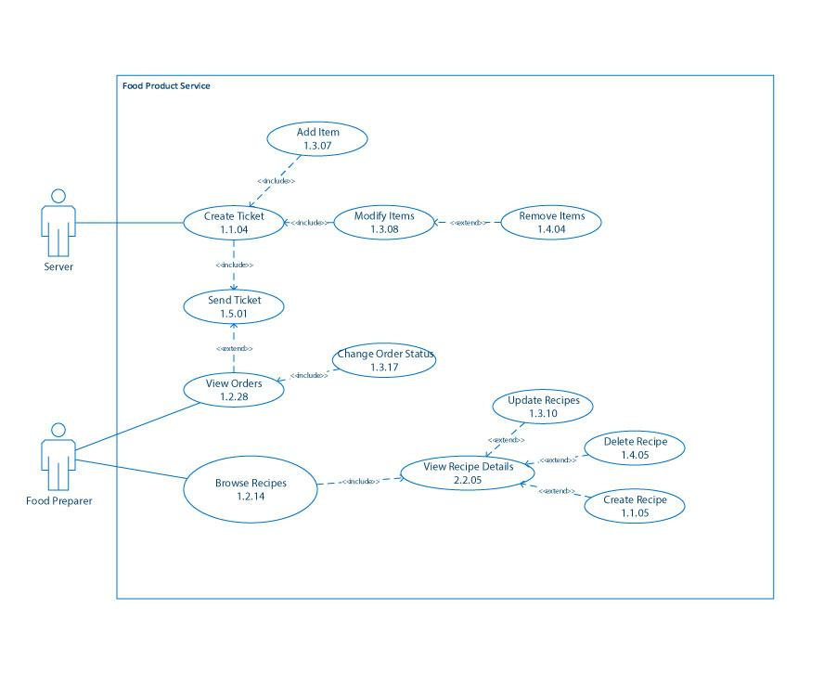

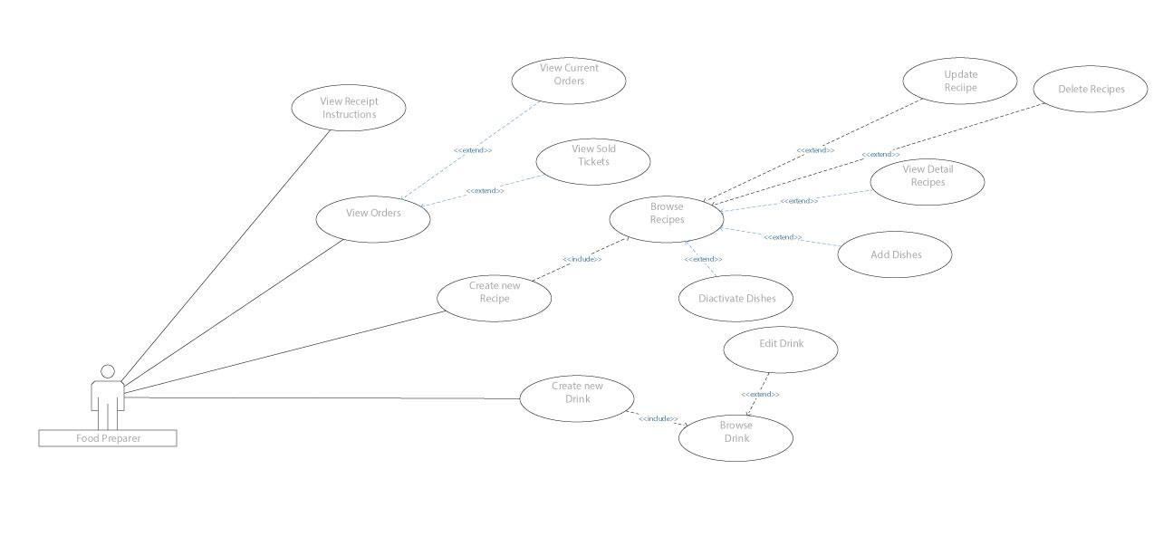

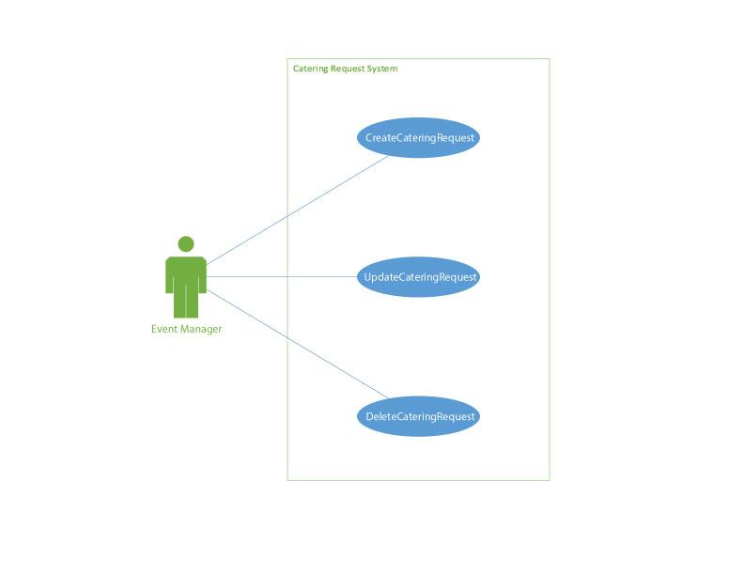

## Supply Operations

The following use cases detail the design relating to the order of supplies and the replenishing of inventory.

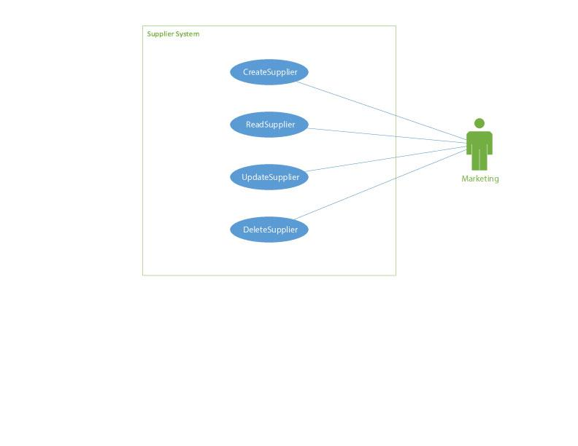

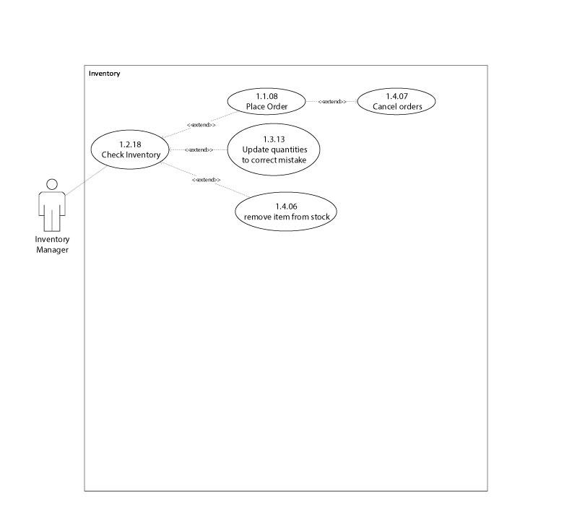

## Facility Operations

The following use cases detail the design relating to the resort maintenance and manufacturing.

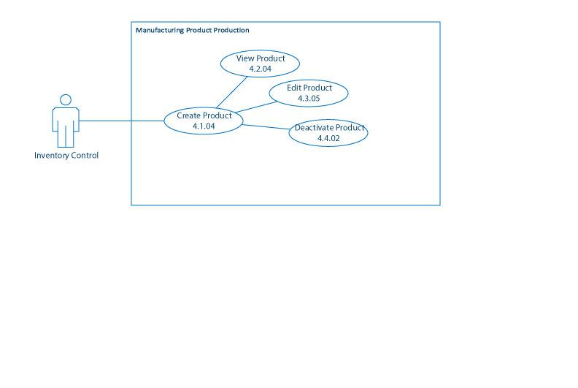

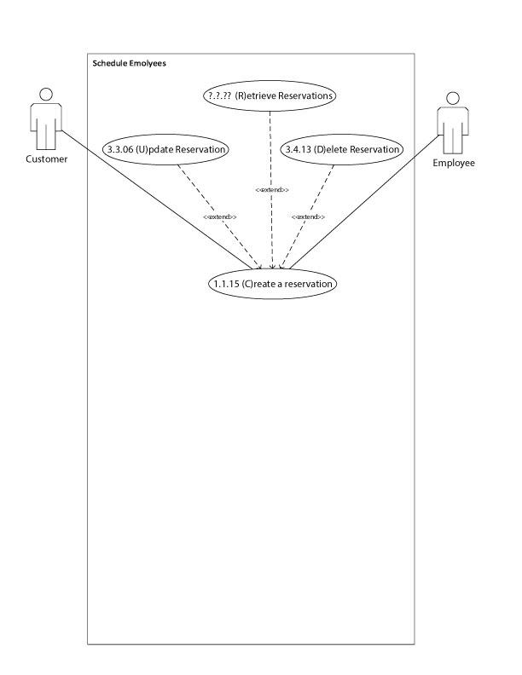

## Guest Operations

The following use cases detail the design relating to the guest and member services including reservations and check in/out processes.

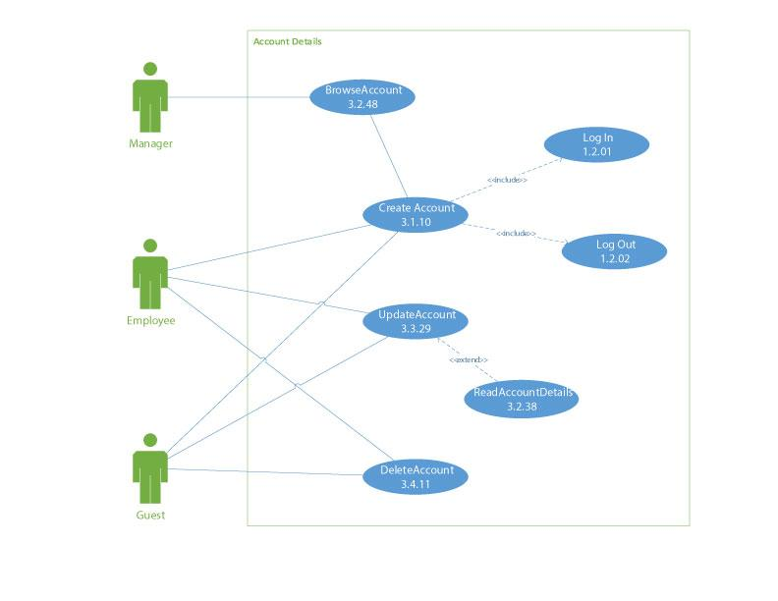

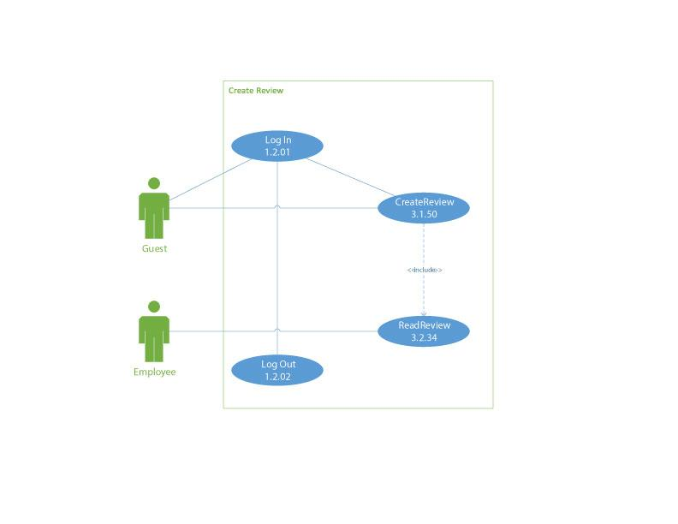

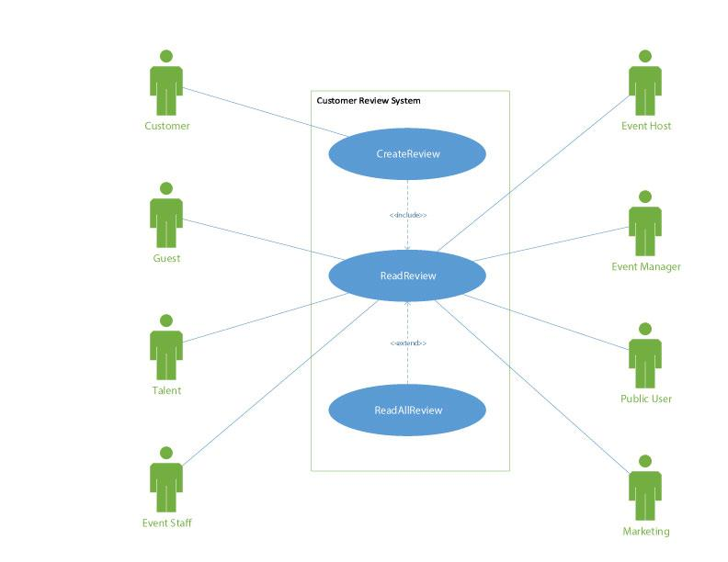

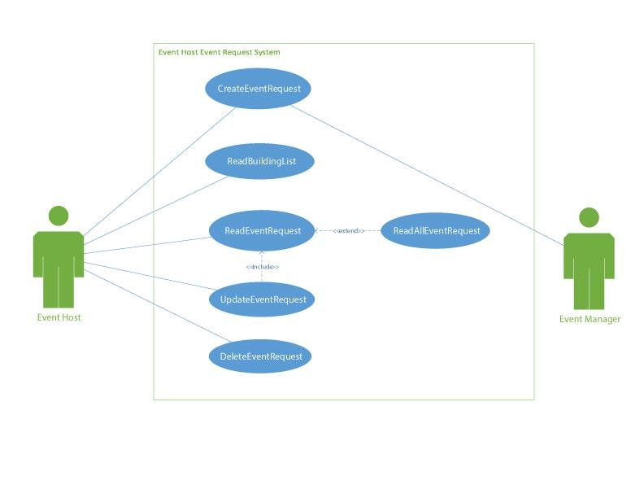

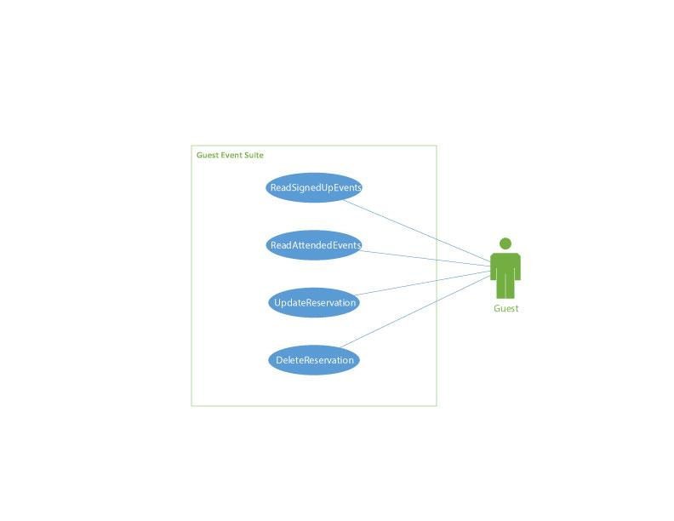

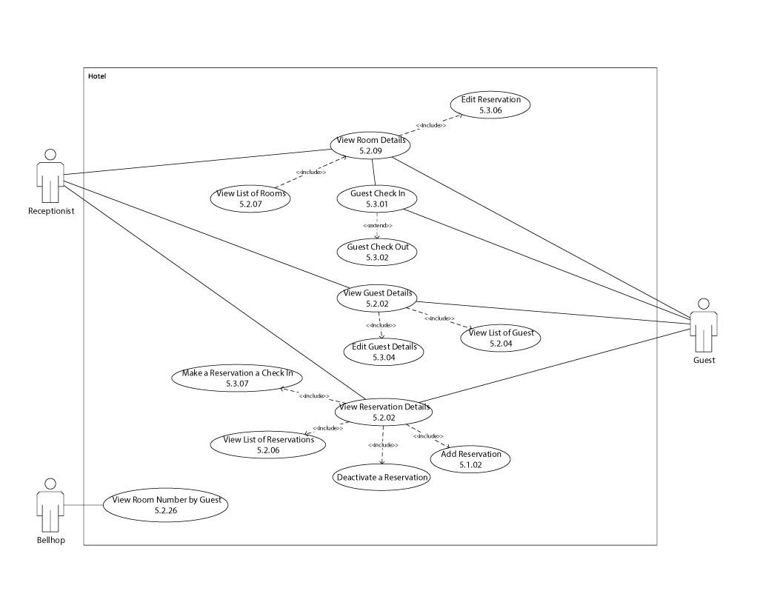

## Personnel Management

The following use cases detail the design relating to the employees and their roles and schedule management.

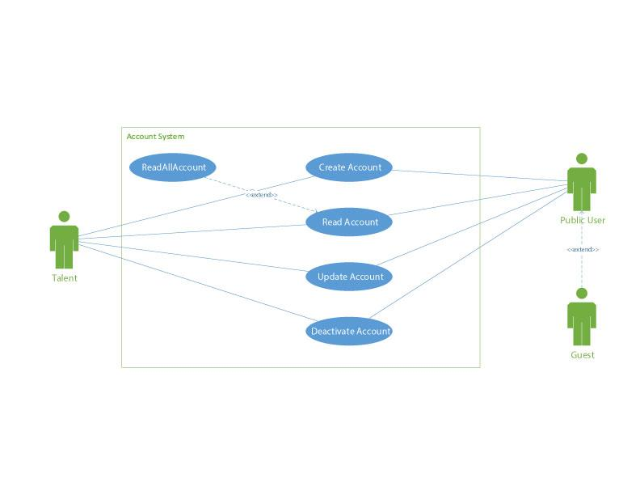

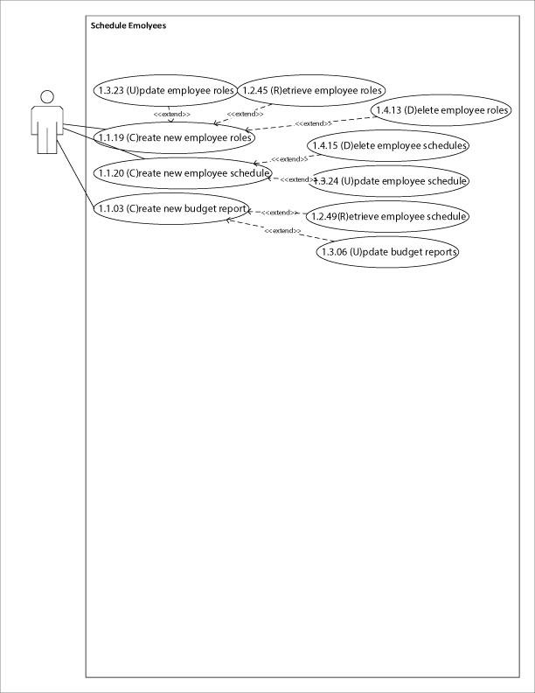

## Event Operations

The following use cases detail the design relating to the event logistics.

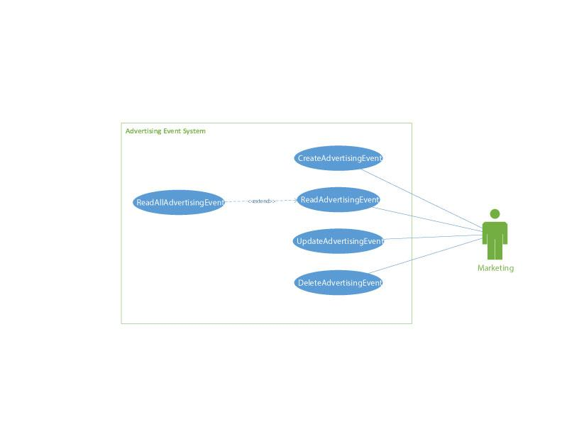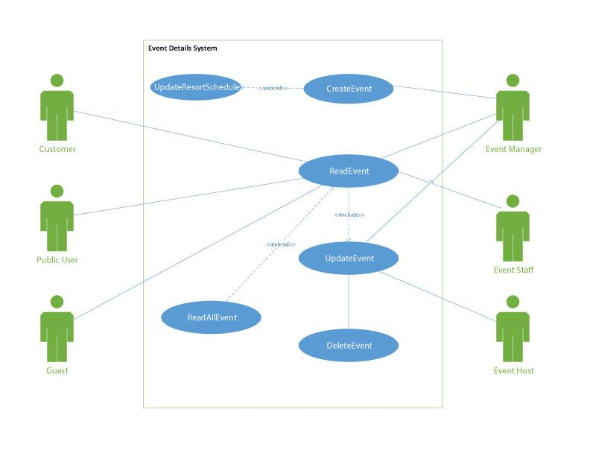

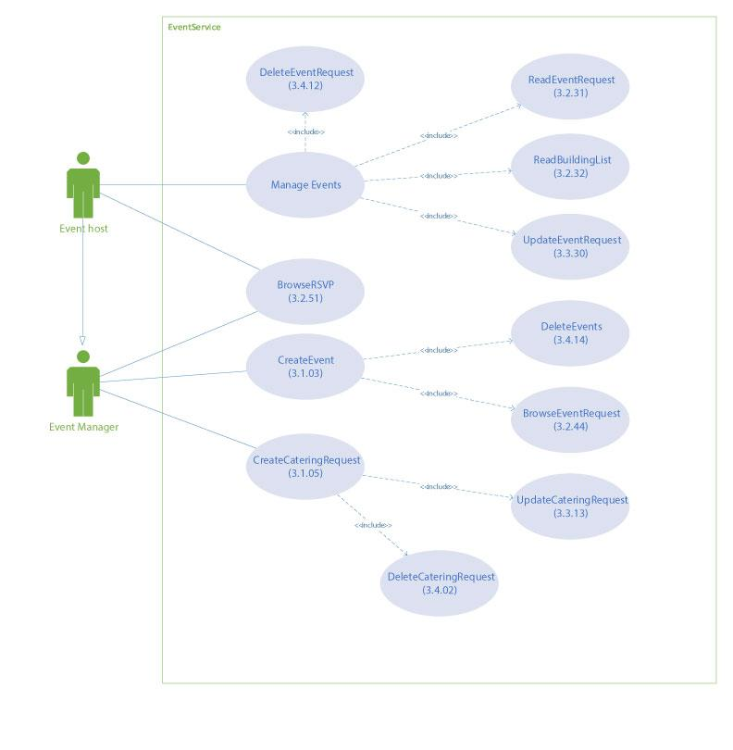

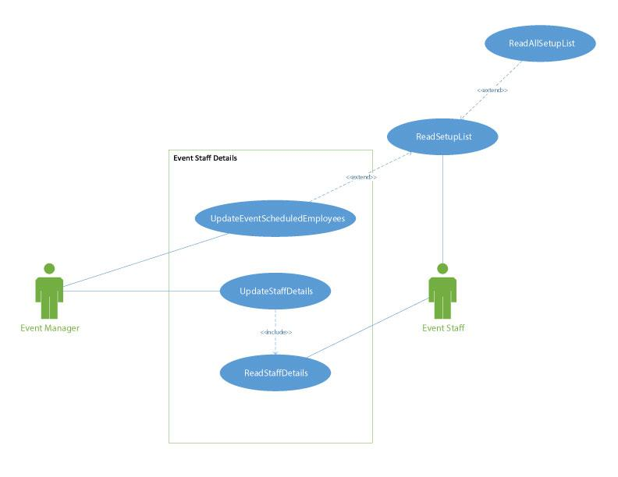

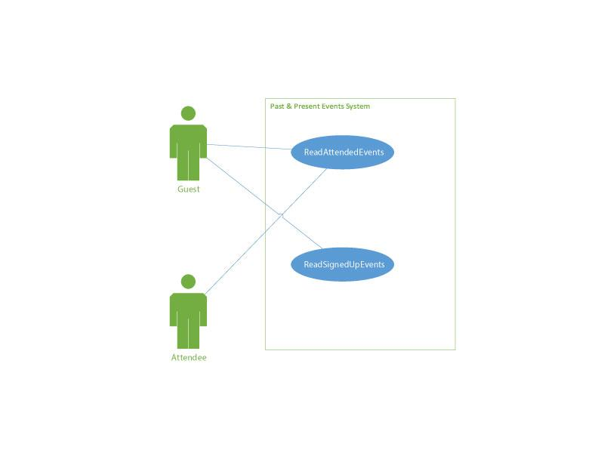

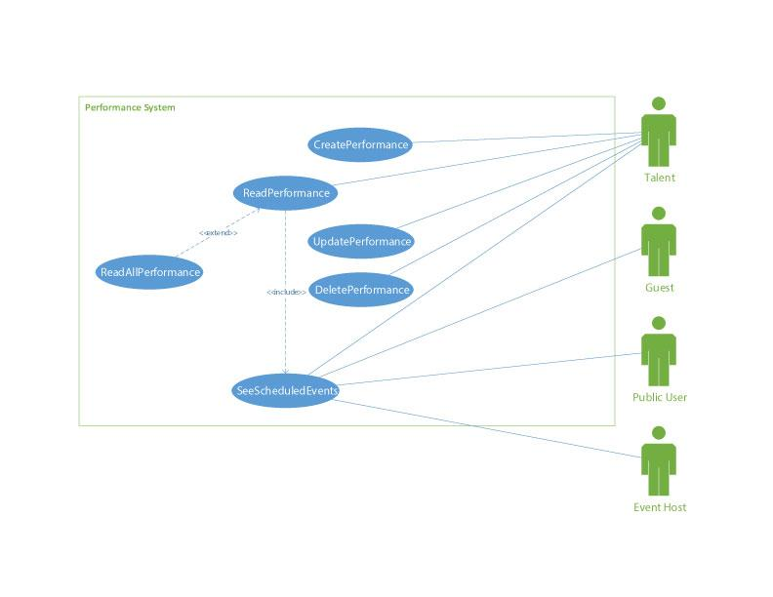

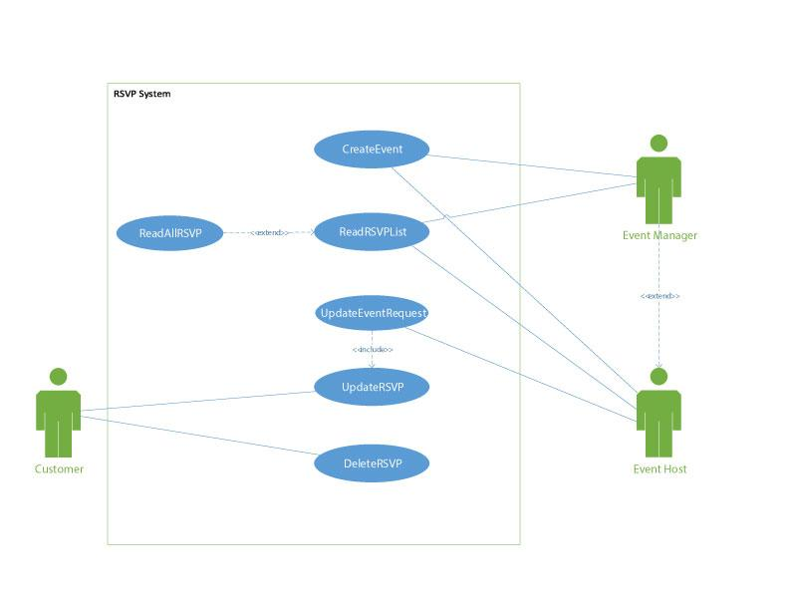

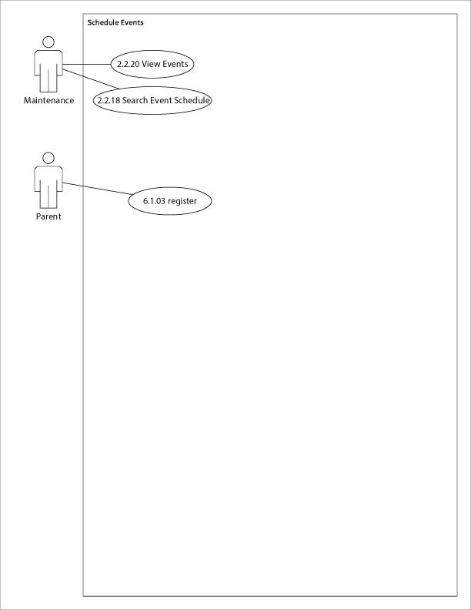

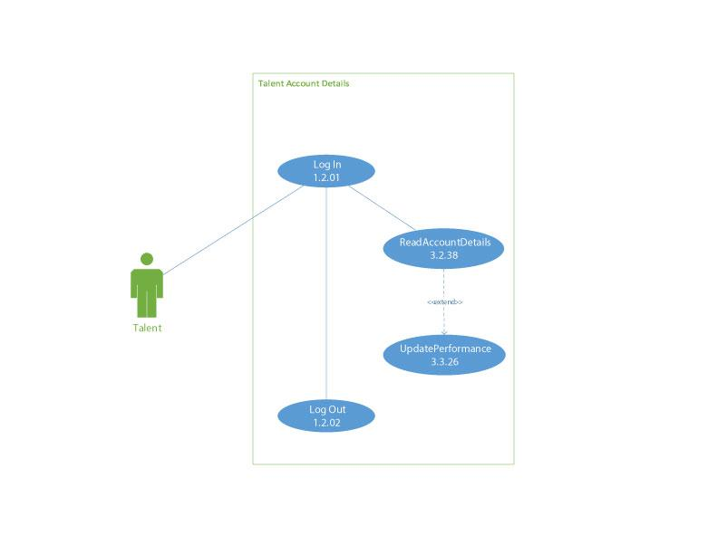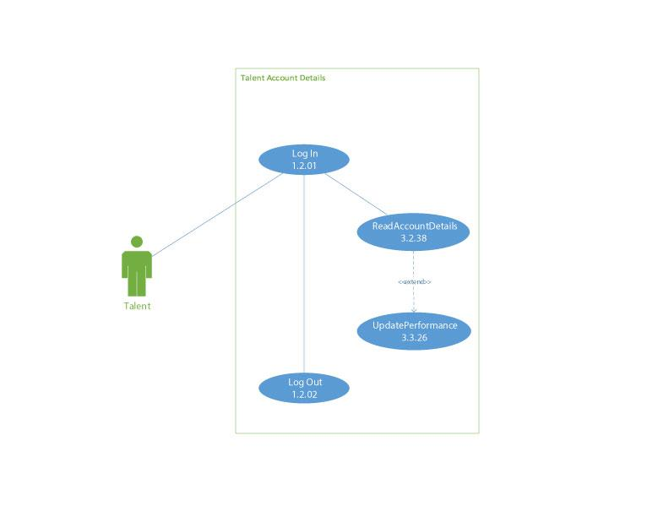

## Service and Appointment

The following use cases detail the design relating to the resort services including valet, dependent care, and resort shuttles.

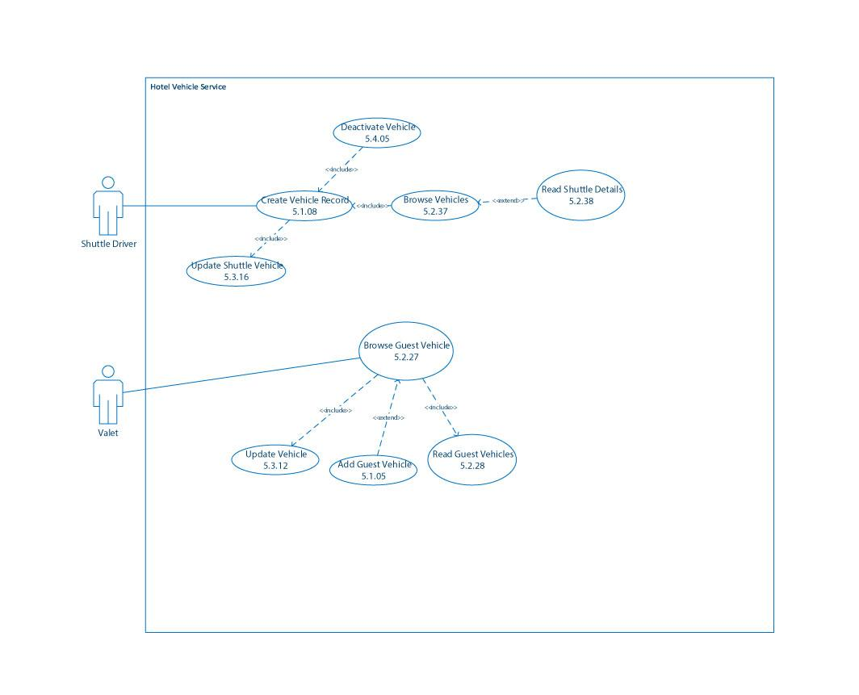

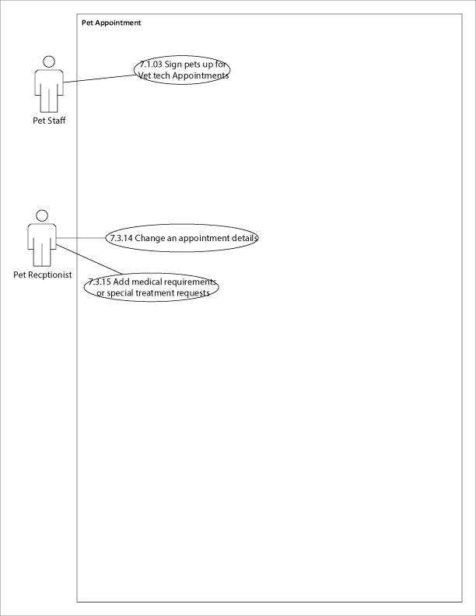

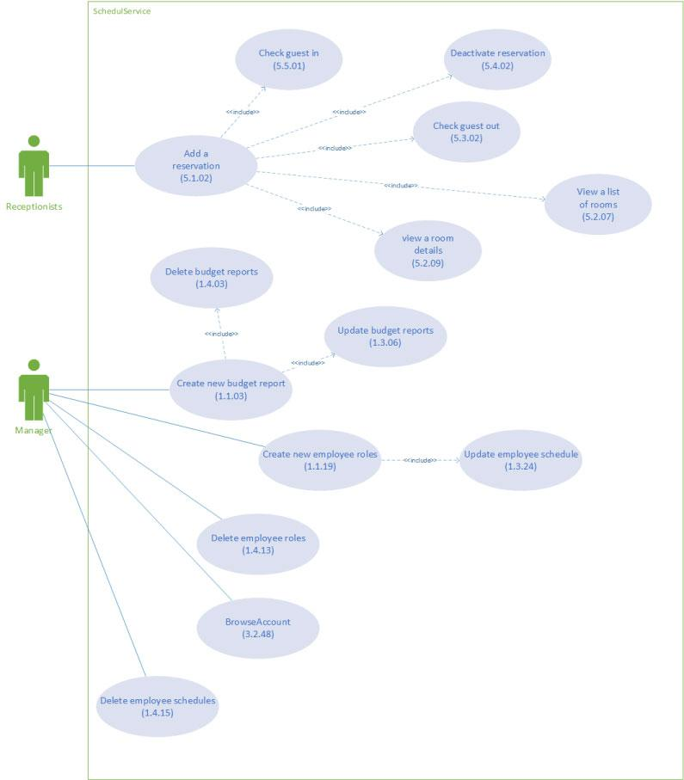

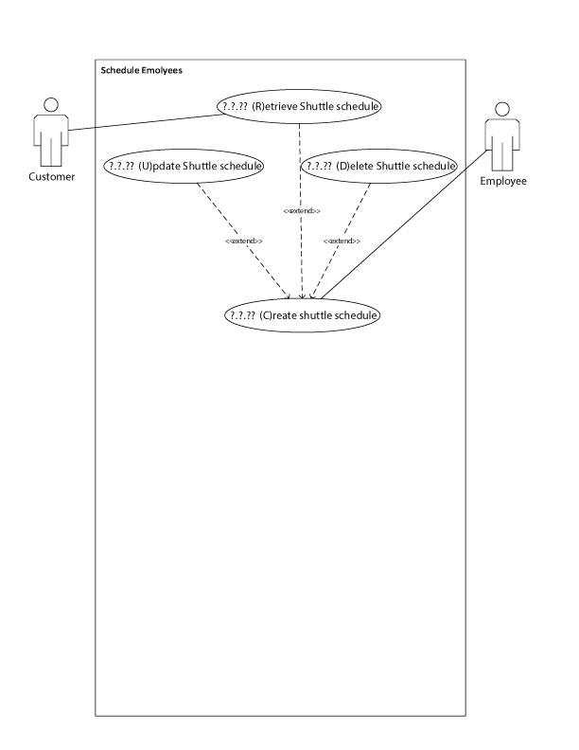

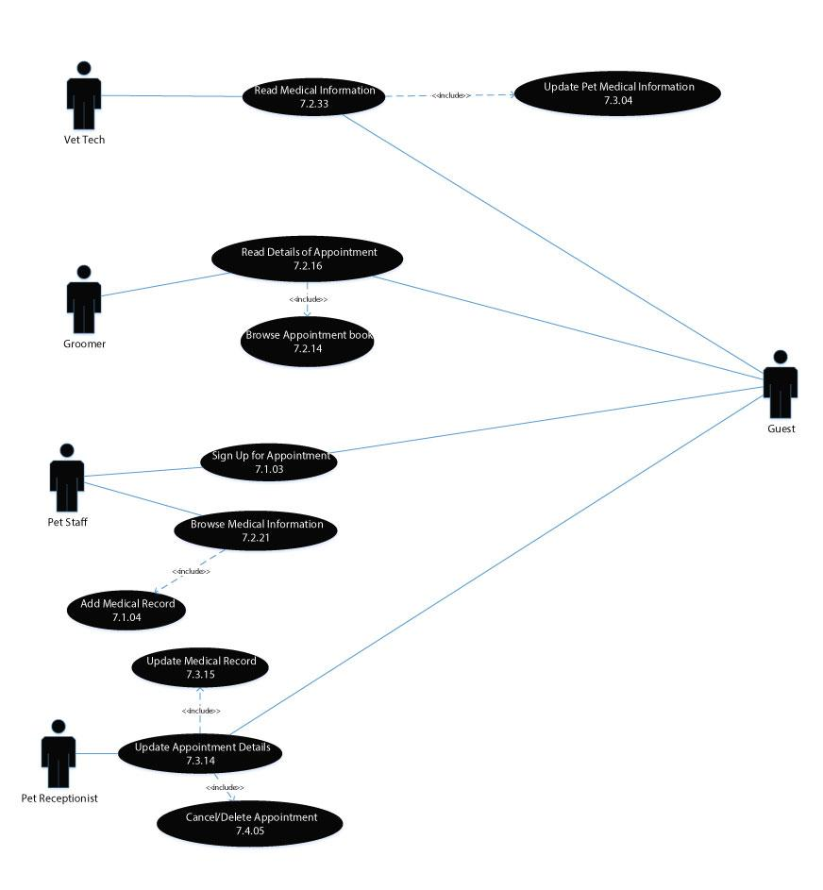

## Product Operations

The following use cases detail the design relating to the resorts shops and restaurants and the products offered.

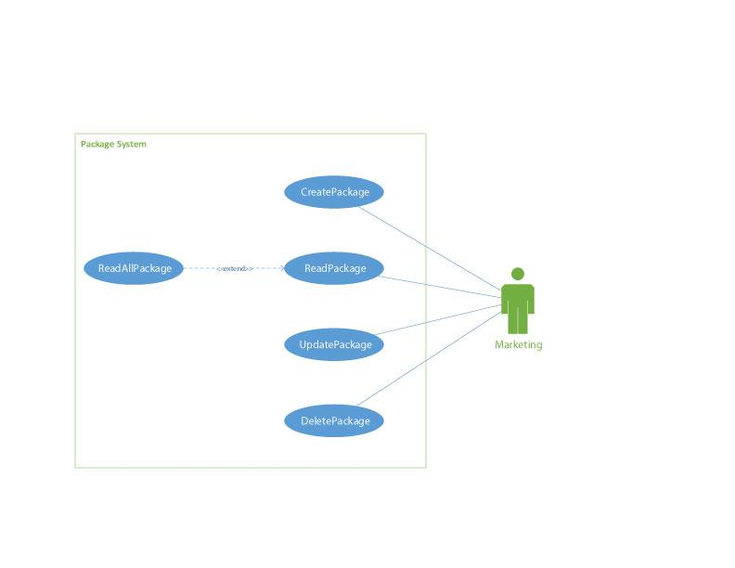

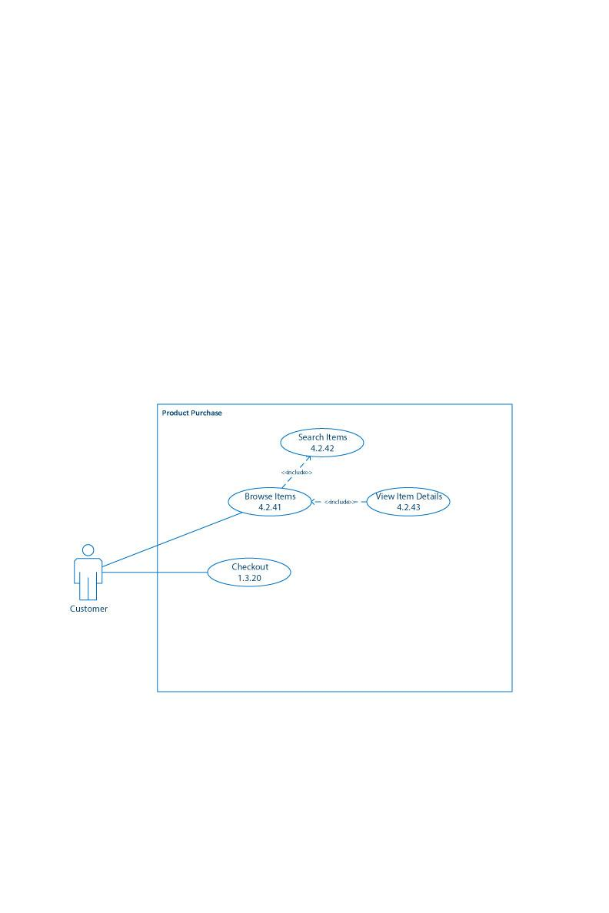

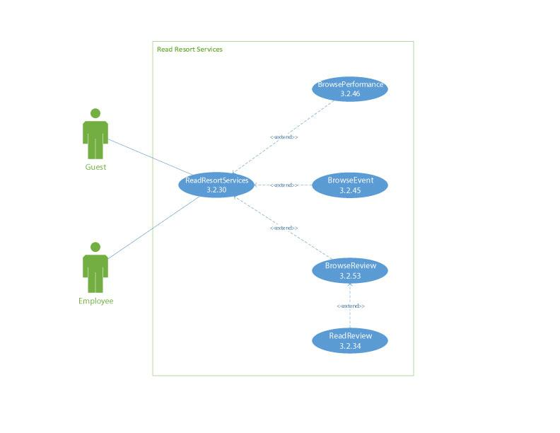

# Activity Diagrams

## Customer Operations

Details the flow of all customer interactions and customer operations

### Catering Request

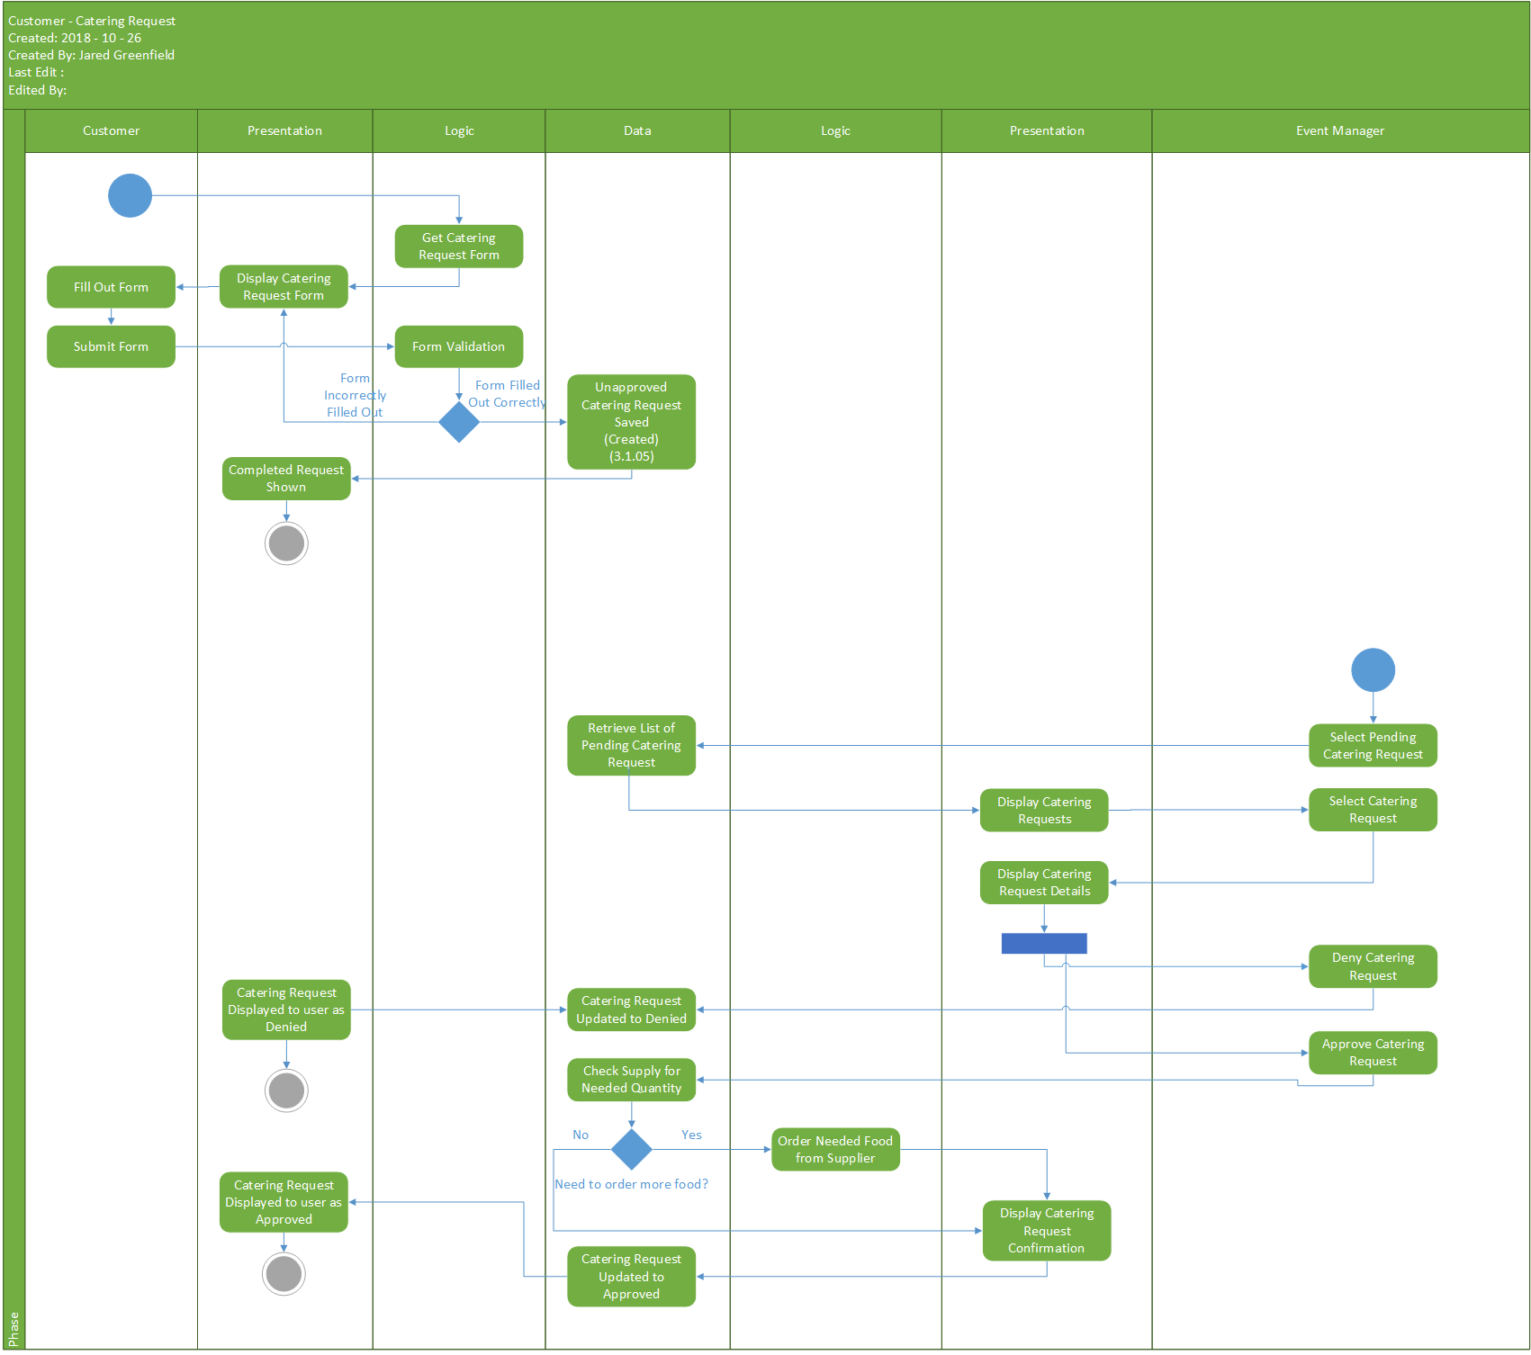

### Request Event

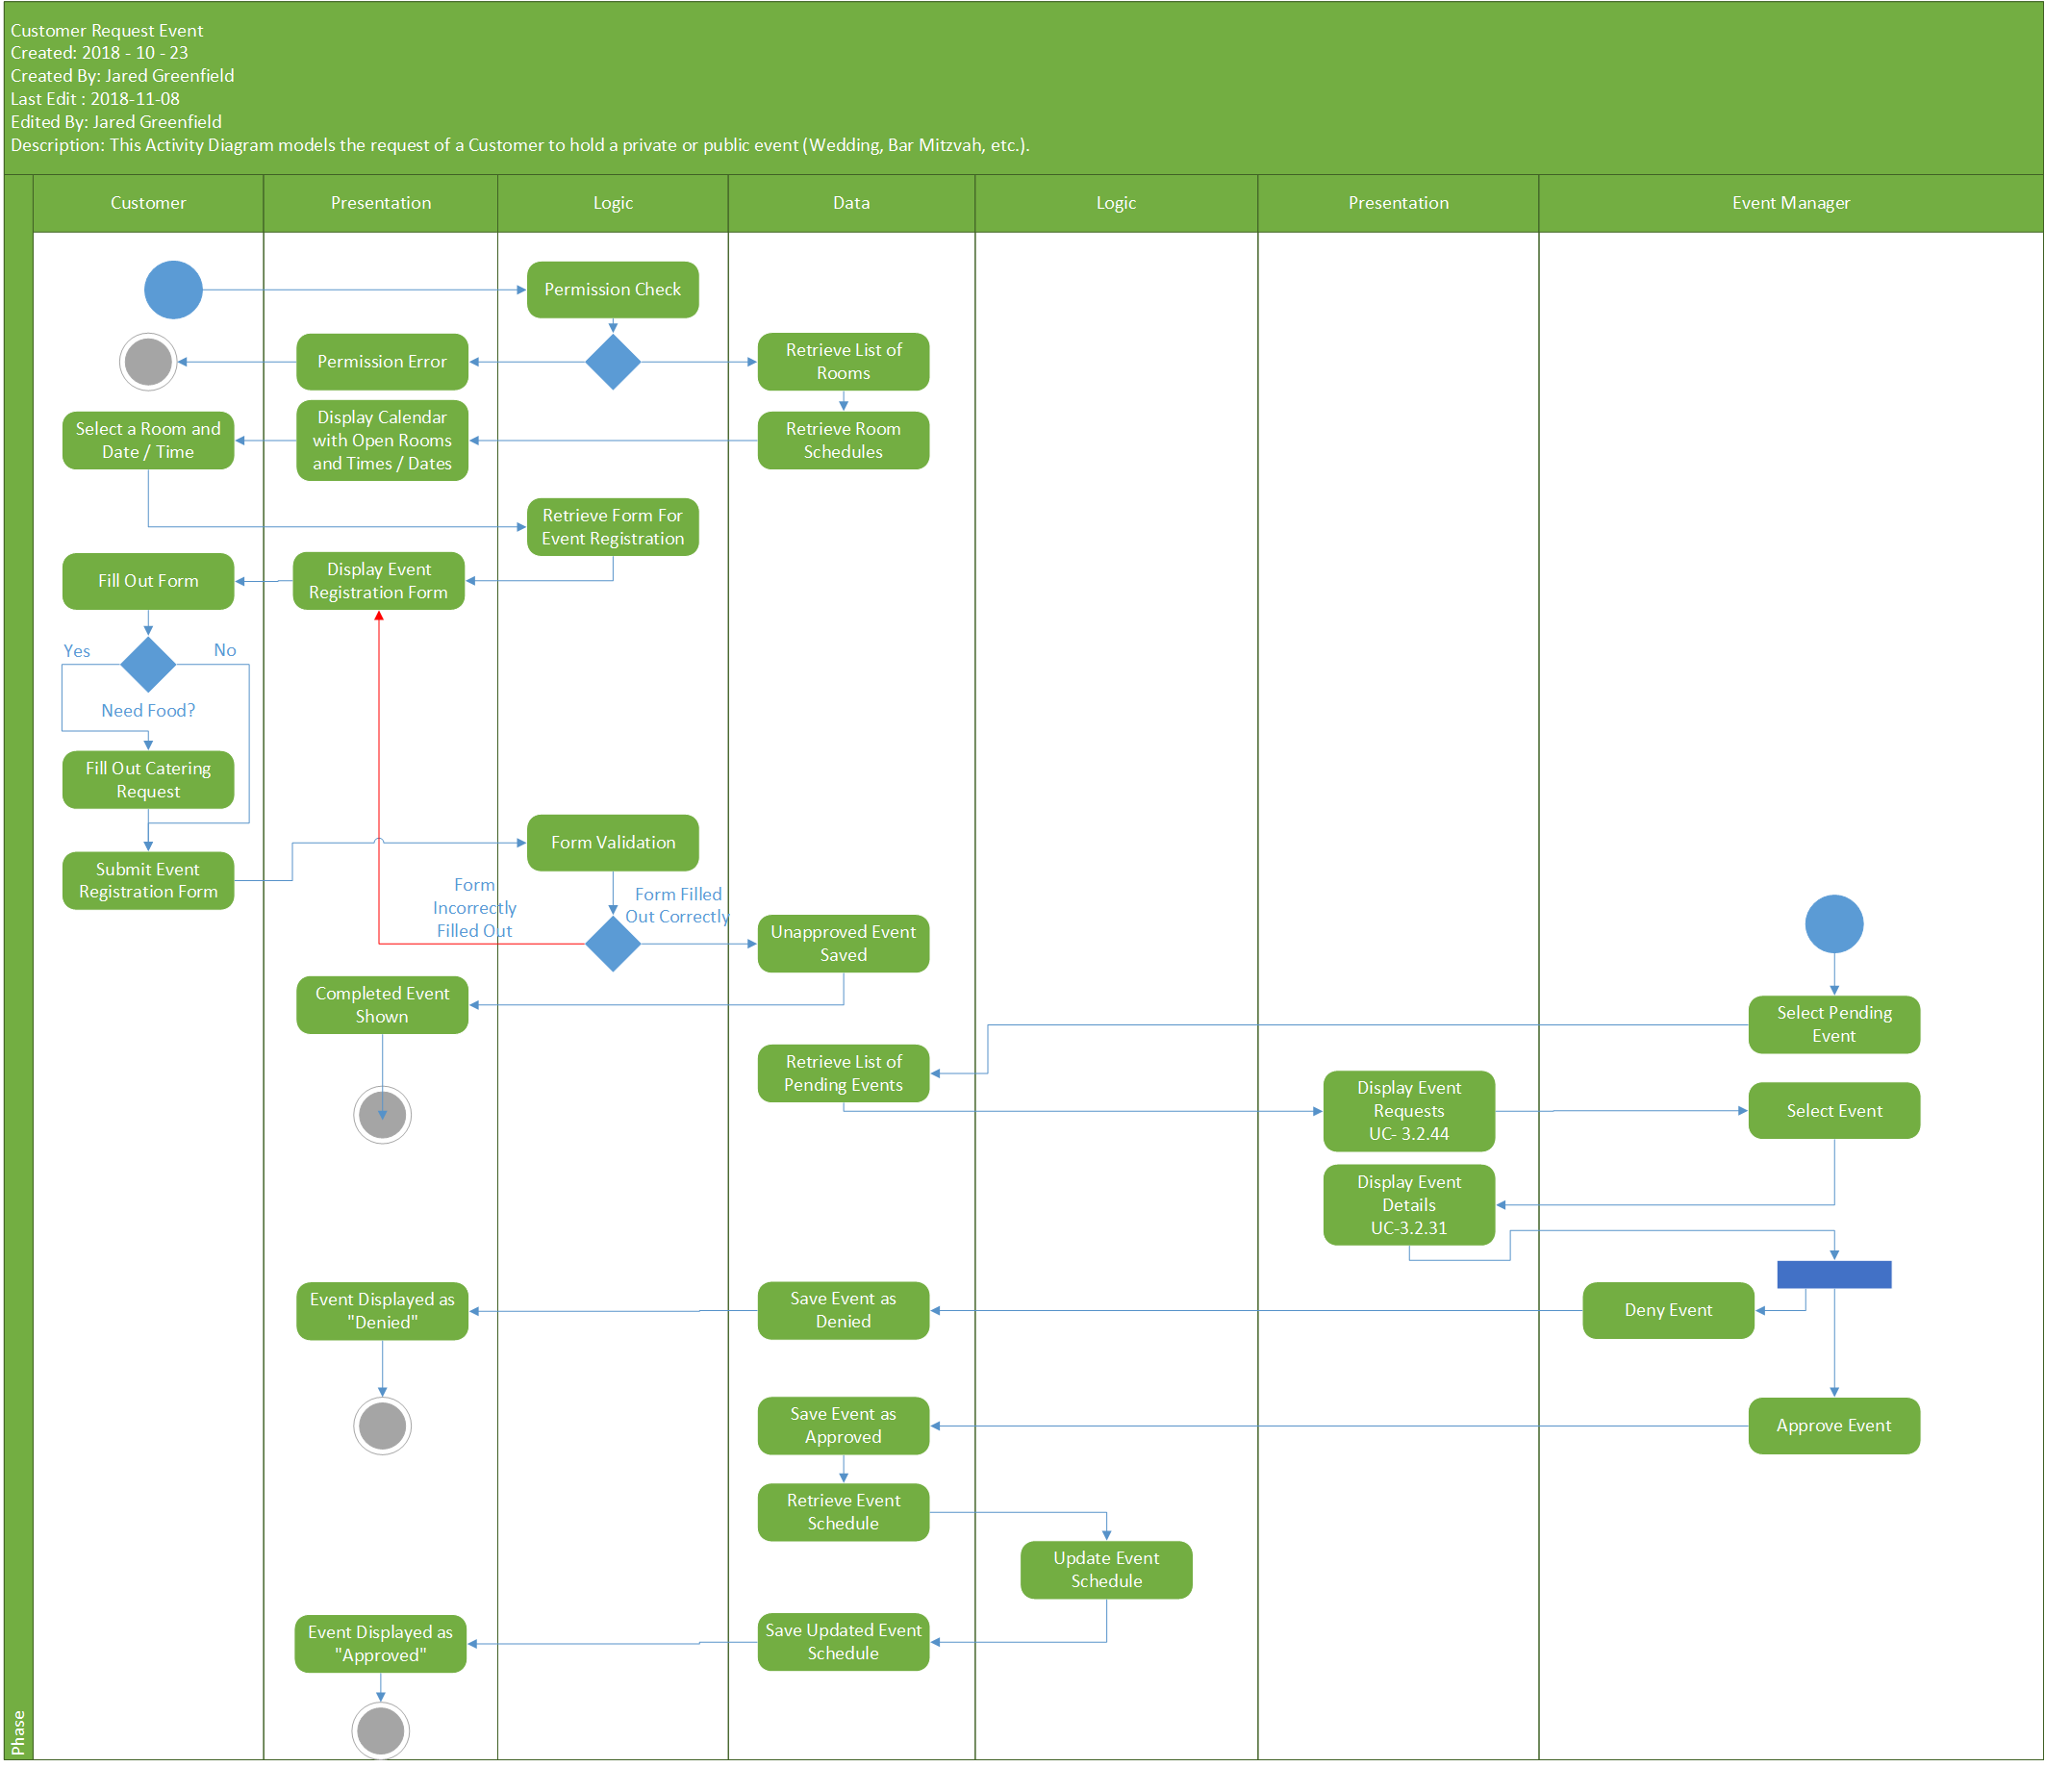

### Reserve Appointment

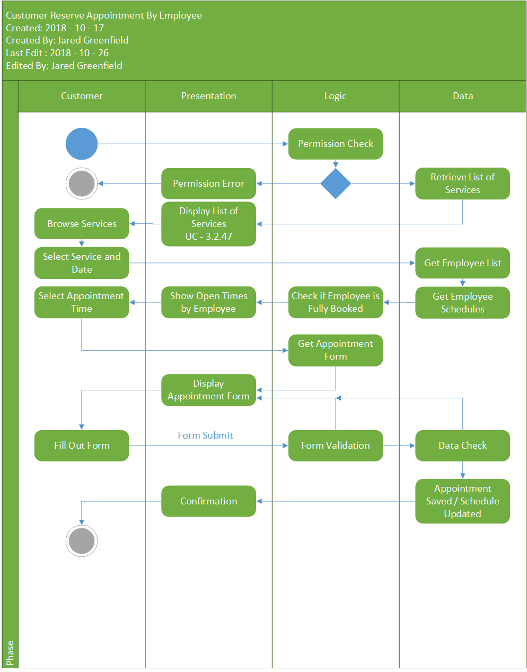

### Reserve Resort Room

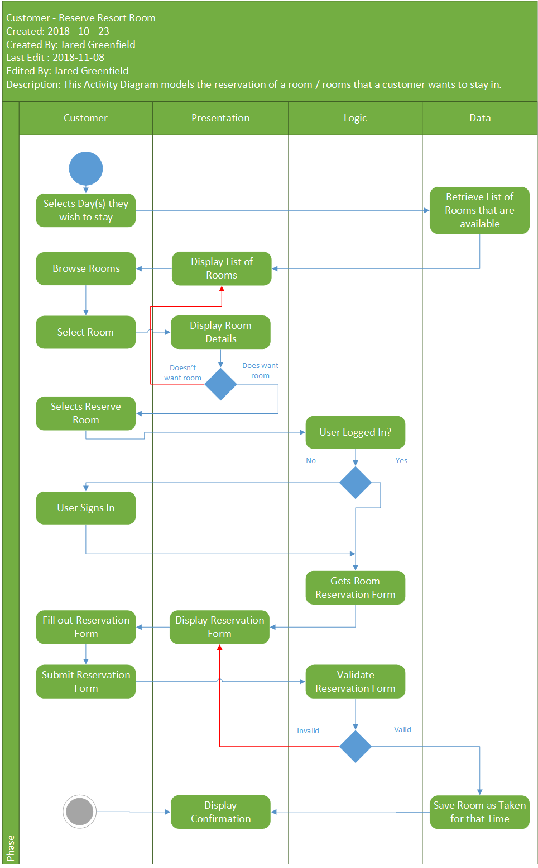

### Reserve Spot in Number Dependent Event

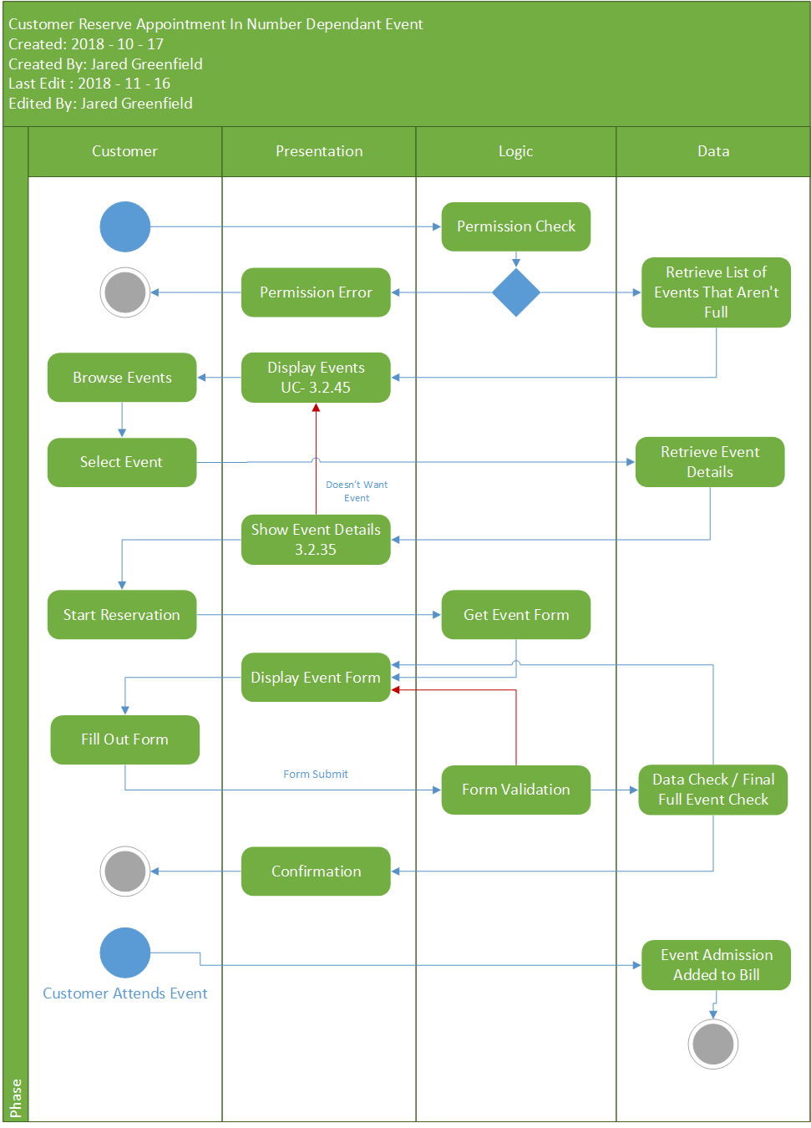

### Process Food Order

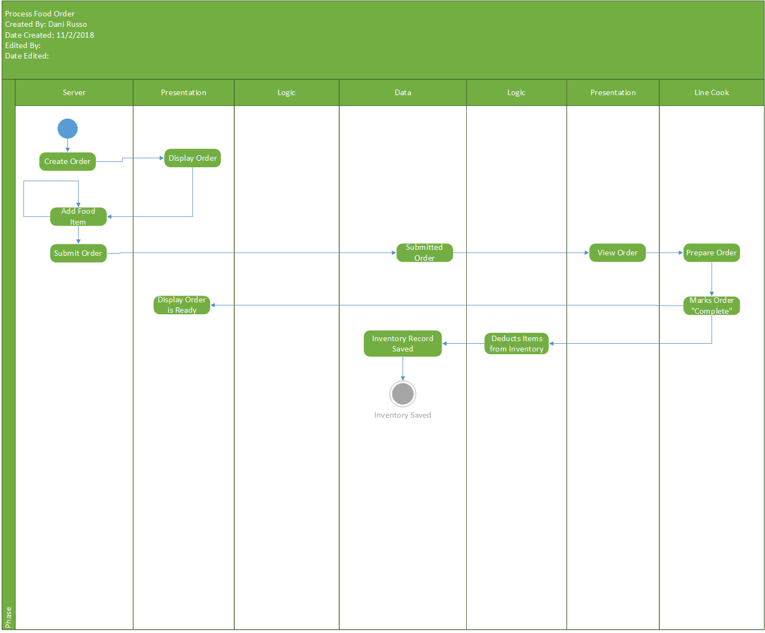

### Food Request

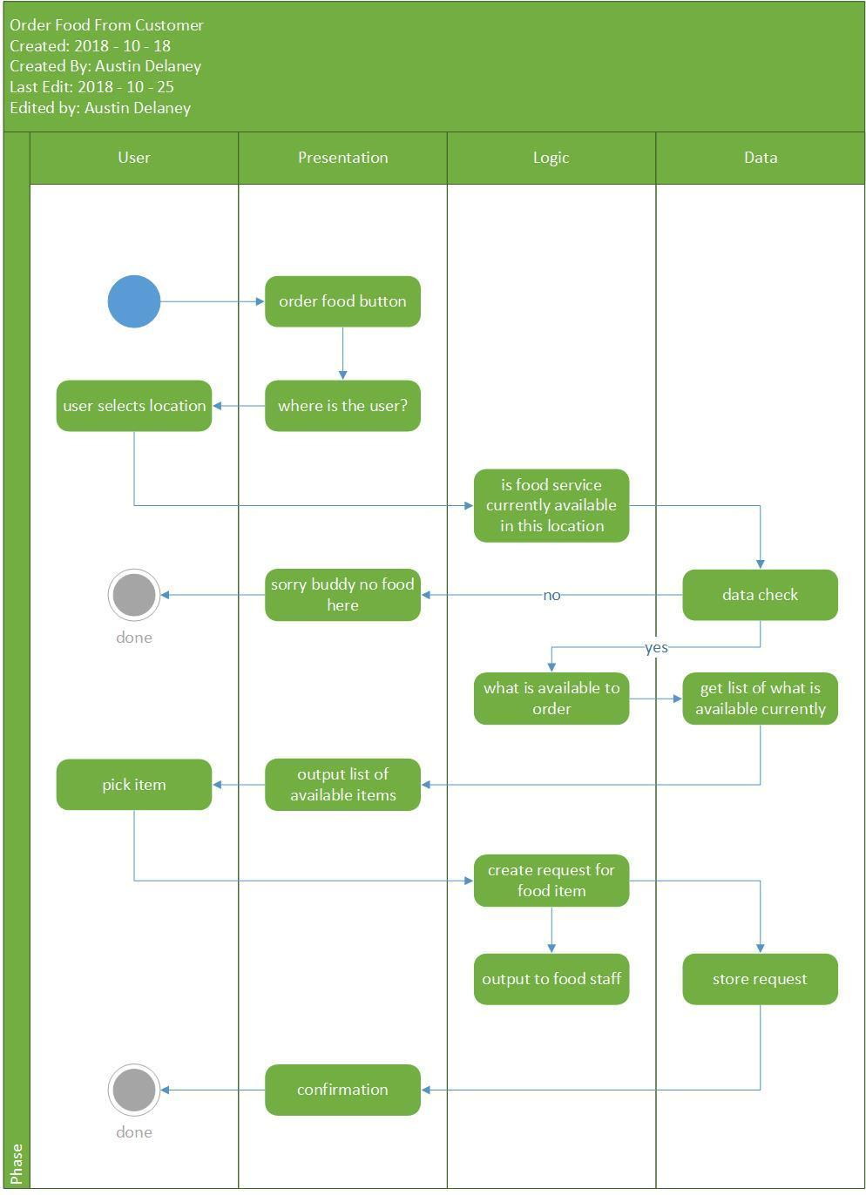

## Materials

Details the flow of resort materials and inventory management.

### Confirm Order

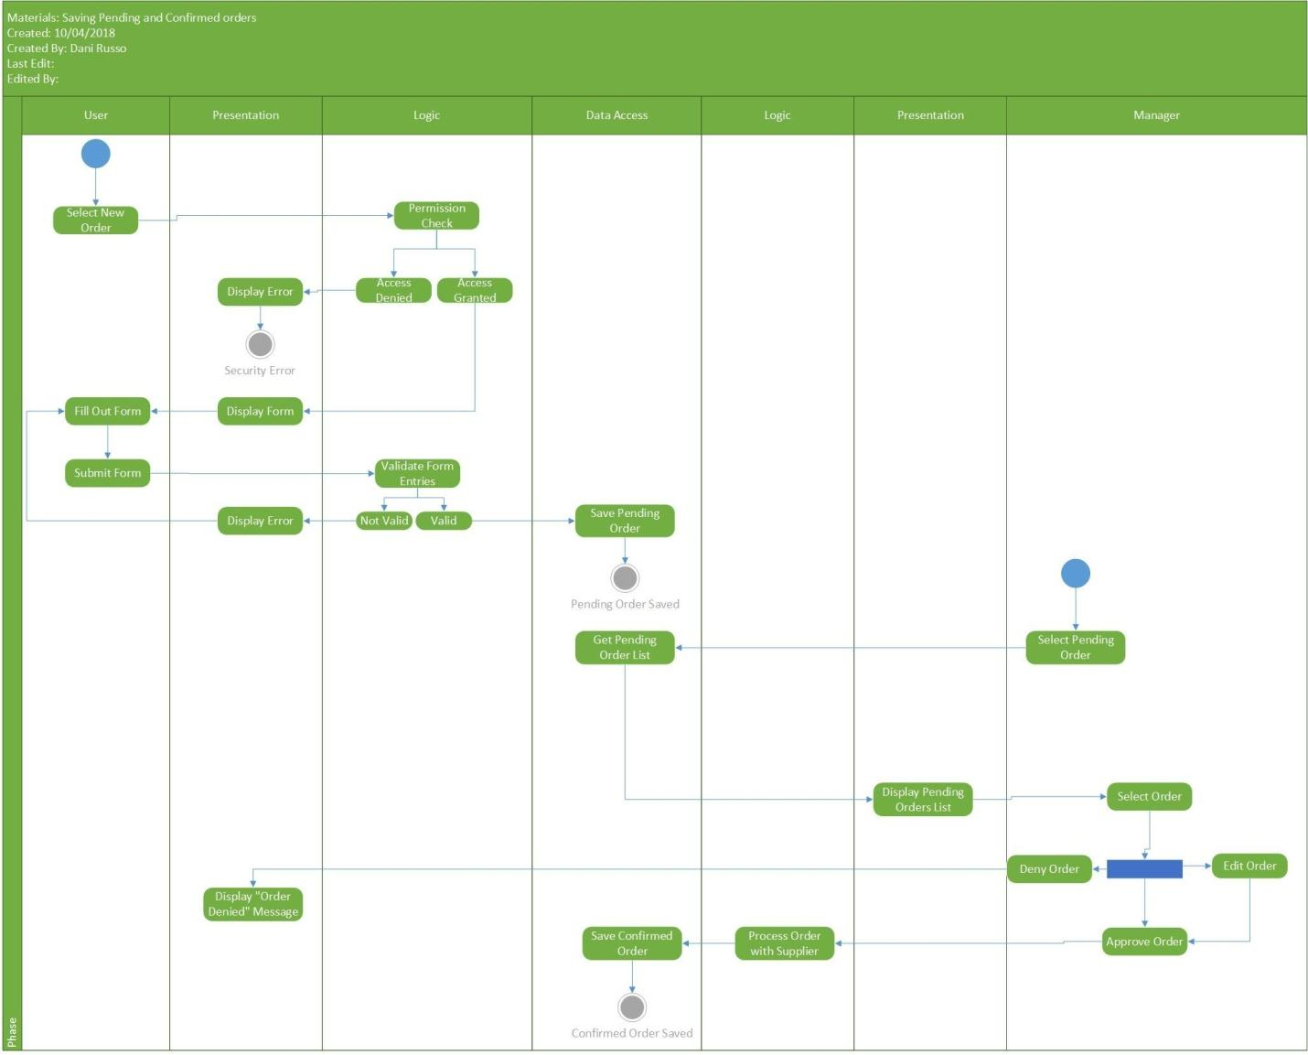

### Delivery

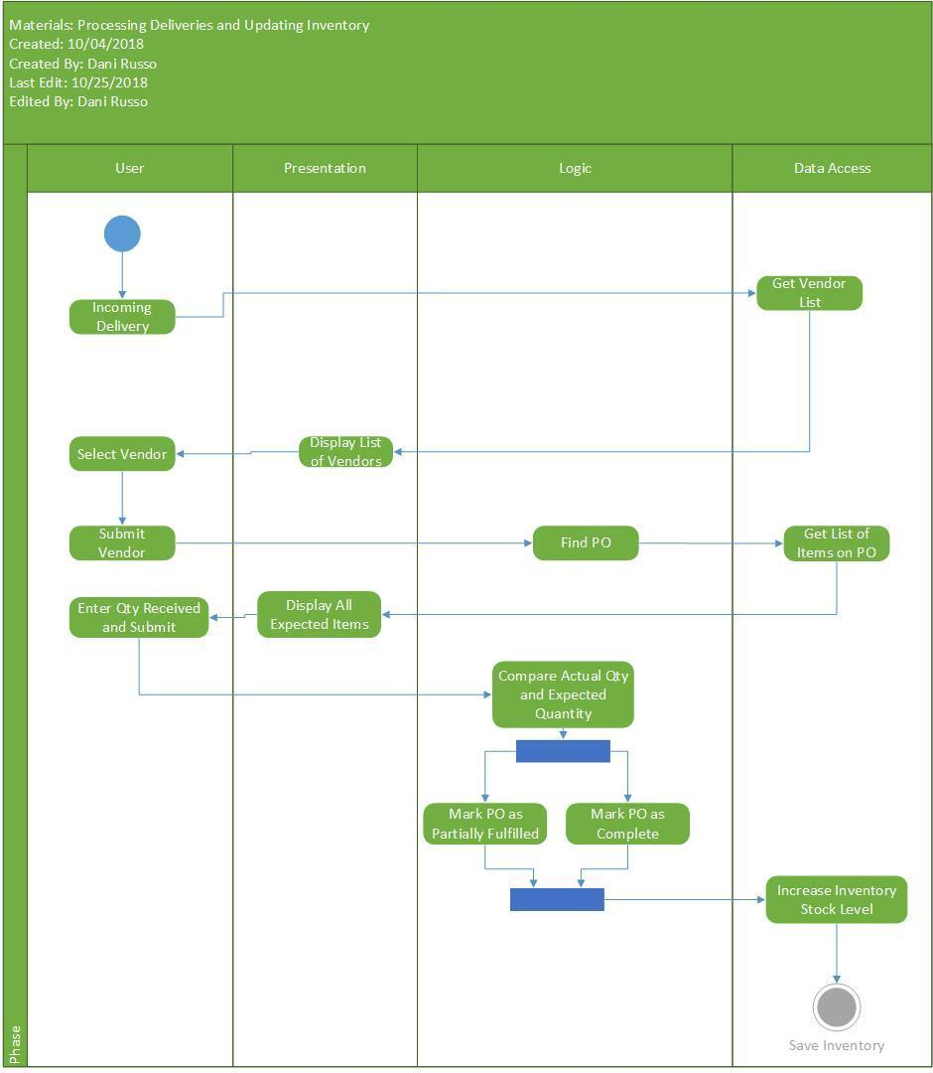

Recipes

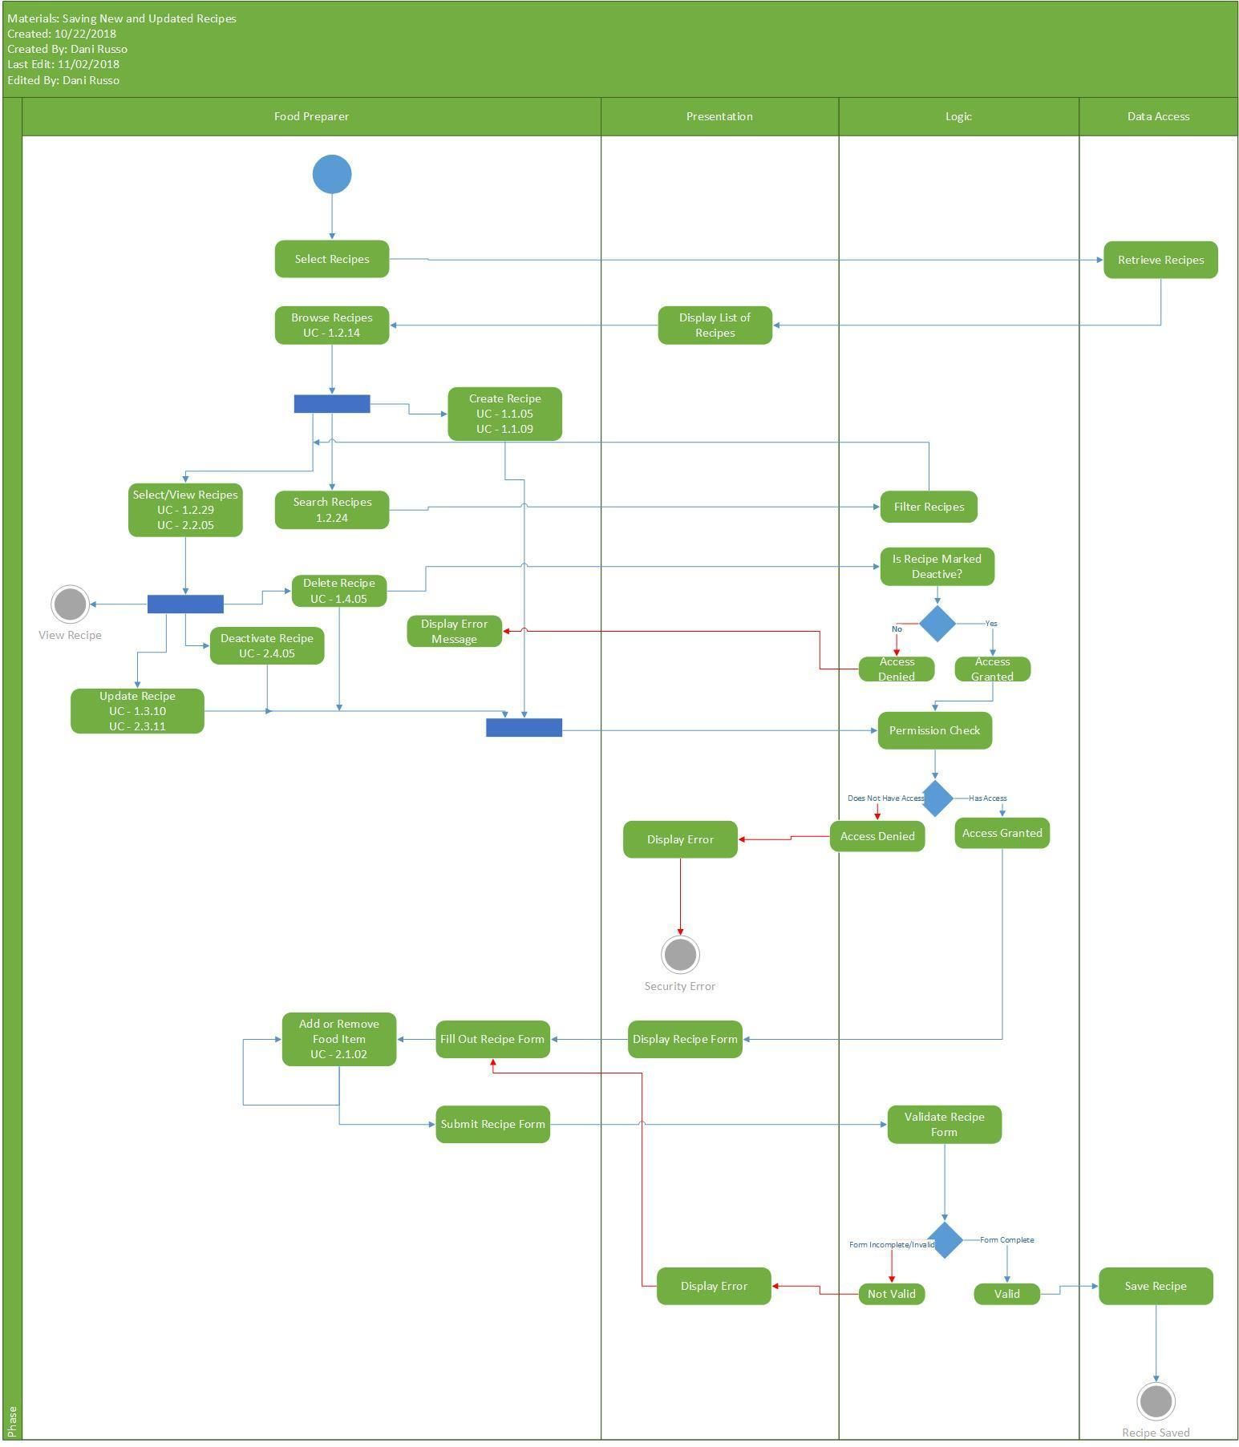

## Personnel Management

Details the flow of manager operations and employee scheduling.

### Appointment

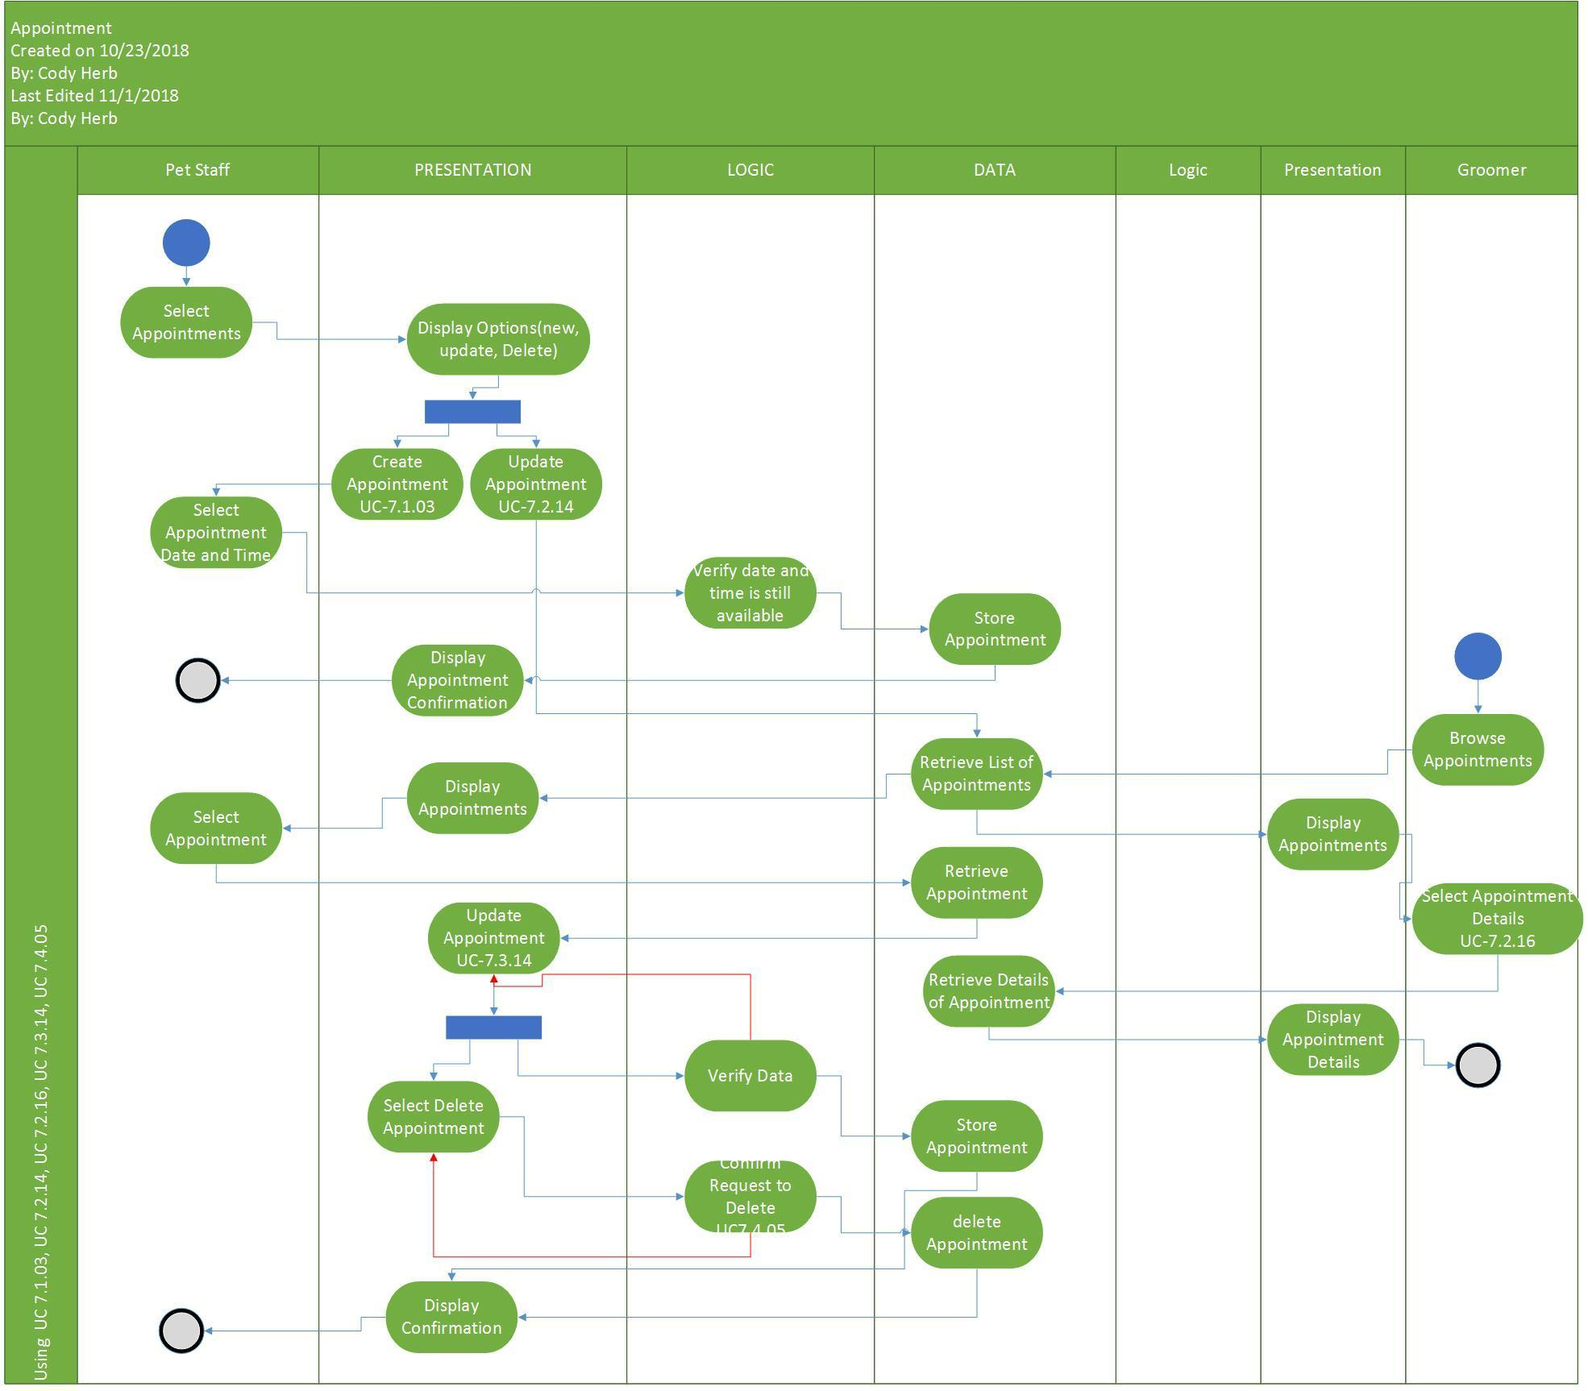

### Purchases and Checkout

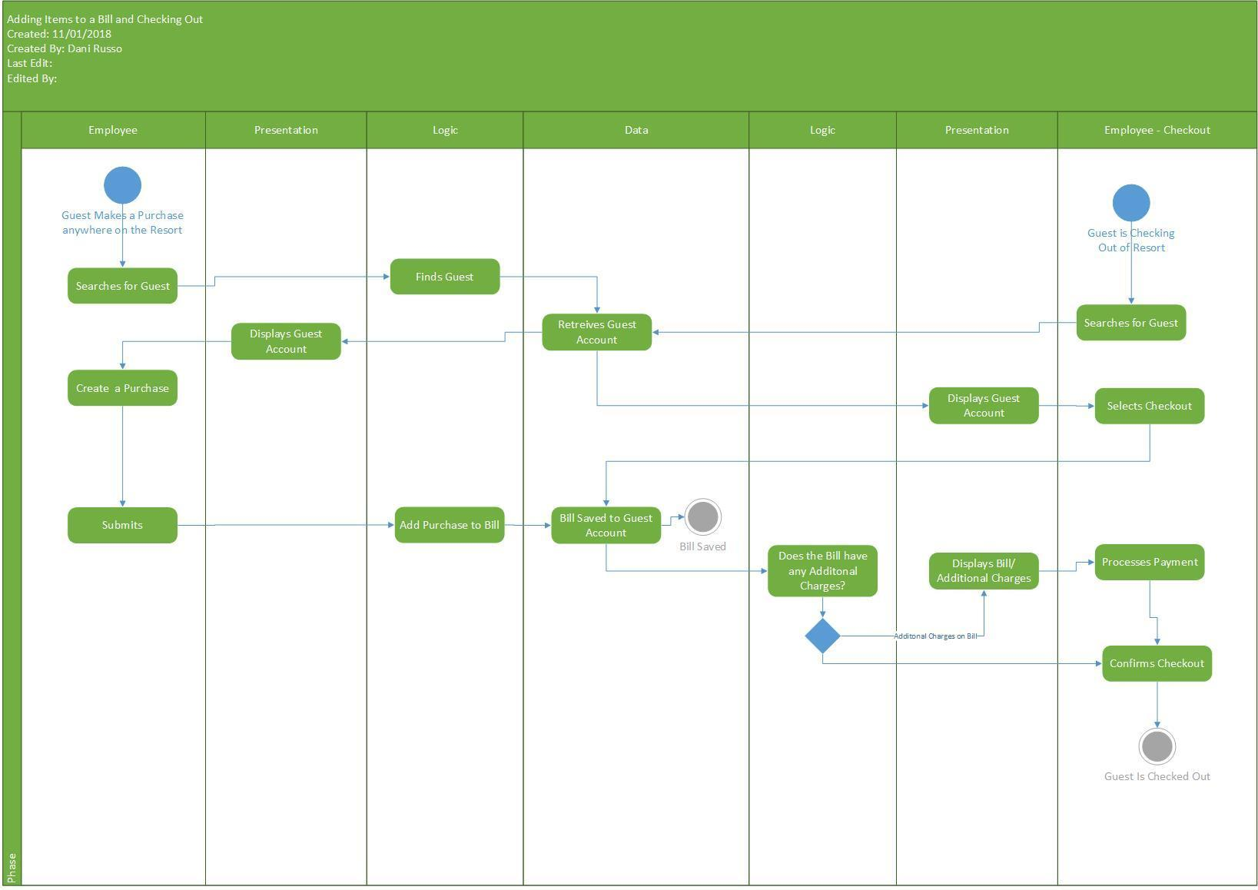

### Event Schedule

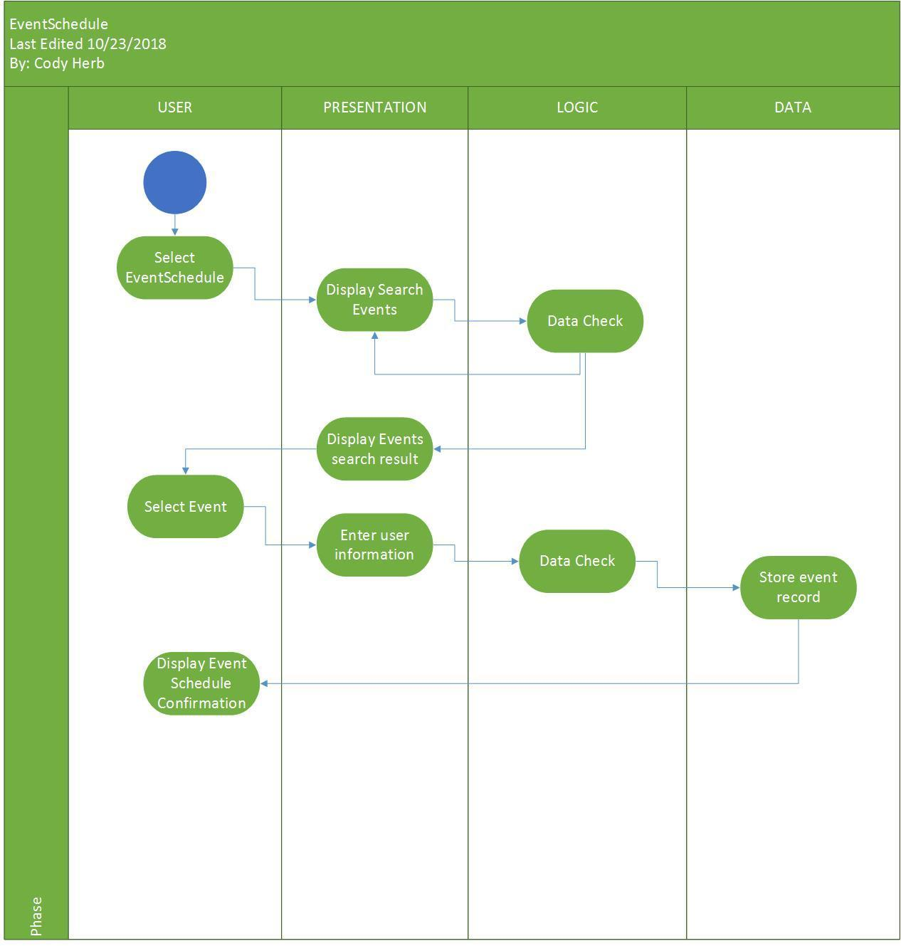

### Maintenance Work Order Viewer

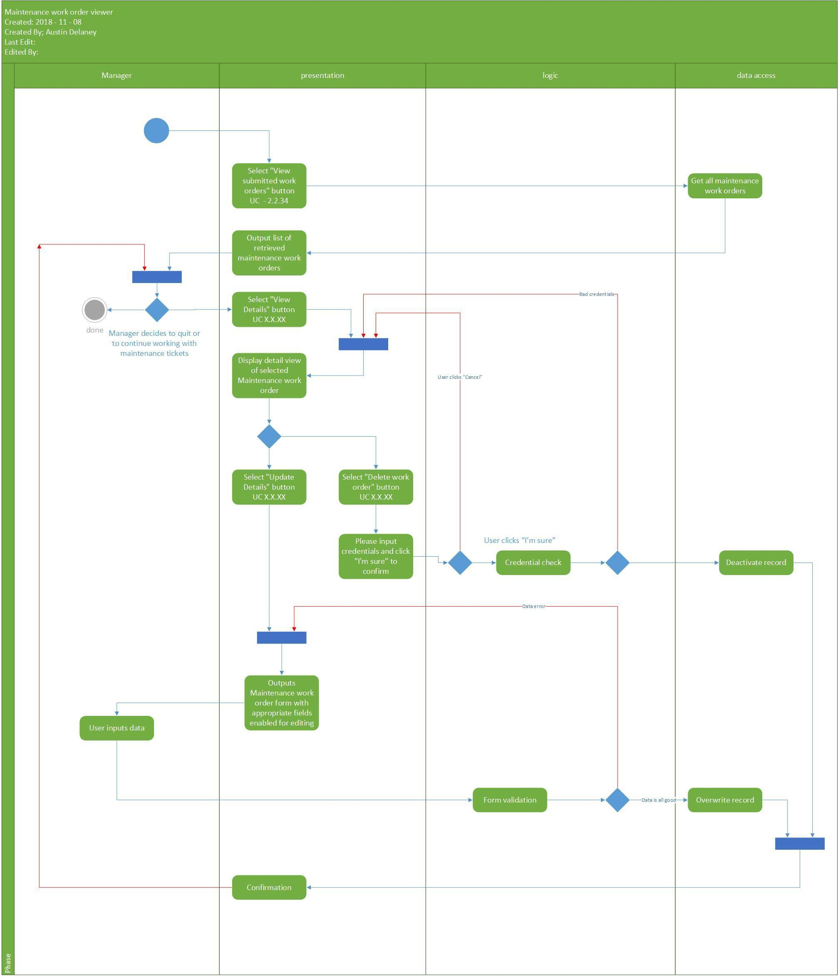

Maintenance Work Order

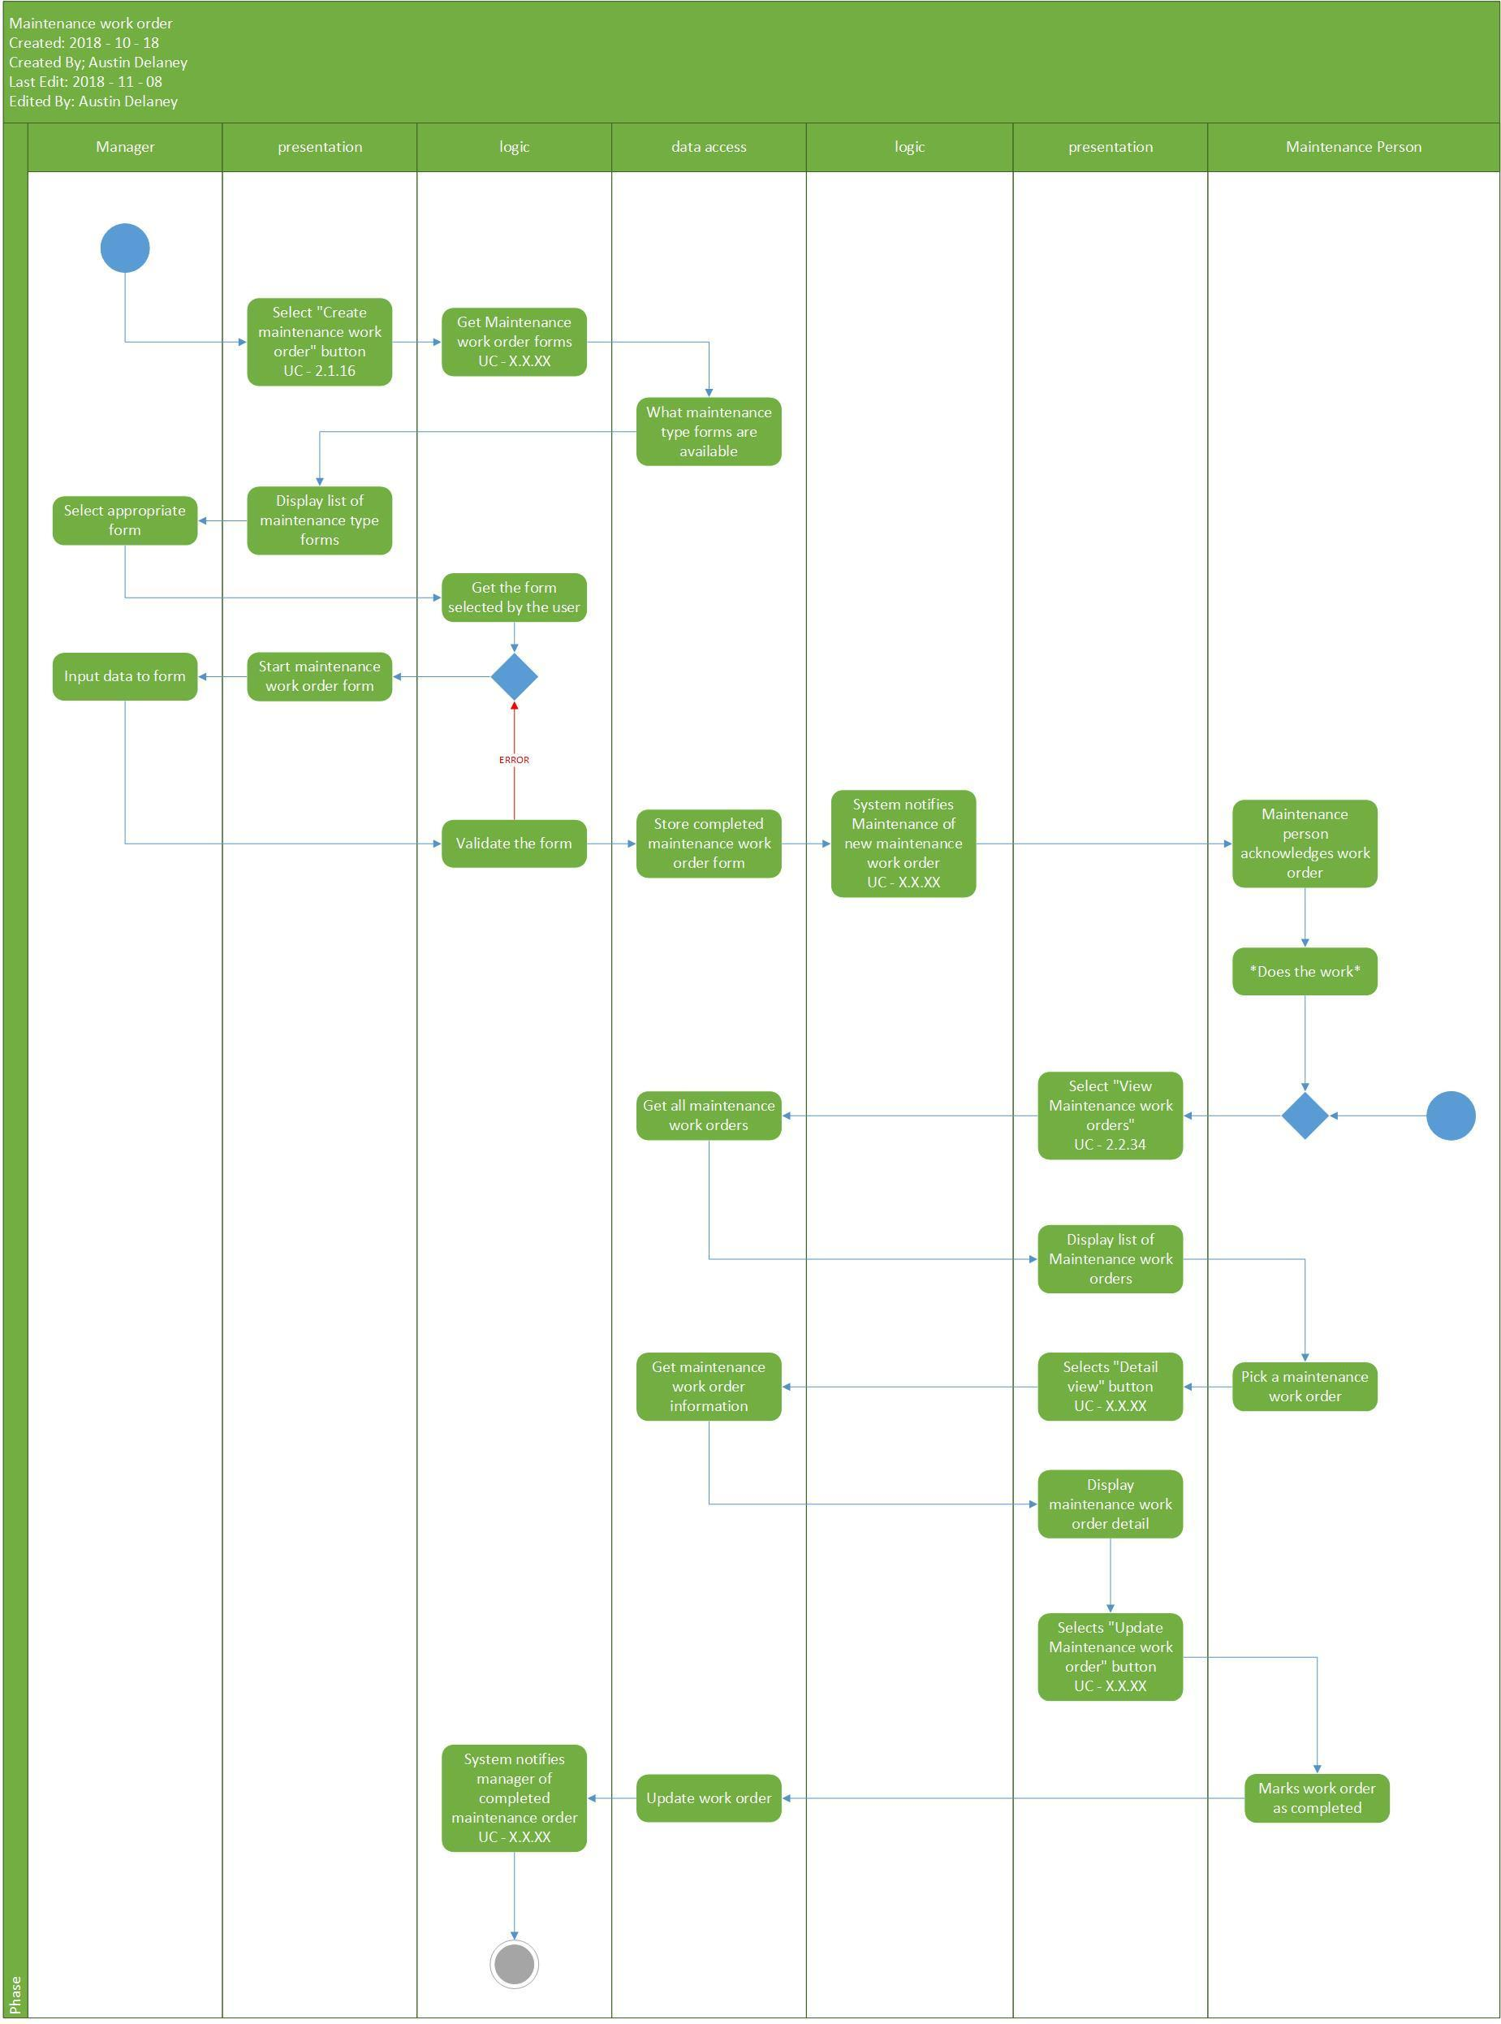

### Maintenance Ticket

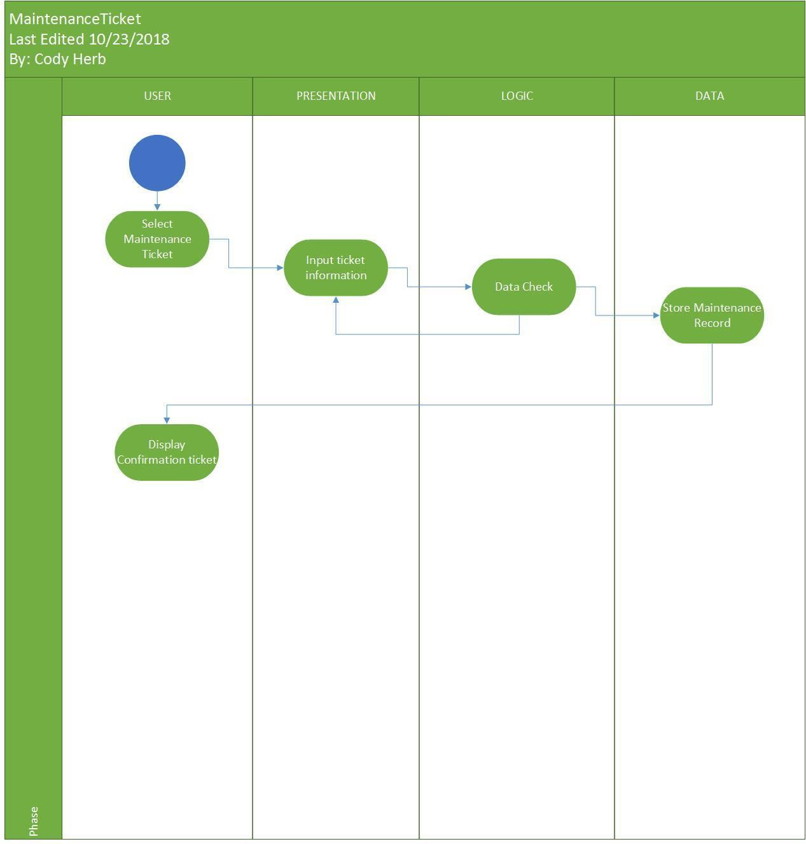

### Manager – Packages

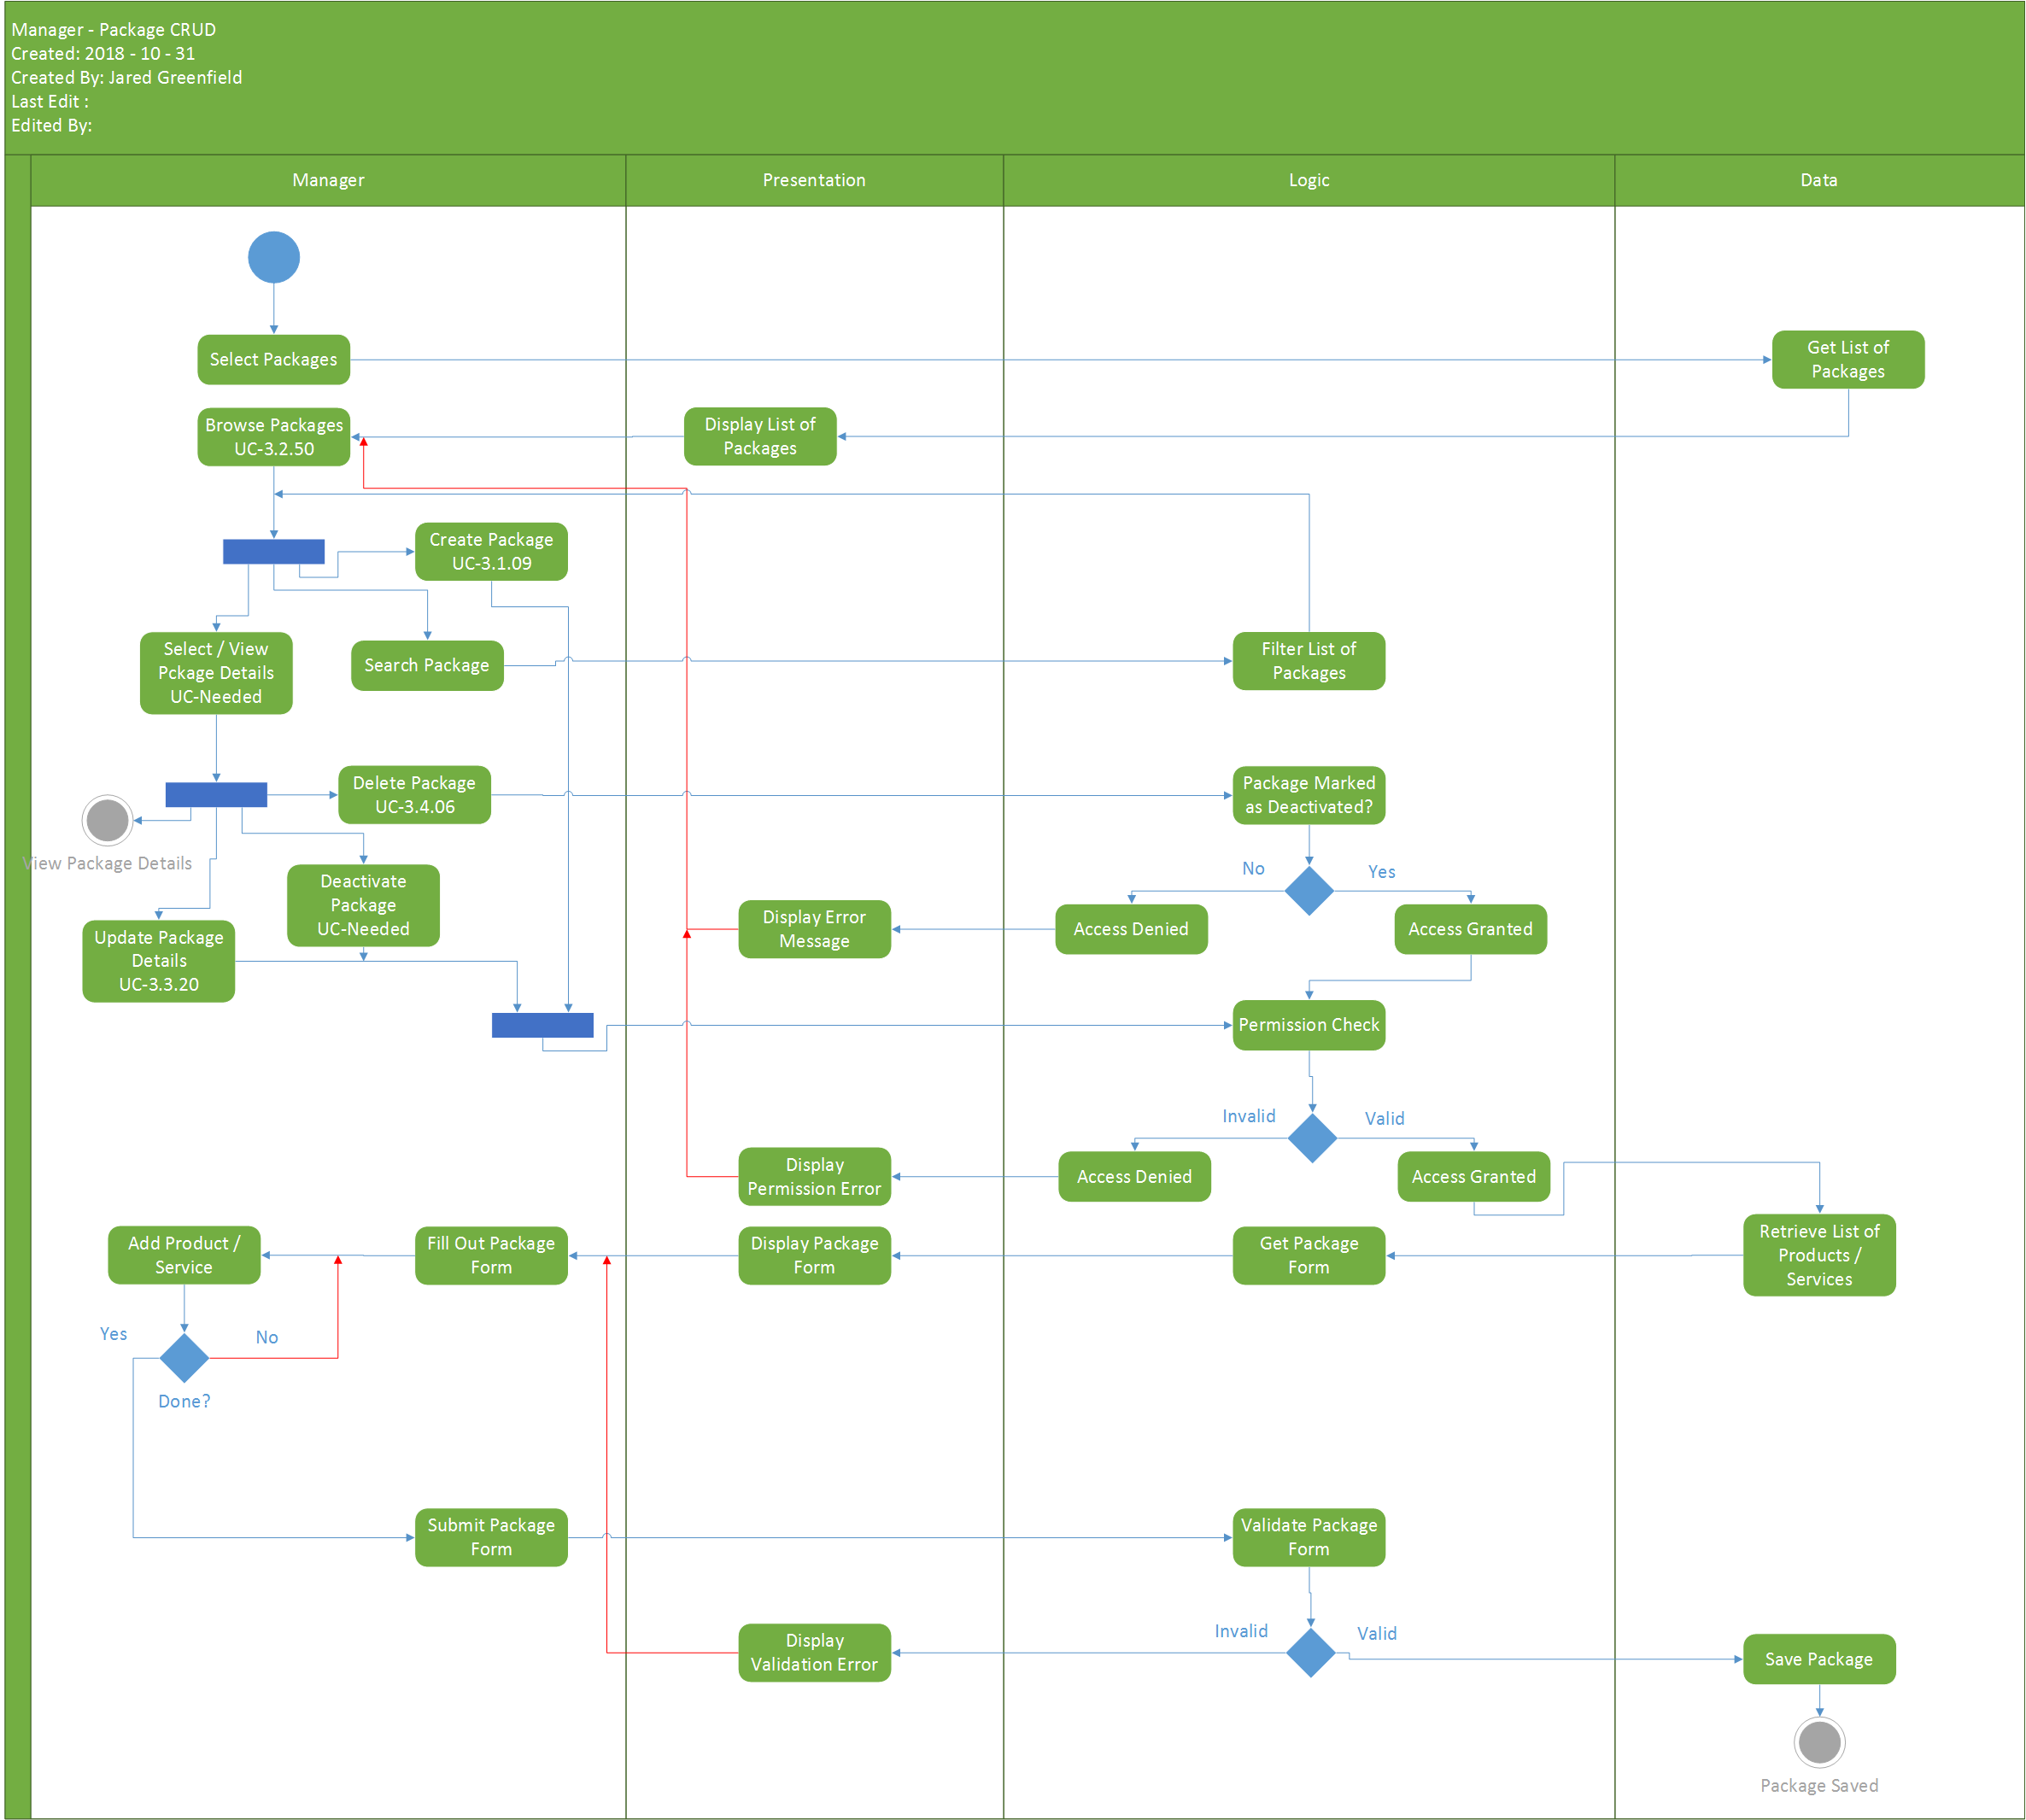

### Manager – Supplies

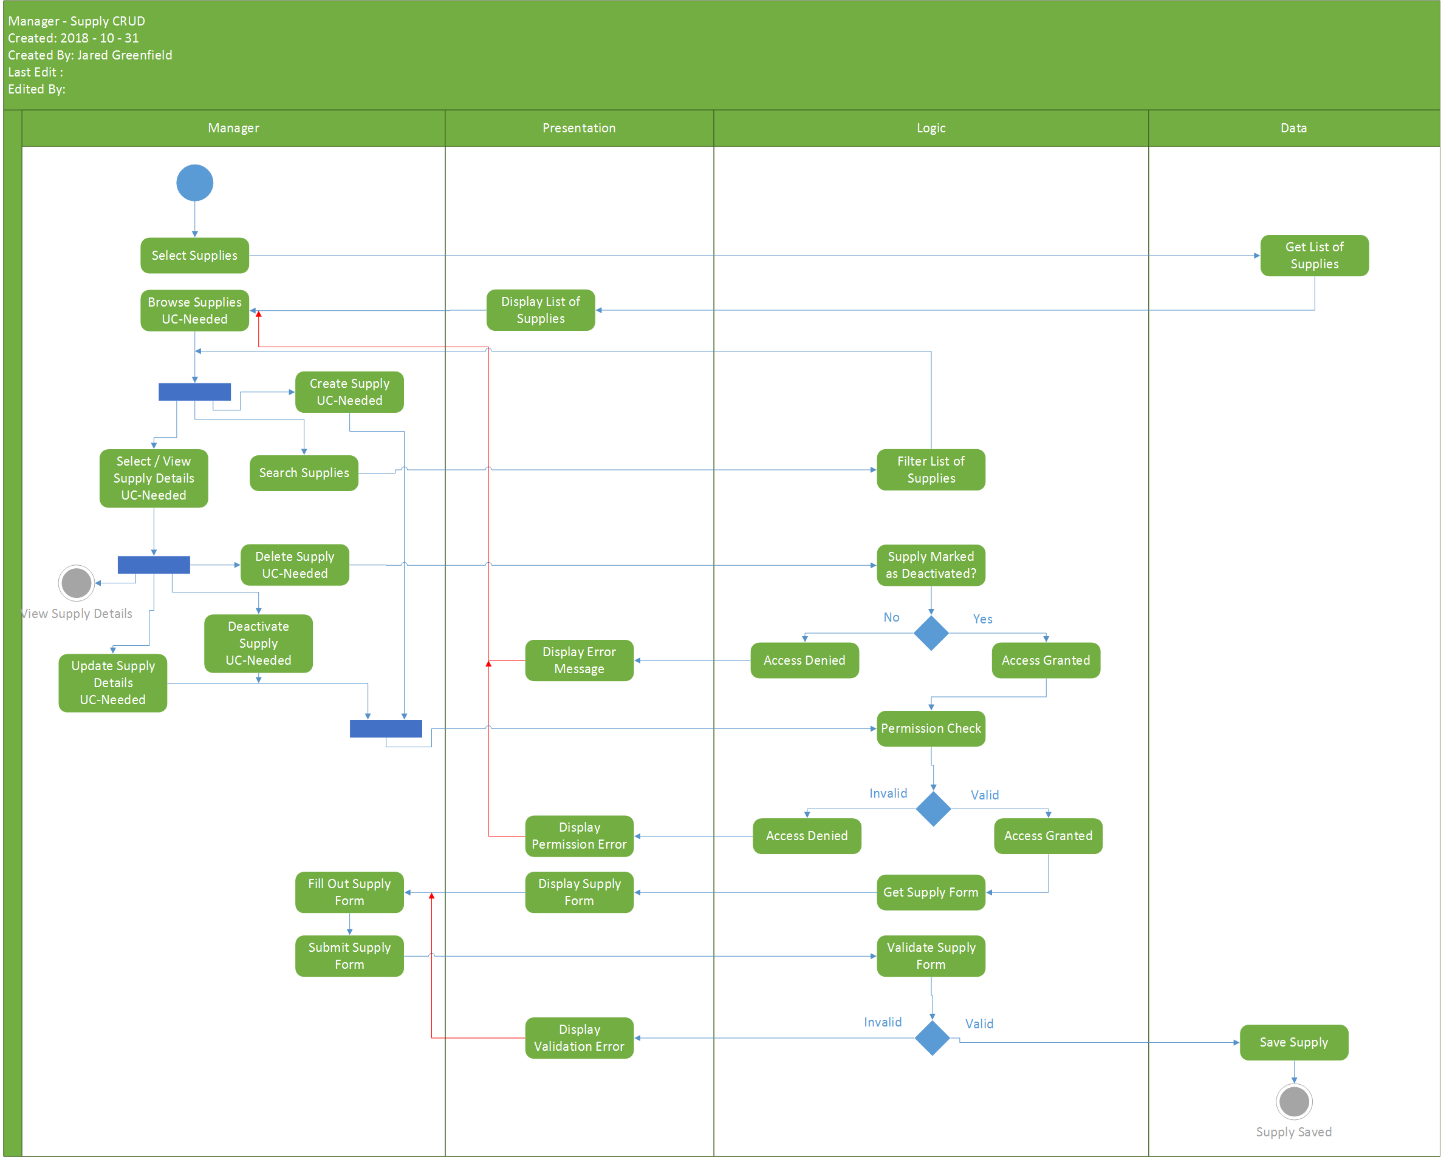

### Performance Schedule

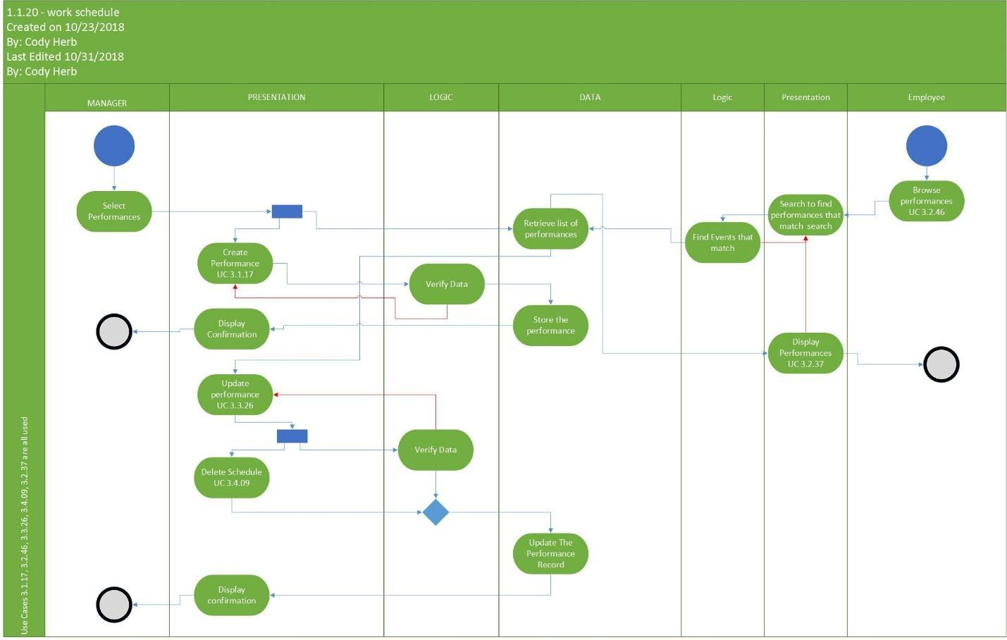

### Employee Time-Off Request

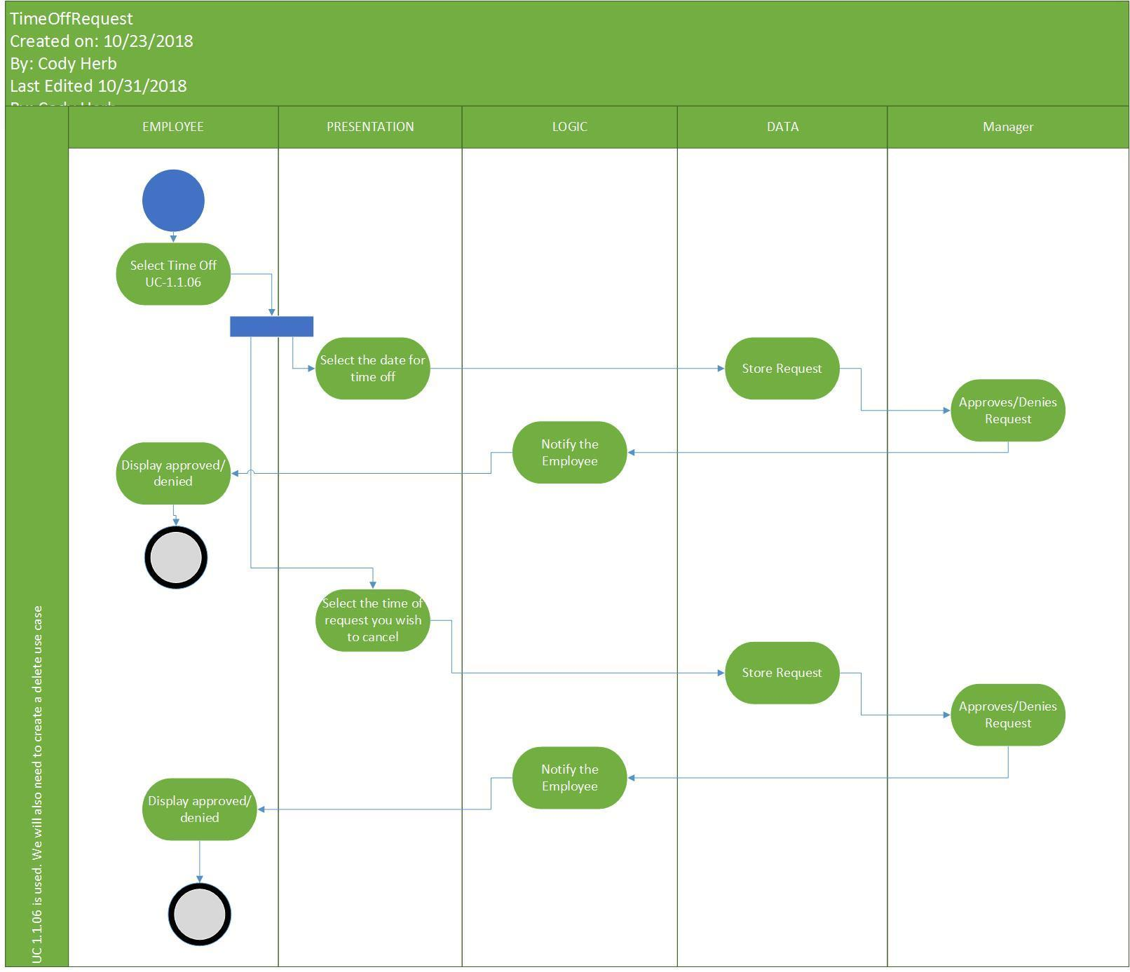

### Work Schedule

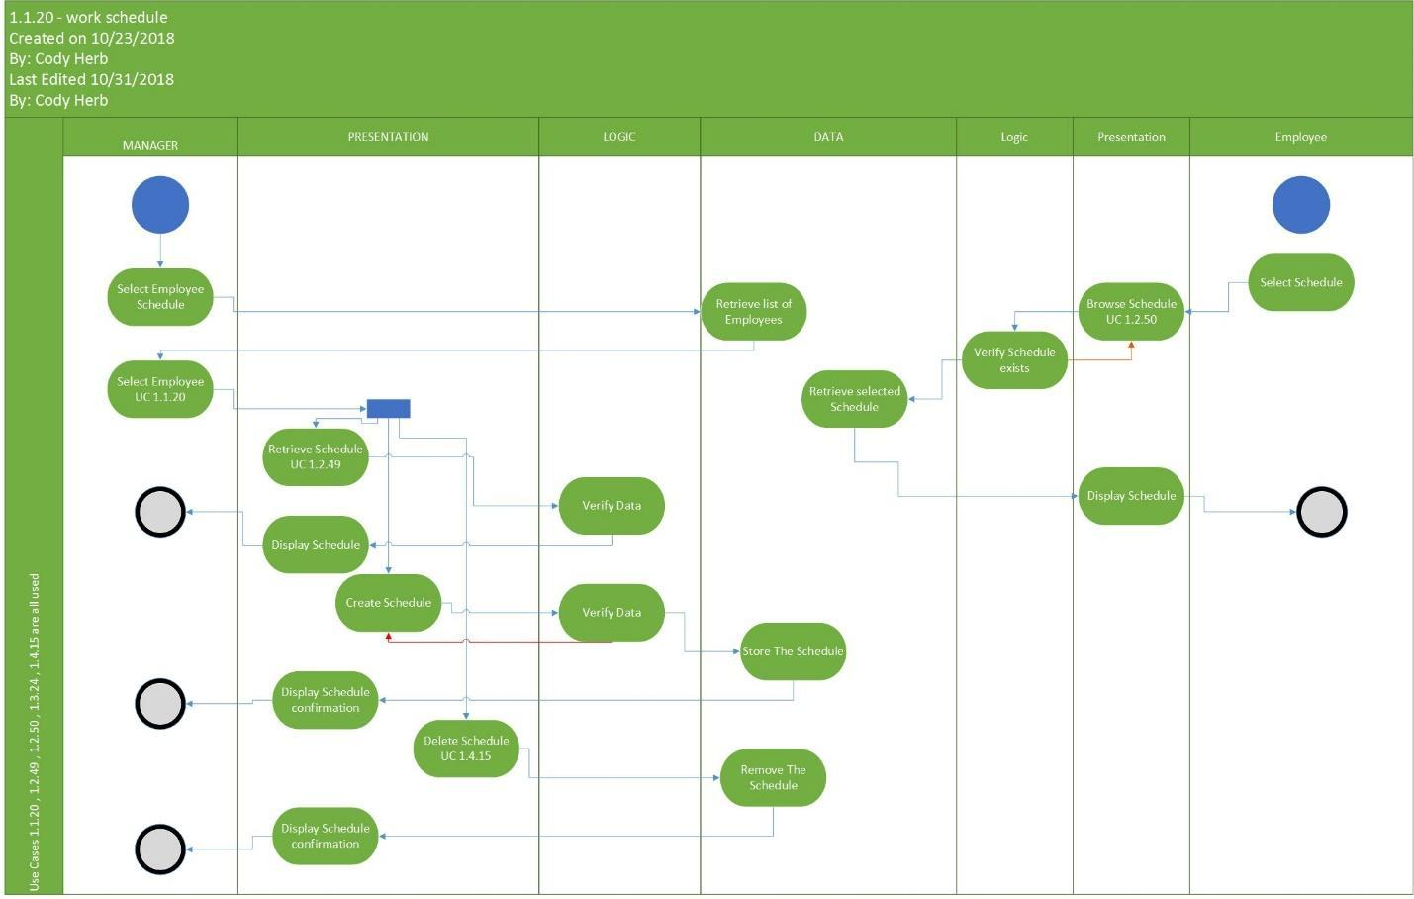

# Interfaces

## Shell

### Internal Shell

## Internal

### Food Operations

The following use cases detail the design relating food operations and items.

### Supply Operations

The following use cases detail the design relating to the order of supplies and the replenishing of inventory.

### Facility Operations

The following use cases detail the design relating to the resort maintenance and manufacturing.

### Guest Operations

The following use cases detail the design relating to the guest and member services including reservations and check in/out processes.

### Personnel Management

The following use cases detail the design relating to the employees and their roles and schedule management and member services including reservations and check in/out processes.

### Event Operations

The following use cases detail the design relating to the event logistics.

### Service and Appointment

The following use cases detail the design relating to the resort services including valet, dependent care, and resort shuttles.

### Product Operations

The following use cases detail the design relating to the resorts shops and restaurants and the products offered.

## External

### Customer Interfaces

# Data Structure

## Food Operations

The following use cases detail the design relating food operations and items.

## Supply Operations

The following use cases detail the design relating to the order of supplies and the replenishing of inventory.

## Facility Operations

The following use cases detail the design relating to the resort maintenance and manufacturing.

## Guest Operations

The following use cases detail the design relating to the guest and member services including reservations and check in/out processes.

## Personnel Management

The following use cases detail the design relating to the employees and their roles and schedule management and member services including reservations and check in/out processes.

## Event Operations

The following use cases detail the design relating to the event logistics.

## Service and Appointment

The following use cases detail the design relating to the resort services including valet, dependent care, and resort shuttles.

## Product Operations

The following use cases detail the design relating to the resorts shops and restaurants and the products offered.

# Sequence Diagrams

## Food Operations

The following use cases detail the design relating food operations and items.

## Supply Operations

The following use cases detail the design relating to the order of supplies and the replenishing of inventory.

## Facility Operations

The following use cases detail the design relating to the resort maintenance and manufacturing.

## Guest Operations

The following use cases detail the design relating to the guest and member services including reservations and check in/out processes.

## Personnel Management

The following use cases detail the design relating to the employees and their roles and schedule management and member services including reservations and check in/out processes.

## Event Operations

The following use cases detail the design relating to the event logistics.

## Service and Appointment

The following use cases detail the design relating to the resort services including valet, dependent care, and resort shuttles.

## Product Operations

The following use cases detail the design relating to the resorts shops and restaurants and the products offered.

# Automation

## Work Scheduling

The automation for scheduling employees on a weekly basis.

### Class Diagram

### State Diagram

### Sequence Diagram

## Ordering Supplies

The automation for ordering supplies on a timed schedule.

### Class Diagram

### State Diagram

### Sequence Diagram

## Reservations

The automation for setting up reservations on a timed schedule.

### Class Diagram

### State Diagram

### Sequence Diagram

## Event Planner

The automation for scheduling events on a timed schedule.

### Class Diagram

### State Diagram

### Sequence Diagram

# Class Diagram

## Food Operations

The following use cases detail the design relating food operations and items.

## Supply Operations

The following use cases detail the design relating to the order of supplies and the replenishing of inventory.

## Facility Operations

The following use cases detail the design relating to the resort maintenance and manufacturing.

## Guest Operations

The following use cases detail the design relating to the guest and member services including reservations and check in/out processes.

## Personnel Management

The following use cases detail the design relating to the employees and their roles and schedule management and member services including reservations and check in/out processes.

## Event Operations

The following use cases detail the design relating to the event logistics.

## Service and Appointment

The following use cases detail the design relating to the resort services including valet, dependent care, and resort shuttles.

## Product Operations

The following use cases detail the design relating to the resorts shops and restaurants and the products offered.

# Data Layer

## ER Diagram

## Data Dictionary

## Stored Procedures

# System Requirements

## Hardware

## Software

### Integrated Development Environments

### Tools

### Languages

## Timeline

# Contributors